
Nashua
Technical
Management
Standards

OFFICE AUTOMATION &
PRODUCTION PRINT

version 2017.02.25
TABLE OF CONTENTS

Introduction 7
Nashua Management Statements 8
Nashua Technical Mission Statement 9
Management Responsibilities 10
Introduction 10
Reporting 10
Responsibilities 10
Goals and Objectives 10
Nashua Technical Management Standards (NTMS) 11
Quality Objectives 11
Organisation Charts (as per ISO 9002) 11
NTMS Audits 11
Quality Problems and Solutions 11
Customer Satisfaction 12
Service call Inspections 12
Staff Appraisals 12
Service Request Management 13
Introduction 13
Responsibility of the Service Controller 13
Availability of Service Controllers / Support Staff 13
Methods of requesting a Service call 13
Call Avoidance 14
Basic Product Knowledge 14
Using the Ricoh Knowledge Base site 14
Franchise Help Desk functions 16
Customer & Call Handling procedures 16
Customer Complaints 16
Logging of new Service Requests 17
Handling Customers with overdue accounts 17
Logging of Calls when the AS400 is down 18
Service Requests outside of normal business hours 18
Service Types 18
Service Requests outside normal business hours 20
Service Controller Training 20
Service Planning 21
Introduction 21
Purpose of Service Planning 21
Service KPI’s 21
Service Level Agreements (SLA) 21
Dispatching Service Engineers 21
Service Call Management 22
Service Call Completion 22
Last Service Call of the day 22
Courtesy calls 23
Response Times 23
Notifying customers when Response times will not be met 23
Registration of Non-Service Activities 23
Customer’s requesting set service intervals 24
Preventative Maintenance Service Calls (Major service calls) 24
Service Engineers 25
Introduction 25
Service Engineer’s Vehicle 25
Service Engineer’s Dress Code 25
Service Engineer’s Tool bag and Tools 26
Training 26
Training Records 27
Customer Visit Procedures 27
Service Call Completion details 28
Parts ordering, Boot/Online stock 29
Parts Ordering 29
Onsite Stock 29
Boot Stock 29
Technical Documentation 29
Problem Escalation Procedures 30
Service Engineer’s Workload 32
Service Engineer’s Skills Development path 32
Skills breakdown 32
Required Skill levels 34
Training 35
Introduction 35
New Employees 35
Staff Training 35
Essential Training course descriptions 36
Customer Relations 36
AS400 Training 36
Technical Director / Managers 36
Product Training 37
Service Controllers 37
Service Engineers 37
Online Training tools 37
Training Records 37
Training Rooms 38
Required training for Service Engineers 38
Training Assessment 38
Continued Service Agreement 39
Technical Service Procedures (National workshops) 40
Goods receiving inspection & evaluation: 40
Copier Repairs 40
Fax Laser Repairs 40
PCB Repairs 40
Refurbishing 41
Cannibalisation 41
Service Response and Downtime Management 42
Introduction 42
Terminology 42
Outside of business hours 42
Ongoing Revenue Division Procedures 44
New Spares Parts Manual (E-Ordering) 44
EQUIPMENT RETURN AUTHORISATION (ERA) NON WARRANTY 46
Warranty on Nedcor / New Printers 47
Sample of Problem Report 49
Sample Problem Report Confirmation 50
IS Department – AS400 Procedures 51
AS400 Training 51
Network Department Nashua User Request 51
Systems Development Department (User Problem Request) 51
Fundamental program Change or Additions (Technical Service Programs) 53
Request for changes to the Service programs 53
Installation Procedures 54
Introduction 54
Responsibilities 54
Pre-Installation forms 54
Post-Installation forms 54
Where do you get the latest versions of the Installation forms? 54
Machine data 55
Delivery of machines 55
New Machine setup 55
Installation Commission 55
Payment of Installation Commission 56
Documentation needed for Installation commission 56
Installation consumables 56
Errors in Installation Commission process 56
Technology Training Procedures 57
Introduction 57
Training Schedules and bookings 57
Training Options 57
Training course booking cancellations 58
Training course pre-requisites 58
Training Life Cycle 58
Online Training Tools 58
My-Ricoh Training portal 59
HP Training Portal 66
Link Product to Engineer 69
Product Training Course Content 70
Training course evaluations 70
Technical Documentation 70
iNForm 70
Technical DVDs 72
NASHUA BUSINESS Intelligence (BI) tool 73
Requesting access to the BI Tool 73
Logon Details 73
Resetting your Password 73
Web details 74
First Logon 74
BI Main logon page 74
Navigating the BI site 75
Franchise Dashboard 75
Engineer Dashboard 76
General Dashboard 76
Using the BI tool 76
Setting a Report Filter 77
HP Global Channel Service Network (GCSN) 78
Confirm Serial Warranty Entitlement 78
Confirm Part Number 79
GCSN Warranty Parts Order Process 81
GCSN Faulty Part or Machine return 87
GCSN Warranty Labour Claim Process 87
GCSN Non-Warranty Parts Order Process 91
GCSN Labour Only Claim – SWAP (Service Without A Part) 94
Re-Link Existing CarePack to Replacement Machines 96
AS400 Procedures in line with GCSN Orders 96
Parts Ordered on GCSN – Link on AS400 96
Machine replacements Ordered on GCSN – link on AS400 97
References 98
Policies and processes 99
Dealer Service Revenue (DSR) 99
Inter Franchise Labour Rates (IFL) 105
Process 105
Franchises not completing IFL forms 105
Current Inter Franchise labour rate 105
Warranty Procedures 106
Software Installation Charges 107
Inter Franchise Labour (IFL) Rate Matrix 108
Relocation Procedures 109
Billing your own and another Franchise’s Customers 111
Inclusive Consumables 111
Inclusive consumable Ordering Process 111
Colour image creation process 112
How do the Copy usage meters increment on Prints and Developments? 112
How are Consumable yields calculated? 112
Prints vs Developments on Colour Products 113
Key Performance Indicators (KPI) 114
Mean Time to Repair (MTTR) 114
First Time Fix (FTF) 114
Repeats 115
My-Ricoh 116
KPI targets for 2017 116
MY-RICOH TRAINING 116
MEAN TIME TO REPAIR (MTTR) 117
FIRST TIME FIX (FTF) 118
Production Print 120
Introduction 120
Skills required for Production Printing 120
Production Print Training 120
Minimum requirements for Service Engineer before Servicing Production Print machines 120
Parts Holding at Franchise for Production Printing 120
Implementation for Production Printing 121
Conducting Site Surveys 121
Field Service Calls on Production Print machines 122
Tools necessary to service Production Print machines 122
Preventative Maintenance Procedures 123
List of Acronyms used in this document 124

Introduction
The Nashua Technical Management Standards (NTMS) has been designed to:
- To set and maintain Technical Standards within the Nashua Group
- Set standards for all of business as defined by Nashua (Pty) Ltd
- Ensure uniformity across the Nashua Franchise network
- Give all role players in the Technical Division a clear understanding of what is expected from them

It is the responsibility of the Technical Franchise Liaison to update the contents of the NTMS manual. New versions will be released with every change. The last version will always override the previous versions of this document. The contents contained in the NTMS manual is policies and standards as defined by Nashua LTD or agreed upon by the Franchise Holders and / or Technical Managers.

It is the responsibility of the Technical Director / Manager to update the documents at the Franchise and to ensure that all Technical Staff is informed about new changes.

In this document, references to Technical Manger includes Technical Director / Managers.
In this document, references to he or she, will include all genders within the Technical Division

For all queries and suggestions on the NTMS, you can contact the Technical Franchise Liaison.

All persons within the Technical Division should have access to the NTMS and should be given time to familiarize themselves with the contents thereof. All queries can be directed to the Technical Director / Manager. Should there be further uncertainty then the queries can be directed to the Technical Franchise Liaison at Nashua LTD.

It is the responsibility of the Technical Director / Manager to ensure that all Technical staff is aware of the NTMS document and that they have full access to this document.

Nashua Management Statements

**** New statements to be entered here ****

Nashua Technical Mission Statement

TO ENHANCE THE
CORPORATE
MISSION STATEMENT
OF
TOTAL QUALITY SERVICE BY
EXCEEDING
CUSTOMER EXPECTATIONS
THROUGH
CONSISTANT
PROFESSIONAL
TECHNICAL SUPPORT
REALISING
MUTUAL GROWTH AND PROFIT

Management Responsibilities

Introduction

The Technical Manager plays a vital role in the effective running of the Technical Department. Technical Departments overall covers many different parts of the business, therefore his understanding and knowledge of each of these areas will assist in the effective running thereof.

The Technical Director / Manager is responsible for assessing all the staff in the Technical department and to identify areas that needs enhancement or where efficiencies can be improved.

Reporting

The utilisation of performance reporting allows the Technical Manager to effectively manage his Technical environment driving efficiencies and best practices. The Technical Manager’s responsibility is with managing his staff and providing them with guidance by utilising the reports available. He consistently must measure their performance the assigned KPI’s.

Responsibilities
The Technical Director / Manager has an overall responsibility in all sections within the Service Department.
Responsibilities include:
- Make available the NTMS to all staff
- Setting Goals and Objectives for the Technical Department
- Ensuring the Technical Department delivers a quality service to their own customers and that of other franchises.
- Ensure that all staff is adequately trained in their relevant job specific functions.
- Follow up on all Customer Complaints
- Do regular measurement against KPI’s to track the performance

Goals and Objectives
As with any company, each Technical Department must have a clear set of Goals and Objectives that they want to achieve. Goals and Objectives should follow the SMART principle:
- Specific
- Measurable
- Attainable
- Relevant
- Time bound

Goals is the description of the broader direction that you as a Technical Department want to achieve. Objectives on the other hand, is the detail on how you want to achieve your Goals and is a lot more specific and time bound.

Example:
Goal | - To increase the overall FTF
Objectives | - All Service Engineers complete training on all relevant products by end of May 2017  - A weekly check of all Service Engineer’s boot stock to ensure they have the correct parts when attending to service calls.

Nashua Technical Management Standards (NTMS)
The Technical Franchise Liaison is responsible for compiling and updating the NTMS manual. The content is a joint effort from the Technical Director / Managers from the various franchises and the inputs from Nashua LTD.

The Technical Director / Manager of the individual Nashua Franchises is responsible for the implementation and compliance to the NTMS.

The NTMS are reviewed on a regular basis and modules may be added or deleted as necessary. When the NTMS are reviewed, it will be made available to all franchises. It is the responsibility of the Technical Director / Manager to ensure that the document is printed and updated in the NTMS manual and that all staff is notified that an updated version is available.

Quality Objectives
Nashua Ltd. and/or the Technical Director/Manager of the individual Nashua Franchise define(s) the quality objectives. The objectives must be communicated to all employees for uniformity. Quality objectives are stated in the Business Plan that also contains an action plan and time schedule with respect to the NTMS.

Organisation Charts (as per ISO 9002)
A detailed organisational chart should be available and visible to all staff. The chart should include all departments that forms part of the Technical Division and clearly display reporting lines

The organisational chart should be updated as and when there are changes in the organisation and be updated or reviewed at least every six months. The last review date should be clearly indicated on the organisational chart.

NTMS Audits
The Technical Franchise Liaison plans and schedules audits at all franchises to ensure that they comply with the standards. The Technical Director / Manager needs to ensure that the relevant persons are available when audits are done. The purpose of the audits is to assist the franchises to find areas where they are able to improve and to verify that the Technical department performs against the standards.

After audits, Franchises are notified on the outcome of the audit. It is the responsibility of the Technical Director / Manager to ensure that areas identified for improvement are corrected.

Quality Problems and Solutions
Any employee can initiate solutions to a quality-related problem by reporting to the Technical Director / Manager. A standard procedure for this matter should be in place and a record is kept of all solutions initiated and results of corrective actions.

The success of a solution to a quality problem is verified by an appointed person within the service organisation.

Customer Satisfaction
Customer Satisfaction surveys should be performed on a regular basis so that the Technical Department can keep on measuring their performance. The outcome of the surveys needs to be evaluated and corrective action needs to be taken in order to meet or exceed customer expectations.

Every service call logged gives the Franchise the opportunity to capture additional customer details (Name & email address). This information will be used to send out customer surveys through a 3rd party (Genex). Monthly reports will be sent to all franchises on feedback received from customers. This will include positive and negative feedback.

Scoring will be on a scale of 0 to 10. All service calls with a rating lower than 5 will be logged on the Resolve system as an escalation. The customer needs to be contacted within 48 hours to resolve the negative rating.

Service call Inspections
To ensure that all Service Engineers follow the Customer Visit Procedures (refer page 26) and that the customer is satisfied with the service they received, Quality inspection calls needs to be done. The frequency of the Inspection calls can be determined by the Technical Director / Manager at the respective Franchises but should not exceed a calendar month apart.

Inspection calls must be done on every Service Engineer and results of this inspections needs to be documented. The results thereof, should also be communicated to the Service Engineer. Any areas where improvement can be done, should be actioned and discussed with the Service Engineer on how this needs to be handled in future

Staff Appraisals
An annual appraisal system needs to be implemented by the Franchise to ensure staff performance are measured and skills development are identified

Service Request Management

Introduction
This process describes the process in how incoming Service request needs to be initiated and processed. The quality of the service operation can be judged by various aspects, however from a customer’s perspective, the way his service request is handled can significantly influence his opinion about the Service Operation and Nashua as a company.

Efficient call handling leads to high “Call avoidance” or rather “avoids unnecessary visits” and this can significantly reduce operational costs.

It is the responsibility of the Technical Director / Manager to ensure that all employees handling service requests are able to perform within the guidelines.

Responsibility of the Service Controller
The Service controller plays a vital role in the organising and effective completion of Service Calls.
Her responsibility includes:
- Accurately capture and verify all Customer details
- To correctly interpret and log the customer’s service requirements
- To ensure that what the customer expects, if followed up
- To be able to assist the customer first line to resolve the problem by utilising supplier online knowledge base systems thus preventing unnecessary Field visits
- Inform customers timeously as to the status of their service request
- Log and report any customer complaints received
- Dispatch Service Engineers to service incidents
- Organise and prioritise service calls

Availability of Service Controllers / Support Staff
During office hours, a sufficient amount of Service Controllers and Support Staff should be available to log and handle Service Requests. In the case where all telephone lines are all occupied, the customer should be advised of other methods of logging a Service Request (Fax, email, etc). An option of leaving a message, being transferred to another operator should be available. The voice message should have an instruction of the information needed to log a Service Request (eg. Serial number, etc)

When the call is received out of business hours, a voice mail message should inform the customer what the formal business hours are. If a standby Service Engineer is available, the voice message should include instructions on how the customer should proceed from there.

Methods of requesting a Service call
There are multiple ways a customer can request a service event it is imperative that the data is checked and verified irrespective of method used to log service call (see call details that needs to be checked on page 16)

Phone
The Technical Department should have a sufficient amount of incoming telephone lines to enable them to handle all incoming Service Requests. The incoming call loads needs to be monitored and adapted if the load becomes too high.

Fax
If this facility is available for customers to use, a Fax machine (or MFP with a Fax unit) should be in the Technical Department in clear view of the Service controllers. This is to ensure that no requests go missing when documents are removed from the machine. Should a Customer use this facility, a standard form needs to be designed to ensure that the customer communicates all the relevant information to the Technical Department.

When a service request is received via Fax, the Service controller needs to check and verify all information on the AS400. Should anything be unclear or incorrect, the Service Controller should call the customer and verify all the information.

Email
The Franchise must set up a general Service Email address (Eg. service@nashuaFranchise.co.za). This email address should be routed to multiple people ensuring service requests are managed in a timeously fashion

When receiving a request via email, the customer should be receiving a notification either by return e-mail or a telephonic call. All customer details and information must be confimed

Web site
(Future development)

Call Avoidance
Call avoidance is the process in which we attempt to first resolve the customer’s problem over the phone or remotely. Irrespective if the call was solved over the telephone, remotely, or if a Service Engineer had to be dispatched, a Service call must always be logged on the AS400.

Should we be unsuccessful in assisting the customer over the telephone, a normal service call should be logged to dispatch a Service Engineer to the customer.

This process does not only assist in reducing costs, but also allows for the opportunity to get the customer up and running resulting in more efficient up time.

Basic Product Knowledge
To effectively assist the customer through this process, the Service controller needs to have some basic Product knowledge (refer page 36) and understanding to enable her to guide the Customer through the process of resolving the issue themselves. This training can be done at franchise level by a Technical Manager, Supervisor or Senior Engineer with the necessary knowledge.

All training done, should be recorded in the training records. (Refer page 36)

Using the Ricoh Knowledge Base site
The Service Controller needs to be familiar on how to use the Ricoh Knowledge Base system. This system has been designed to assist any person to resolve many lower level issues by themselves. To have access to the Ricoh Knowledge base system, the Service Controller must have access to an internet connection and the following Ricoh web site:
www.ricoh-support.com

On first entry onto the website, set the country in the top right-hand corner. (AFRICA – South Africa)

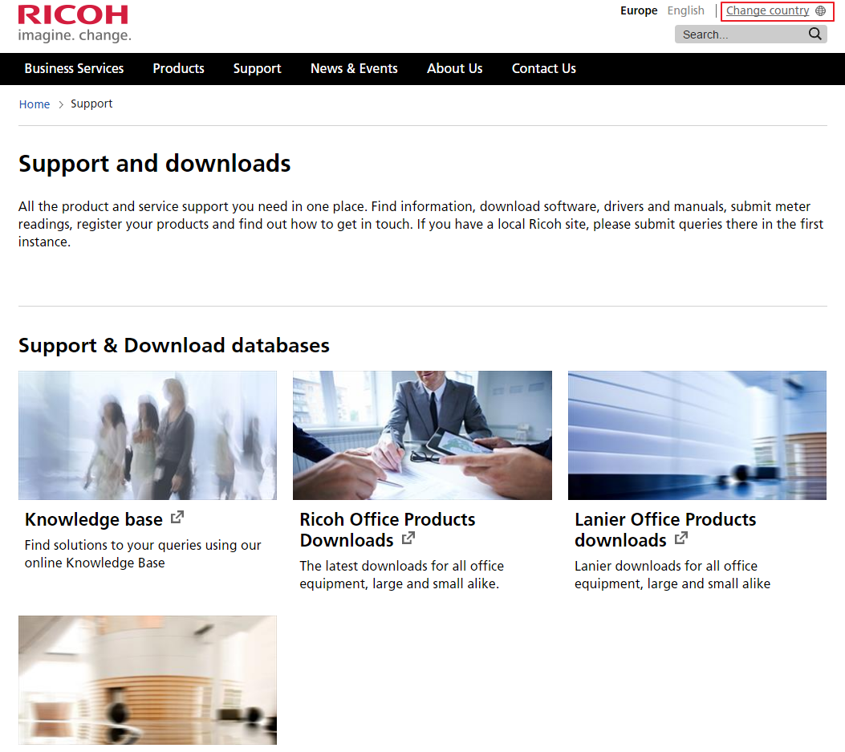

To get to the Helpdesk functions, select the “Support” option

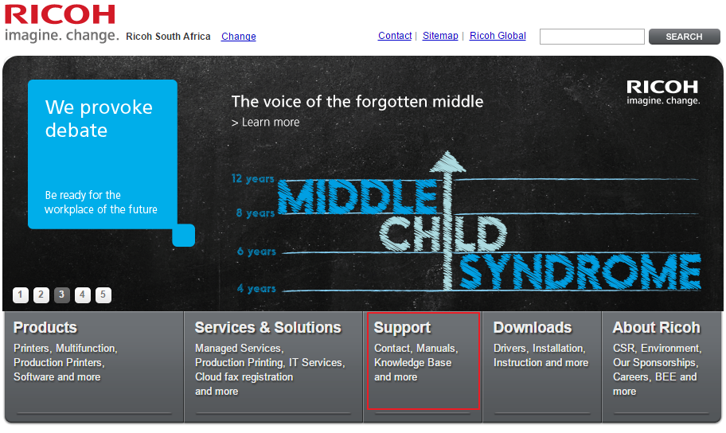

Then open the Knowledge Base

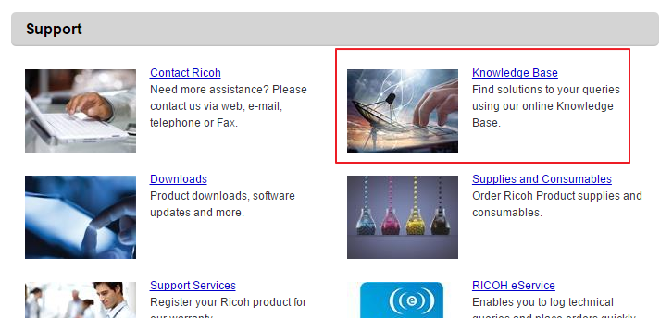

Select the product that you need assistance on and follow the instructions on screen

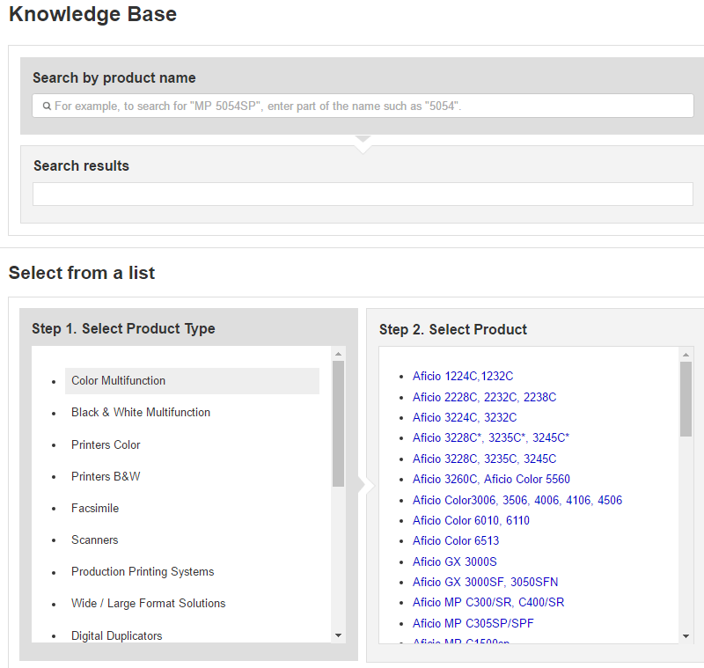

The process of getting information on all basic (and more complex) issues are clearly outlined. Follow the steps as described on the Knowledge Base to assist the customer in resolving the problem at hand.

Some customer’s may want to implement the Knowledge base system to assist them to resolve issues. (Example: Customers with dedicated IT departments). Share the web site information. The site contains a wealth of information that can assist customers to resolve many issues before they need to log a service incident.

If the Service call is resolved over the telephone, the correct Service Type needs to be used to identify the call as completed over the telephone. (“Solved by Phone”)

Franchise Help Desk functions
Some franchises may have a Help Desk system in place in which they would assist Customers and Service Engineers alike. This function may also be taken up by a resident Workshop Manager / Service Engineer. Should they be able to assist the customer over the phone, it is the responsibility of the Workshop Manager / Service Engineer to get the necessary details to enable to Service Controller to log and complete the call on the system.

If the Helpdesk person is appointed to assist Service Engineers, he should receive the same technical Training as field Service Engineers. This Helpdesk person can also be utilised to download drivers and firmware for Service Engineers. This will help minimise internet usage and assist in improving the customer experience.

Customer & Call Handling procedures
In order to handle the customer calls in a satisfactory and efficient way, all Service Call operators must have attended a Customer Relations Training course.

(Refer to Training Procedures for information on Customer Relations Training courses – page 35).
Records should be kept of all Training courses attended

Customer Complaints
All Franchises should have a method of registering and keeping track of all customer complaints. The Technical Director / Manager and Service Controllers should have access to this document/process at all times so that it can be updated at any time. If any person other than Technical Director / Manager registers a complaint, the details of this complaint should be forwarded to the Technical Director / Manager so that he is aware of these.

The Customer Complaints register should contain the following information:
- Date / Time recorded
- Name of person logging the complaint
- Customer Name
- Contact Details
- Description of the complaint
- Status of the complaint
- Name of the person who is assigned to investigate / resolve the complaint
- Resolution
- References to all correspondence and documentation
- Date / Time Resolved

The register needs to be updated during the process of the investigation and resolve. All complaints received by the Service Controller/s has to be reported to the Technical Director / Manager so that he is aware of this at all times.

All resolved complaints has to be archived (electronic / physical) for future reference.

Logging of new Service Requests
All Service Requests should be logged directly (and immediately) on the AS400. Most franchises handle a huge amount of service requests, and therefore not logging them immediately on the AS400 increases the chances of Service requests being missed or incorrectly handled. NO requests may be written down and logged at a later stage for any reason (except when the system is down) what so ever. All future calls must also be

When a new Service Request is logged, the Service Controller (or the person logging the call) should check / verify the following items:
- Serial number
- Model
- Company Name
- Address
- Telephone number
- Contact person
- Problem of the machine reported
  - The Controller should probe the Customer to get as much possible information on the nature of the problem they are experiencing.
  - The correct Problem code should be registered for this service call
- Use the correct Service Type for the Service call logging (refer to Service Types below for description)
- The opening and closing business hours of the customer

After the Service Request has been logged, the following information should be shared with the customer:
- Call number (Reference number)
- An estimate when the Service Engineer will attend to the Service call
- If the call is a far distance from the office, the customer needs to be informed when the Service Engineer will be servicing machines in the relevant area

Handling Customers with overdue accounts
An overview or information should be available of customers that have overdue payments. A procedure must be in place that describes what actions should be taken in case of an overdue payment.

It is the responsibility of the Technical Director / Manager to have this process in place and that it is communicated to all Service Call operators.

Logging of Calls when the AS400 is down
Only when the AS400 is down, may a Service Request be written down in a register / log book. This register must contain all the relevant information the Service Controller would need to log the Service Request properly. Once the AS400 is up and running again, the calls should be logged with the details recorded in the register.

Except for the information needed on a normal Service call that is logged directly on the AS400, the following additional information should also be recorded as well:
- Date and Time of logging the Service Request
- Name of the Service Controller logging the request
- If the Call has been completed, then all the completed call details can be added to this log.
  - Service Engineer Name
  - Parts used
  - Meter readings, etc
- Call register needs to be archived for future reference, should there be any queries.

Service Requests outside of normal business hours
Customers calling outside of business hours should be notified via voice message of the official business hours of the Franchise. Added to this, if the Franchise provides the service, the telephone number of the Standby Engineer should be given.

Should a Standby Service Engineer be contacted after hours, the Service Engineer needs to inform the customer of any call out fees and charges. For customers that is on CSA, the fees may consist of call out fees, but parts replaced on the machine is included in the CSA.

Service Types
Using the correct Service Types when logging a Service call, will ensure that correct reporting is done.

Service Type | Description
After Hours
Awaiting Instal Cpl | When the main installation cannot be completed and must be completed at a later stage, this Service Type can be used
Awaiting Instal Stk | Not all the accessories is available during the time of installation
Awaiting Install Customer | Use this service type when logging an installation call where the customer has postponed the installation due to limitations on his side. (eg Network points not available, Renovations, etc.)
Awaiting IT Instl CPL | When the Franchise’s Service Engineer does not have the necessary knowledge of doing the IT portion of the Installation, or the policy at the franchise is that the IT portion needs to be done by a different Service Engineer, this service Type can be used
Awaiting Quote Acceptance | The call is still outstanding and has this Service Type to indicate that you are waiting for the customer to accept the quote that was given to him.
Awaiting Spares | This call has been logged off that it needs parts. The call where the parts is replaced will have a service type of “Awaiting Spares”
Awaiting Specialist | The Service Engineer was not able to repair the machine and has requested that a more senior Service Engineer / Supervisor attends to the call. The call is logged off and the Awaiting Specialist call is created.  The Awaiting Specialist call should not be done by the same Service Engineer that logged this call, however he may be logged as an Assisting Service Engineer
Call Cycle | When a Future / Call Cycle call is logged, it will have a call type of “Call Cycle”
Consultation | Not used
Consumable Runner | This service Type is dedicated for calls where a contract exists that Nashua replaces the consumables (Toner / paper / etc.) on the machines at the customer site.  This service type will to influence the FTF or Repeats but MTTR will be measured on them.
Courtesy | On this call type, the Service Engineer does not service the machine. The purpose of this call is purely for customer relations.  The Repair time is restricted on this service type and the Service Engineer is not allowed to log off parts on this Service call type. The Service Engineer should make a test copy and take the necessary meter readings.
Customer Damage
Customer Repair
Ex-Dem/Con Machine
In Transit
Installation | A new / refurbed machine is being installed at a customer site. This may also be the set up call in the workshop
Normal | Not used
Post-Installation | Not used
Pre-Installation | Not used
Preventative Maintenance | Preventative Maintenance Service Calls are basically the same as Courtesy calls, except that the Service Engineer physically works on the machine. The service call procedure is the same as for a normal service call (refer page 26 for details).  This call type is also used when a proper Preventative Maintenance call is scheduled with the customer. On this call the Service Engineer replaces all the PM parts as described in the service manual.
QC Return
Quality Inspection | Development not complete…  This Service type was added to allow the Manager / Supervisor to do regular service call inspections when the Service Engineer has completed the call. This has a time limit and cannot be created more than 2 days after the original visit.
Quote | The customer has damaged the machine and a quote is issued or the machine does not have a CSA and the machine needs a quote before it is repaired. The service type generates the next service call automatically (Awaiting Quote Acceptance)
Refurb
Re-Installation | Machine is relocated to a new site and needs to be re-installed. This type of installation attracts a different Installation commission value.
Remote | This is an old service type used for Remote Diagnostics on Fax machines. This is not used any more, and therefore we are now using this for calls where the IT person remotely monitors the customer’s machines via one of the following methods:  - @Remote  - ProAct  - Team Viewer sessions  This allows us to log the time spent on these calls where no meter readings is recovered when the process is busy
Replace Kit | Used for machines where the Display panel gives an indication that the User kits are reaching PM yield.
Report Call(Meter Reading | On some occasions a Service Engineer is required to get one of the following reports off the machine:  - Meter Reading report  - SMC reports  - Team viewer sessions  On all these calls he will need to get a meter reading to enable him to complete the call on the system. The machine is not serviced on this Service Call Type.
Service | This is a normal service call request that is received from the customer
Solved By Phone | When a Service Controller resolves an issue over the phone, the calls need to be logged off with this service type. The service type does not require any meter readings.
Training | Used for when the Customer needs to be trained on how to use the machine to its full capacity
Workshop | All workshop calls

Service Requests outside normal business hours
Franchises may offer the facility to support customers outside of normal business hours. Depending on the contract with the customer, this may attract additional Service costs. These terms need to be clearly communicated with the customer beforehand. Should charges apply, the Service Engineer needs to ensure that the customer signs the charge docket.

All service call information should be manually recorded (if not already logged on the AS400), and given to the Service controller the next working day so that the service call can be logged accordingly.

Service Controller Training
Service Controllers are the main contact point when the customer’s call to log service requests. Therefore, the way that a Service Controller converses with a customer, makes a major difference in the opinion that a Customer may have about Nashua. In order to ensure the best customer relations, all Service controllers should attend a Customer Relations training course. (refer page 35 for details on Customer Relation Training Courses)

Service Planning

Introduction
Good and efficient planning starts with the accuracy of the Service call capturing. Verifying details of your customer and the machine they report, good interpretation of the problems and accurate recording thereof, is the basis of good planning process. This will assist in increasing the FTF and reducing MTTR and ultimately increase the customer satisfaction levels.

The Technical Director / Manager is responsible for the enforcing and monitoring of all Service Planning processes.

Purpose of Service Planning
To co-ordinate Service Activities in such a way that:
- Service requests are managed within the agreed response time.
- Unnecessary visits are kept to a minimum.
- Resources are dealt with in an efficient and effective way.
- The customer satisfaction levels are met in accordance to expectation.
- The service activities are profitable.

Service KPI’s
These KPI’s are set and measured to ensure efficient and professional service delivery. All technical staff has a role and part in these KPI’s. In specific the MTTR of an Engineer can be effected by the service controller’s actions when logging calls and completing calls, it is important for them to understand the importance of their actions that can influence the MTTR results. The FTF is under the control of the Engineer but are also influenced by the correctness of the data captured by the service controller. Importantly your technical staff must work as a team and understand that individual actions can influence performance against KPI’s

Service Level Agreements (SLA)
A customer is able to sign 2 main types of SLA with Nashua:
- Response time SLA
- Downtime SLA
These MTTR SLAs is a contractual agreement between Nashua and the Customer. It describes the time delay from when the service request has been logged up to the time that the Service Engineer responds to the call or up to the time the service request has been completed respectively.

As this is a contractual agreement, the SLA Service Calls take priority over other Service calls. Both the Service Controller and the Service Engineer should understand the importance of these calls and treat them accordingly.

Dispatching Service Engineers
Service Engineers should only be dispatched to one service call at a time. This includes sites where on-site Service Engineers are deployed. In areas that are very complex, it is not a problem that the Service Engineer is aware of the outstanding call locations as he may advise the Service Controller as to the most efficient route to the next service call. The Service Controller in conjunction with the Technical manager has the final say over the next service call that needs to be done by the Service Engineer. This allows her to allocate any Service calls according to set priority.

Service Engineer should only be sent to service calls for machines that they have been trained on. (see training required for Service Engineer on page 25)

Once the Service Engineer has completed a Service Call, the next service call automatically forwards his next call to his mobile application or the Service controller can share these details telephonically.

When a Service Engineer needs to be informed of the next service call over the phone, the instructions must be detailed and complete. The following information must be shared with the Service Engineer:
- Service Call number
- Serial number
- Customer name
- Customer address
- Location of the machine at the customer
- Contact person (Name and telephone number)
- Type of Contract (SLA / CSA / Chargeable / etc.)
- Problem that the customer has reported
- Any special instructions from the customer

Service Call Management
A Service controller should always have a clear understanding about the outstanding and allocated service calls in the geographical service area. Knowing exactly where Service Engineers are and where the outstanding calls is, allows her to do proper planning to minimize the MTTR of all Service calls. With this information she will be able to know when Response and Downtimes are not going to be met, and will then be able to inform customers timeously.

Service Call Completion
The Service Engineer needs to complete all service call details immediately on completion of the service incident. He may do so my either phoning the service controller, or by completing the call on his mobile application. Call completion details must be complete and accurate. If no further calls is received on his mobile application, he needs to call the Service Controller to ensure that there are no further tasks to perform.
(refer page 27)

It is the responsibility of the Service Engineer to ensure that all the correct Call completion details are given to the Service controller. It is the Service Controller’s responsibility to ensure that all details received from the Service Engineer is correctly and accurately entered into the AS400 and if there is any queries, that she communicates with the Service Engineer to get the information.

Only on full completion of the Service call on the system, does the Service Engineer receive his next service call. Service Controllers prioritise service calls on the system, and Service Engineers with the mobile application will automatically receive the next service call with the highest priority.

Last Service Call of the day
Service Engineers with a Mobile application
All Service Engineers that has access to the mobile application, needs to complete the last Service Call details on their mobile application and submit the details so that the system can capture and process the call details.

The Service Engineers will automatically receive the next service call when they next logon on to their mobile application. This will include the first call that he will then attend to the next morning.

Service Engineers without a Mobile application
Service Engineers that do not have the mobile application, and has completed the service call after normal business hours, needs to ensure that they give the information to the Service Controller first thing the next morning.

Service Engineers without the mobile application is to be given the first service call of the next day so that they can be at the customer at the start of the business day the next morning.

If a Service Engineer was unable to complete his service call the previous day, the call should be completed on the next business day morning before accepting new service requests.

Courtesy calls
When the Service Engineers have completed their service calls, they can be utilised to visit customers that have not had service calls in a long time. Before a Service Engineer visits the customer the Service Controller needs to first check the following:
- Is the customer’s account in good standing? (not on HOLD)
- Is this call not creating a Repeat of other Engineers?
When the Service Engineer visits this customer the normal Service Procedures needs to be followed (refer page 26). Further the service call should be logged by using the Service Type = “Preventative Maintenance”. The service call is completed in the normal manner (refer page 27)

The Technical Director / Manager needs to make the decision on how Service Engineers are utilized when there is no outstanding service calls.

Response Times
Every Service department needs to have an agreed Response time in which they want to respond to customer’s service request. The aim here is to have a target response time for all CSA customers that do not have a Response or downtime SLA. This would typically coincide with the targeted KPIs for the franchise.

Remember that customer with an SLA calls always take priority over non-SLA customers.

Notifying customers when Response times will not be met
All customers should be notified if agreed Response time cannot be met.
SLA customers
All SLA customers should be notified at minimum of one hour before the agreed SLA time expires, if a Service Engineer cannot attend to the Service call in time.

Non SLA customers
All Non-SLA customers should be informed if the Service Engineer will not be able to attend to the Service call in the time set by the Technical Management.

Registration of Non-Service Activities
Productivity is quite a difficult thing to measure if you cannot determine how the Service Engineer spends his workday. All Service calls are normally logged on the AS400 and from this we are able to determine how much time is spent on repairing machines and travelling to customers.

The Service Engineer also has to perform other duties that is normally not recorded in the service call log as requested by Management. Therefore, all non-service call activities need to be logged against a Service Engineer’s name on the AS400. Non-Service activities should not exceed the duration of a workday.

The Technical Director / Manager must utilise the standard list of activities on the AS400 Technical Admin menu. These activities should be monitored by the Technical Director / Manager to improve efficiencies. Service Reports can be requested from the AS400 with detailed information about all activities logged.

Customer’s requesting set service intervals
Customers may request that a Service Engineer services their machines on a set interval (Weekly / Daily / etc.). The Technical Director / Manager should Agree as part of the conditions of the CSA/SLA that this is possible and cost effective and if there will be additional charges to the customer
The AS400 can then be set up to generate a new Service call on the agreed dates. These service calls are called Call Cycle service calls. These calls will not influence the FTF of the Service Department / Service Engineer. (refer page 116 for details on FTF measurements). The new Service call will automatically be generated on the morning (Start of business day as set on the Franchise parameters) of the date loaded on the AS400.

Preventative Maintenance Service Calls (Major service calls)
The Technical Service manuals has a complete description on procedures to follow when a Preventative Maintenance Service calls needs to be performed on a machine. These service calls are normally seen as major service procedures and therefore takes longer to complete than standard Service calls. For this reason, it is important to schedule these service calls with the customer considering any disruption to their day to day activity.
Where available, a PM kit should be booked out to the Service Engineer, as this ensures that all PM parts are available at the time of the PM service call. If PM kits are not available, the Service Engineer should order all required PM parts beforehand so that they are available on the day of the scheduled PM call.
The Preventative Maintenance call may cause a Repeat call and therefore will not be seen as a FTF service call. Planning by the Service Controller can prevent this from happening.

Service Engineers

Introduction
Service Engineers are the individuals that has most interaction with our customers. The way they conduct their job will have a great influence on the Customer’s opinion about Nashua and the way we operate. Therefore, it is very important that Service Engineers have a good rapport with customers, dress neatly and have a professional attitude towards their work.

We only have one opportunity to make a first impression on a customer. Therefore, the way that a Service Engineer conducts himself on the visit to the customer will play a big role in achieving just this. A Service Engineer dressed appropriately carrying a clean toolbox already gives the expectation to the customer that he will be doing a proper professional job.

The Service Engineers should always make a good impression when visiting the customer. They should strive to increase call avoidance by not only repairing problems on machines, but also to teach the customers how the product they have can be utilised more effectively.

Service Engineers should receive the required training to do their job effectively and efficiently.

Service Engineer’s Vehicle
A Service Engineer depends on his vehicle to get to Customers to resolve customer problems.
It is the Service Engineer’s responsibility to ensure that his vehicle is regularly serviced and in road worthy condition.

As his vehicle is part of his and Nashua’s image, it is the Service Engineers responsibility to ensure that his vehicle is clean and neat at all times.

Service Engineers would normally carry bootstock parts in their vehicles. Parts and tools should not be visible from the outside of the vehicle and be locked away securely

Service Engineer’s Dress Code
The Service Engineer’s dress code should show professionalism and also allow him to do his job within the constraints of health and safety regulations. It is the Technical Director / Manager’s responsibility to ensure that his Service Engineers always confirm to the Company’s dress code standard.

A franchise should have a standardized dress code that includes the following:
- Formal Trousers
- Short or long sleeved shirt with Nashua Franchise Name on shirt
- Formal Shoes
The following is not considered as appropriate clothing:
- Sneakers/ sports shoes
- Shorts
- Old/dirty or sloppy clothing
- Caps
- T shirts
- Denim’s / Jeans

Service Engineer’s Tool bag and Tools
It is the responsibility of the Technical Director / Manager of the Nashua Franchise to provide the right tools and equipment to the Service Engineers so they will be able to perform their day to day duties professionally and efficiently keeping customer experience in mind. Depending on Franchise the tools could be supplied to Engineer at a partial cost to the Engineer or fully supplied and owned by the Franchise.

A Service Engineers tool bag and tools should always be clean and in a working condition. The effective performance of his task is only as good as what his tools allow.

Below is a list of Hardware and Electronic tools that all Service Engineers should have available on hand:

HARDWARE
- Tool bag (Should be sturdy, clean and able to protect his tools)
- Set of Screw drivers (various lengths, preferable Magnetic) (Flat, Star and jewellers screw drivers)
- Spring hook/s
- Pliers (Standard, Long nose, circlip & Side cutters)
- Torch (in working condition)
- Vacuum cleaner: A vacuum cleaner that has the ability to earth the suction pipe. This minimizes the chances of electric surges while cleaning the machines
- Test charts (B/W and Colour)
- Multi-meter (in working condition at all times)
- Cleaning Liquids and materials
ELECTRONIC
- Notebook / Tablet
- Memory Stick (up to 2GB)
- SD Cards (For updating firmware)
- Electronic Documents (Service Manuals/ Parts Catalogues / Technical Bulletins, etc.)

Tool bag inspections
Tool bag inspections should be done at least every 2 months to ensure that the Service Engineers have all the necessary tools and that all tools /tool bags are in a good working condition. Record should be kept of every tool bag inspection. Notes must be made of corrective actions to be taken to get the tool bag up to standard. Corrective actions should be followed up within 14 days to ensure that they have been corrected.

Training
Service Engineer training is a combination of Hardware, software and soft skill training. These skills is a requirement for the Engineer to ensure customer satisfaction in service delivery. (Refer to the module on Training for additional information)

Customer Relation Training
Service Engineers deal with customers face to face and therefore they should be taught how to deal with customers at this level. Customer relations is an integral part of our whole organisation. This also then means that Service Engineers greatly contribute to this process. They way that a Service Engineer approaches a Customer is a factor that influences a customer current and future view when dealing with Nashua. Therefore, it is vital that all Service Engineers attend a training course in customer relations. (refer page 35 for more information on Customer Relation training courses)

Hardware and Product Training
Proper training will always improve a Service Engineer’s skills and reduce the amount of unnecessary costs due to mistakes made during the servicing procedure or from incorrect fault diagnosis.

A Service Engineer should always strive to increase his knowledge and skills on the products that he works on. This responsibility lies with both the Technical Director / Manager and the Service Engineer. Service Engineers should have the freedom to ask for training if they feel that their job function is being hampered if they have insufficient knowledge. Just as much as it is the Technical Director / Manager’s responsibility to monitor the work progress of every Service Engineer and to recognize when the job quality is limited due to insufficient knowledge.

Product training can be done in various ways
- Trainer led training (in classroom format)
- Online training (via the Supplier portals)
- On the job training (guided by a Senior Engineer / Supervisor)
- Workshop training (new Engineers should always start their training in a controlled workshop environment)

Service Engineers should only work on products that they have been trained on. The Service controller should be aware of all training completed by Service Engineers, thus preventing sending an untrained Service Engineer to a service Call.

Training Records
As per all company procedures, the training records of all Service Engineers should be kept on file with the Technical Director / Manager or with the HR division of the particular Franchise. (refer page 36 for the details on what should be kept)

Customer Visit Procedures
A standardised service visit procedure will always ensure that all Service Engineers follow the same procedure when servicing a machine, and should the next Service Engineer arrive at this machine, he will always know what has been done on the machine as a standard procedure. This procedure is structured in such a way that all sections of the machine is cleaned and serviced based on set standards. Properly cleaned machines performs more efficient, increasing part life and reducing service call outs.

The following procedure should be followed on all customer visits:
- On arrival the Service Engineer should introduce himself and the company he works for.
- Explain the reason for his visit
- Ask to speak to person that has reported the machine
- Ask the contact person to describe the problems. (Get samples if possible)
- Print Meter reading report
- Make Test prints to simulate problem
- Print SMC logging data and evaluate if necessary
  - Check Jam and SC counters
  - Check Firmware versions
- Clean machine (top to bottom approach)
  - Optics
  - Drum cavity
  - Development Area
  - Cleaning Units
  - Fuser
  - Paper feed stations
  - Peripherals
  - Interior and Exterior of the machine
- Repair any broken / worn parts
- Make the necessary adjustments to machine
- Test the machine to ensure the problem has been resolved (if not, resolve the problems left)
- Reset counters
  - Jam Counters
  - SC Counters
  - PM counters for any parts that has been replaced
- Update firmware, should this be necessary
- Print Counter sheet for future reference
- Clean the area around the machine
- Report back to customer
- Get customer to sign any documents as determined by Franchise
- Complete call on Mobile application or call Service Controller to log off the call

For customers that do not have a CSA, the Service Engineer needs to be able to explain the benefits of signing a CSA with Nashua.

Service Call Completion details
Any system depends on the accuracy of the data that is entered. Just so it is important that Service Engineer reports back accurate information. This includes all data received on the Service Call as well as the data that he will input when completing the service call.

Check the following:
- Customer name
- Customer Address
- Customer Contact person
- Customer telephone number

Complete the following:
- Action Code
- Repair Code 1 and 2
- Date and Time Completed
- Meter readings when the Service Engineer arrived at the customer
- Meter readings when the Service Engineer has completed the call
- Distance travelled to the Service call
- If assisted by another Service Engineer, the details for that Service Engineer needs to added
- Machine operational (Y/N)
- All parts details for parts replaced (Part Number / Qty used )
  - It is the responsibility of the Service Engineer to ensure that the correct part numbers are given to the Service controller

If any parts are not logged off on the Service call, due to any reason, it is the responsibility of the Service Engineer to ensure that the Service Controller gets the details so that she can rectify the Service call history for this machine.

Parts ordering, Boot/Online stock

Parts Ordering
When ordering parts for a machine, it is the responsibility of the Service Engineer to ensure that the correct parts are ordered. Service Engineer needs to refer to parts catalogues and modification bulletins to ensure the latest part numbers are used.

When receiving the new parts from the Parts Controller, the parts needs to be checked for damage and that the correct part has been supplied. Should any parts be received damaged, the Service Engineer needs to report this to his Technical Director / Manager immediately. The Technical Director / Manager to follow up on the reason for damage so that corrective action can be taken.

Onsite Stock
With recognised SLA customers / major account sites, the Franchise may make the decision to keep onsite stock of Parts and consumables. This can be managed in one of 2 ways:
- Warehouse
A warehouse can be created and all parts and consumables can be added to this warehouse. The relevant stock is then transferred to the Service Engineer’s boot stock when he needs to install it into a machine. Stock levels can be easily managed and “dead” stock can be transferred back to the main warehouse for installation at other sites. Warehouse stock level reports need to be used to determine and check stock levels.

- Boot stock
A “dummy” engineer can be created and then a boot stock assigned to this Engineer. All stock on this “Dummy” engineer can be managed through the boot stock program and therefore minimum and maximum levels can be maintained quite easily. “Dead” stock can be monitored and moved back to the main warehouse. Should a Service Engineer need a part or consumable, the Service Controller can move it from the “Dummy” Engineer to the active Service Engineer. Boot stock programs can be used to control and check stock levels.

Boot Stock
All boot stock should be kept out of site and secured in the Service Engineers vehicle. The parts should be kept out of direct site from outside the vehicle. No parts should be left in direct sun light to prevent damage. Parts should be kept in a crate (or some form of sturdy structure), so that they are protected from damage when then vehicle is in motion.

The AS400’s boot stock facility will keep track of parts in the Service Engineers boot stock. However, this is only as accurate as how accurately parts are logged off by the Service Engineer. For this reason, it is important to do regular boot stock checks. Boot stock reports will allow the Technical Director / Manager to compare the amount of parts in the Service Engineer’s boot stock to what the AS400 says they should have. Investigations can be done to find error if the values do not correspond.

Maximum and minimum counts of Parts can be input into the AS400 to assist in ordering the parts again when the Service Engineer’s boot stock becomes low.

The Technical Director / Manager has the ability to change Boot stock levels should the Service Engineer’s MIF, service area or Preventative maintenance schedules change.

Technical Documentation
Service Engineers are expected to service a large range of products and it is virtually impossible to remember all the technicalities for all products. Thus it is important that all Service Engineers have access to proper and complete technical information. It is the responsibility of the Technical Director / Manager to ensure that technical information is available for all Service Engineers and it is the responsibility of the Service Engineer to ensure that he has all the Technical information with him at all times, this could be physical or electronic documents.

With technology advancing so quickly, it is becoming easier and cheaper to store more and more information. Thus there are various ways in which a Service Engineer can get access to this information:

Technical data can be stored in one or more of the following ways:
- Stored on DVDs
- Stored on memory stick
- Stored on Tablet / PC

Customers are not always receptacle to allow a Service Engineer to open documents on their computer systems. Thus it is preferable for a Service Engineer to have their own system to download and process Technical Documentation, firmware and software.

Technical online facilities are available from most of our suppliers. This will include Technical Bulletins, Technical Tips and online information. All Service Engineers should have access to an internet connection to enable them to connect to online facilities to get Technical Information.

Problem Escalation Procedures
A clear problem escalation procedure should be available at every Franchise. This procedure should be explained to all Service Engineers to ensure the procedures are followed correctly. Each franchise should set a standard time that a Service Engineer should spend on a machine, before starting the escalation procedures. A set time of 2 hours before the problem is escalated. The following process should be followed.

The escalation line should be the following:
- Service Engineer
- Service Supervisor / Manager
- Nashua LTD’s Product Specialists
- Supplier

NOTE: the escalation process below
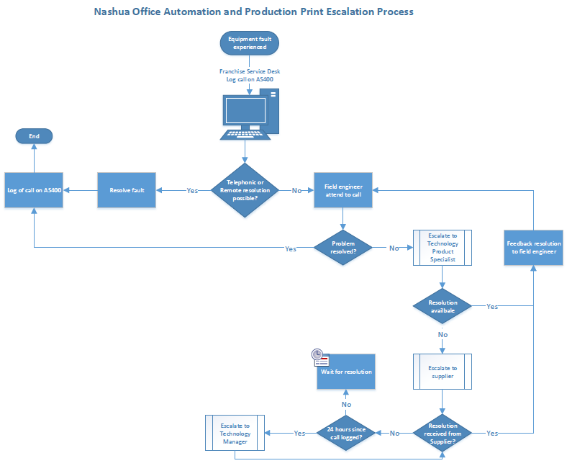

Service Engineers should not directly contact Nashua LTD’s product specialists directly, but rather contact their immediate supervisor / manager first. Should they be unable to assist to rectify the problem, the problem can be escalated to Nashua LTD.

The following information regarding the problem machine must always be available:
- Problem description
- Call number
- Parts replaced
- Procedures already followed
- SMC reports
- Firmware versions

When a problem has been resolved, it is the person who has reported the problem’s responsibility to close the event with Nashua LTD’s Product Specialists.
NOTE:
For all Production Print machines, a Problem report form must be completed first before the Product Specialists are contacted. The Product Support Form can be downloaded from iNForm under the Production Print section. (Product Support Form.pdf)

Service Engineer’s Workload
During office hours, a sufficient amount of Service Engineers should be available to attend to Service Requests. As a rule, 200 machines per Service Engineer would be the norm. This is dependent on the Service Area and the distribution of machines within the service area. Production Print Service Engineers would also have less machines to attend to due to the more technical advanced serviceability of the devices.

The workload of all Service Engineers should be monitored and adapted if necessary.

Service Engineer’s Skills Development path

Effective servicing can only be achieved if the foundation of a Service Engineer’s skills is solid. Therefore, all Service Engineers needs to have a clear understanding on the foundation (Basic) training that needs to be completed as a minimum requirement before attempting Product Training.

The Ricoh Basic training program is divided into the following sections:
To simplify the process, the basic training modules has been categorised as follows:

Skills breakdown
- My-Ricoh Basics
  - Installing Flash plug-in for Reader
  - my-ricoh.com - User Training
  - Parts Finder
- OA (Level 1)
  - Copier (Tech)
  - Core Technology Manual - HW Servicing
  - Digital Imaging (Tech)
  - Digital Imaging V2 - HW Servicing
  - Paper (Media)
  - The Paper Making Process
- OA (Level 2)
  - Gel Technology Awareness
  - GelJet - HW Servicing
  - Image Quality
  - MFP Awareness
  - Process Control - HW Servicing
  - Troubleshooting (Tech)
  - Troubleshooting V2 - HW Servicing
- OA (Level 3)
  - ARFU - HW Servicing
  - Printing - HW Servicing
  - Printing V2 - HW Servicing
  - Priport (Tech)
  - Scanning (Tech)
  - TGOS & PPP Green Awareness for Service Technicians
  - Toner and Ink Cartridge Yield
  - Wide Format Awareness

- Fax (Level 1)
- Fax awareness
- Fax G3 - HW Servicing
- Fax (Level 2)
- Internet Fax (Tech)
- IP FAX

- Basic Colour (Level 1)
- Colour Awareness
- Colour Awareness R2
- Basic Colour (Level 2)
- Advanced Colour
- Colour Management (Tech)

- Projector
- Basic DLP Projector - HW Servicing
- Basic LCD Projector - HW Servicing
- Projector Essentials

- Production Print
- Introduction to Production Printing
- Introduction to Print-On-Demand market
- Advanced Media Training
- Advanced Media Training for Operators
- Profiling Fundamentals - Operations
- The Value of AFP

- Connectivity / IT (Level 1)
- LAN Basics
- GW Networking (Tech)
- GW Networking Update (Tech)
- GW Scanning (Tech)
- Network Printing for Windows (Tech)
- Network Printing for Windows v2 (Tech)
- Network Printing for Windows v3 - Inbox Con
- Scanner Awareness
- Printer Drivers (Tech)
- Printer Drivers 2009 (Tech)
- Network Printing (Tech)
- Printer Awareness
- Connectivity / IT (Level 2)
- Computer Hardware & Software
- Lite Software Solutions V2 Version1 (Tech)
- Mail - Inbox Connectivity
- Network Management (Tech)
- Network Printing for Mac - Inbox Connectivity
- Network Printing for Novell - Inbox Connectivity
- Printer Driver Management Using WSH (Tech)
- Troubleshooting for Connectivity Master (Tech)
- Web Based Driver Installer
- Web SmartDeviceMonitor v2.0 (Tech)
- Web SmartNetMonitor 1.20 (SPT) (Tech)
- Connectivity / IT (Level 3)
- Unix (Tech)
- PCL/PJL - Inbox Connectivity
- RPCS
- Mac OS
- LDAP - Inbox Connectivity
- Barcode and OCR Package - Software Services
- AS/400 - Software Services
- Card Authentication Package -Introduction
- MPS / MDS
- MPS Basic - Section 1
- MPS Basic - Section 2
- MPS Basic - Section 3
- MPS Basic - Section 4
- MPS Basic - Section 5

Required Skill levels

- Trainee Engineer
  - My-Ricoh Basics
  - OA (Level 1)
  - Fax (Level 1)
  - MPS / MDS

- Field Engineer / Workshop Engineer
  - My-Ricoh Basics
  - OA (Level 1)
  - OA (Level 2)
  - OA (Level 3)
  - Fax (Level 1)
  - Fax (Level 2)
  - Basic Colour (Level 1)
  - Connectivity / IT (Level 1)
  - MPS / MDS

- Production Print Engineer
- My-Ricoh Basics
- OA (Level 1)
- OA (Level 2)
- OA (Level 3)
- Fax (Level 1)
- Fax (Level 2)
- Basic Colour (Level 1)
- Basic Colour (Level 2)
- Production Print
- Connectivity / IT (Level 1)
- MPS / MDS

- IT / Solutions Engineer
- Connectivity / IT (Level 1)
- Connectivity / IT (Level 2)
- Connectivity / IT (Level 3)
- MPS / MDS
- External Training (Any one of …)
    - CompTIA N+
    - Networking Fundamentals MTA Exam 98-366
    - Security Fundamentals MTA Exam 98-367
    - Windows OS Fundamentals MTA Exam 98-349

Training

Introduction
Training is an essential element to ensure that processes are followed correctly and the products are serviced in the most effective manner. Training will strengthen weak areas in the skills of your Technical Department. This will also ensure that all persons in the Technical Department is at the same level and therefore the technical department can operate more efficiently.

It is the responsibility of the Technical Director / Manager to …
- To put processes in place to measure the skill levels of all persons in the Technical department, in order to identify areas where inefficiencies exist
- Once identified, these inefficiencies need to be addressed by means of training.
- Ensure that sufficient time is put aside to allow for training of employees to get educated on the skills that is required for the job
- Ensure that new and transferred employees meet the minimum requirements for their positions

It is the responsibility of managers, supervisors and Technical staff to …
- Identify and report training requirements to the Technical Director / Manager of the Technical Division

New Employees
All new employees should attend an initial training program. The orientation program should include the following:
- Company policies
- Introduction to all employees of the company
- Customer Relations Training (refer page 35 for more information)
- Basic Knowledge on Nashua’s product technology
- Registering an email address for the person
- Maintenance and Service procedures
- Introduction and registration to Electronic tools
  - My-Ricoh
  - HP portal
- Dress code
- Tool bag and tools

Staff Training
Training required by all Technical staff is as follows:

Service Controllers
- Customer Relations & Telephone skills (refer page 35)
- Basic Product Training (refer page 96)
- Company Procedures
- Safety Rules and Regulations
- NTMS awareness and understanding

Service Engineers
- Customer Relations (refer page 35)
- Company Procedures
- Safety Rules and Regulations
- NTMS awareness and understanding
- Product Training
  - Classroom
  - My-Ricoh online training
  - HP online training
- Generic Training
  - CompTIA N+ training or
  - Microsoft MTA training
Managers
- Customer Relations (refer page 35)
- Company Procedures
- Safety Rules and Regulations
- NTMS awareness and understanding
- Management Training course

Essential Training course descriptions

Customer Relations
All persons within the Technical Department dealing directly or indirectly with customers should attend a Customer Relation training course. These courses teach the individual on how to deal with customers in all types of situations. This interaction determines the customer’s perception of Nashua
This training should include the following, but not limited to:
  - How to control a conversation
  - How to identify the requirements of the customer
  - How to handle angry customers
  - How to project the intention 'to help' the customer
  - How to be honest with the customer
  - How to pay attention to the customer and not let your mind wander
  - How to be outcome focussed without being pushy or dominating

AS400 Training
Nashua has a very comprehensive ERP system that handles Service requests, contracts, stock holding, billing and much more. Because of its complexity, it is essential that proper training needs to be done on the AS400.

Technical Director / Managers
All Technical Director / Managers should complete some form of Management training.
Training should include …
- Financial management for non-financial managers
- Project Management
- Customer Service
- High Performance management

Management is training and updated in order to perform consistently on the job.

Product Training

Service Controllers
All Service controllers should receive Basic Product training. This will equip them with the necessary knowledge in assisting customers to resolve basic problems on the machines.

This training should consist of:
- Product recognition (difference between the different products we service)
- What is Service Codes and why does the machine generate them
- Resetting Service codes
- Service messages on the machine
- Replacing Toner
- Replacing Paper
- Remove paper jams from the machine
- Where and how to retrieve the Serial number of the machine
- Where and how to get the machine’s meter readings

Service Engineers
Before attending any product training, a Service Engineer should have completed the pre requisite and basic training courses. These courses are the foundation on which all product training is based. If the basics is not understood in full, the interpretation of machine working and problems will not be correctly handled.

For Trainee Service Engineers, Basic Training courses are essential in their career development as this is the foundation of all training courses they will be attending in future.

Various Product training courses are available from the Technical Product Specialists at Nashua LTD. These training courses should be booked through the Technology Administrator. (Refer to the Technology Training section within this manual for more details on Product Training)

Product training course content is described on page 67

Online Training tools
Our suppliers have online training tools where a Service Engineer is able to register and complete training courses. These training courses are very comprehensive and Service Engineers should be encouraged to complete the courses for their own development.

When an employee resigns, all his online training accounts needs to be locked. (See process on page 63). The appointed Report administrator is able to generate regular reports on online training progress.

Training Records
Any and all training should be recorded and the training records should be kept by the Technical Director / Manager or the relevant HR division. The data is stored for the full period that the person is employed.

- Date/s attended
- Training Course
- Trainer name
- Trainee name
- Pass / Failed
- Signature of Trainee

This applies to all training in mentioned in all of the modules within these standards.

The successful completion of job-related seminars and other courses should also be recorded in the employees training records.

Training Rooms
A training room environment should be available at each franchise. This does not necessarily need to be a dedicated area for training only, but may double up as a boardroom or similar environment. The practical sections of training may take place in the same area (if sufficient space is available) or in the workshop area of the Franchise.

For efficient training, the Training Room area should be sufficiently equipped for training purposes.

Training room requirements:
- Desks
- Chairs
- Multimedia Projector
- Whiteboard or Flip chart (& Markers)
- Network & Internet connections
- PCs (if Service Engineers do not have their own Notebooks)

Required training for Service Engineers
It is the responsibility of the Technical Director / Manager to ensure that training facilities are available when training is conducted at a Franchise. (See training options on page 55). The Training area should be sufficiently equipped to facilitate training. (see training room requirements on page 37)

For training, a machine/s must be made available for Practical experience and familiarisation

If no training room is available at the relevant franchise, the Service Engineers needs to be sent to Nashua LTD or alternative Franchise with necessary facilities.

Training Assessment
Training programs are developed to meet the employee’s needs and to execute the job sufficiently.
When excessive non-conformance or quality problems occur, training is provided for employees when applicable.

A training plan per fiscal should therefore be developed. (Generic and Product Training)

Continued Service Agreement

Pending Exco approval (Pieter Els)

Technical Service Procedures (National workshops)

Goods receiving inspection & evaluation:
All goods returned to Nashua Technical Services (Repairs, Ex Demo’s & Returns) will only be accepted with a valid Equipment Return Authorization (ERA) authorized by the following departments:
- Technical Services
- Major Accounts
- Nashua Franchise
The Goods Receiving coordinator will immediately inspect the unit and complete a Goods Return Checklist. Technical Services Engineers will do evaluation of the unit in accordance to the ERA and Problem Report.
The sending party will be notified of any discrepancy via phone, e-mail or Fax.

PLEASE NOTE THE FOLLOWING:

- Completed Problem Reports Faxed/E-mailed to relevant Department
- Drain & Secure machine for transport.
- Adequate packaging for all goods.
- If accessories have to be send with machines, request this to be included in the ERA.

Copier Repairs
On receiving a Problem Report, Technical Services will issue an Equipment Return Authorization (ERA) to the requesting party. Upon receiving the equipment, it will be actioned in accordance to procedure: Goods Receiving Inspection and Evaluation. An engineer will evaluate the condition of the unit and record all defective parts for replacement. His Supervisor completes a quotation (If Requested) and forwards it to the customer for approval. On approval the Engineer will complete the repair as per quotation and problem report. Quotations not accepted will carry a handling fee as determined by National Workshops.

Fax Laser Repairs
On receiving a problem report, Technical Services will issue an Equipment Return Authorization (ERA) to the required party. Upon receiving the equipment, it will be actioned in accordance to procedure, goods receiving inspection & evaluation. An Engineer will evaluate the condition of the unit and record all defective parts for replacement. His Supervisor completes a quotation and forwards it to the customer for approval. On approval the Engineer will complete the repair as per quotation and Problem Report. Quotations not accepted will carry a handling fee of R75-00.

PCB Repairs
P.C.B. send for repair will only be accepted with a problem report and purchased order. P.C.B. must be Bar Coded. The Admin Clerk creates a Job Card then places the board in a queuing system. The Engineer will, from the information provided on the problem report, or by physical testing, and with reference to supporting Nashua Data held by Technical Services, analyze if the unit is repairable or not.
Repaired units are invoiced in accordance to Electronic Price List and returned to the customer.
Units unrepairable: The Engineers will complete a P.C.B Irreparable Form stating the reason, sign it and inform his Supervisor. The Irreparable Form will be faxed to the customer concerned. On request only the faulty unit will be returned.

Refurbishing
Customers own units for Refurbishing will be handled in accordance to Goods Receiving Inspection & Evaluation procedures.
Technical Services only to issue Equipment Return Authorization (ERA).

Cannibalisation
Initiated by Ongoing Revenue Division who will email / fax Technical Services a Cannibalization Authority Form together with a Schematic of a relevant part and an Order.

The department Supervisor will see if a machine is available for Cannibalization. If not, Parts Division will be notified. If available, the relevant part is stripped by a Service Engineer. The stripped parts are wrapped, identified and sent to Parts Division with relevant documentation.

Service Response and Downtime Management

Introduction
Service delivery has evolved in the market place and customers are cognisant of response versus downtime (MTTR) of their equipment. Applying uniform standards as per the NTMS will enable us to provide superior service and customer satisfaction

It is the responsibility of the Technical Director / Manager that all employees handling service requests are able to perform within the scope of these standards.

Terminology
Response time and MTTR (Downtime) is measured in business hours. Business hours is as defined within the Servicing Franchises AS400 parameters.

Response Time
The Response Time for a service call is measured from the time that the call has been logged at the Service organisation, up to the time that the Service Engineer has marked the call taken.

MTTR (Downtime)
The Downtime for a service call is measured from the time that the call has been logged at the Service organisation, up to the time that the Service Engineer has completed the service call.

Refer to KPIs on page 112 for information about MTTR targets

Outside of business hours
In some cases, it is necessary to accumulate the MTTR time when calls are logged or completed outside of business hours. The calculation process applies for both Response time and MTTR. This is best described by means of some examples:

In these examples business hours are from 08:00 to 16:30 and from Monday to Friday.

Example 1
Logged: 11/05/2016 08:30 (Wednesday)
Taken: 11/05/2016 09:00
Completed: 11/05/2016 18:00

MTTR: 480 minutes (business hours) + 90 minutes (after hours) = 570 minutes
In this case, the time after business hours is added to the calculation

Example 2
Logged: 10/05/2016 07:30 (Tuesday)
Taken: 10/05/2016 10:00
Completed: 10/05/2016 12:00

MTTR: 0 minutes (after hours) + 240 minutes (business hours) = 240 minutes
In this example the MTTR is only calculated from the start of the business day

Example 3
Logged: 10/05/2016 07:00 (Tuesday)
Taken: 10/05/2016 07:30
Completed: 10/05/2016 12:00

MTTR: 60 minutes (after hours) + 240 minutes (business hours) = 300 minutes
As the call has been marked taken before the start of business, the MTTR is calculated from 07:00

Example 4
Logged: 14/05/2016 09:00 (Saturday)
Taken: 14/05/2016 09:30
Completed: 14/05/2016 11:00

MTTR: 120 minutes (after hours) + 0 minutes (business hours) = 120 minutes
As the call has been marked taken before the start of business, the MTTR is calculated from 07:00

Ongoing Revenue Division Procedures

New Spares Parts Manual (E-Ordering)

ONLINE FRANCHISES
- Create the purchase order.
- Final acceptance of e-order. Franchises must please ensure that the final acceptance is released by a person with the correct authority levels.
- Once the e-order acceptance has been approved (by Franchise authorised person only) an e-order needs to be created.
- Please remember that once this e-order has been created it will immediately be released by the Order Entry Clerk at Nashua Ltd and no changes can be made thereafter.
- Franchises need to ensure that they have double checked the e order before final submission.
- Franchises need to ensure that they have reviewed the e-order acceptance access levels.

NASHUA LTD ORDER ENTRY CLERK
- Order Entry clerk accesses the order on AS400.
- All e-orders received by Nashua Ltd, will be released immediately by the Order Entry Clerk. This means that no amendments after release will be possible.
- Nashua Ltd cannot accept any responsibility for any errors or omissions on an e order as the onus lies with the franchise to double check the e order before final submission.
- Should the Order Entry Clerk be unable to process the e-order, the process documented below will take effect.

UNABLE TO RELEASE E-ORDER
- Should the Order Entry Clerk be unable to release an e-order for any of the below mentioned reasons, the Order Entry Clerk has to electronically communicate reasons why he/she is unable to release the order, to the relevant contact person at the franchise placing the order:
  - Back Orders
- When new stock has been loaded on the AS400, no new e-orders that are received will be released while ongoing revenue is in the process of releasing all outstanding back orders. This is to prevent any new e orders consuming new stock prior to all older back orders being released.
- Should we be unable to supply a part/s the Order Entry Clerk will notify the relevant Franchise Parts Controller of the item/s that has gone on back order via an electronic Back Order Notification Form
- The Order Entry Clerk will communicate with the relevant Product Manager/s regarding the estimated ETA of the relevant part/s that has gone onto back order.
- Once the Order Entry Clerk has received ETA information, the ETA will be inserted as a note against the Product Code on the AS400.
- Changes to the ETA/s it will be maintained in the Notes facility on the AS400 and all the Parts Controller need to do is check the note/s against the relevant part number/s

  - Incorrect quantities ordered
- Should a Franchise realise that the incorrect quantity had been ordered on a particular part and the e-order had already been released but the order had not been collected, Nashua Ltd will raise a GRN (Goods Returned Note) and pass credit where necessary.
- Should the stock already been collected the Equipment Return Authorisation process must be followed.

  - Raising of part numbers
Should a part number have to be raised Franchises will be required to place a manual order and must supply the following information:

- Franchise account number, Franchise details, official Purchase Order number, date of order, Part number, correct quantity and Part description.
- Full machine model details
- Contact details to be provided on order for query purposes.
- Relevant documentation
  - Index page, Schematic diagram, description page and cover page indicating which part is required.
- Mode of transport
  - Indicate on order who and how the order will be collected.
  - Should a courier collect we require the courier name and account details clearly recorded on manual order.
- Official Manual order to be scanned and e-mailed to the following email address in the Ongoing Revenue Division: ongoingrevenue@nashua.co.za.

  - Nil picks/short supplied
- Warehouse will generate the GRN other relevant documentation as well as move any stock still appearing on AS400 into WIP and investigate the shortages.
- Documentation is sent to Ongoing Revenue Division who will then notify the relevant Franchise’s Parts Controller via email that an item has been nil-picked or short supplied.
- Should the Franchise still require this part a new e-order will have to be created and Ongoing Revenue will place a new order with the relevant Supplier.

  - AS400 not operational
- Nashua Ltd
- Should the AS400 be offline at Nashua Ltd all e-orders will only be released once the AS400 is online.
- In an extreme emergency the relevant Technical Director/Manager needs to call the Ongoing Revenue Manager to discuss the option of supplying the part required urgently on a manual docket.
- Franchise
- The Manual Order Process will apply.

  - E-order released by unauthorised person at Franchise
- It remains the relevant Franchise’s responsibility to ensure that the correct/authorised person has created the e-order.

- Once the reason we are unable to release the e-order has been communicated to the relevant Franchise, the onus rests with the Franchise to provide the correct information, where necessary and requested, back to the Order Entry Clerk for the release of the order. Should the Franchise not feedback the required information the e-order will remain unreleased on the system until such time that the relevant information is received from the Franchise. IT IS NOT THE RESPONSIBILITY OF THE ORDER ENTRY CLERK TO CONTINUALLY RE-REQUEST THE RELEVANT INFORMATION.

EQUIPMENT RETURN AUTHORISATION (ERA) NON WARRANTY

ABLE TO RETURN
A Franchise can request the return of goods within 21 working days from date of invoice, provided:

- Nashua Ltd is able to resell the item/s the Franchise wants to return. Nashua Ltd.’s ability to resell will be based on the frequency of sales on the particular item, current stock levels, age of machine model, the part will be used in and should be a regular or fast moving item.
- If the part is ordered as per the parts manual and it is still not the correct part, franchises can return the relevant part, provided the item is returned in its original packaging and part and the box should both be in its original condition and the criteria in point 1., are met.
- Any other items that are returned must be in its original packaging and the packing must still be sealed as well as conform to point 6.
- Should Ongoing revenue have processed the order incorrectly. (Manual order process)
- The incorrect part was supplied by UTI.
- Parts that are returned should be packaged in separate courier bags or boxes. PLEASE DO NOT PASTE OR ATTACH any courier documentation or labels directly onto the original packaging.
- In order to return a part the relevant Franchise needs to submit and electronic ERA request on the AS400.
- The relevant Product Manager will check and verify that the information supplied by the Franchise on the ERA form is correct. Based on this the Product Manager will either accept or reject the ERA.
- Should the ERA be accepted the system generates the ERA acceptance form and the Product Manager will e-mail the ERA to the Franchise contact for their immediate attention and signature. The ERA is to be mailed back to the Product Manager who originated the ERA.
- Please keep in mind that the goods will not be accepted back unless we have received the signed ERA form.
- Should the ERA be rejected the relevant Product Manager will submit the reason for rejection on the AS400 ERA and the Franchise needs to provide the correct information before the process can continue.
- Once the Franchise has submitted the correct information the above acceptance procedure will take effect.
- The ERA form is only valid for 7 working days from date of acceptance by the Product Manager.
- Please note that the relevant part/s needs to be returned within this time frame together with the original signed ERA Acceptance form and the original invoice the parts were supplied on.

UNABLE TO RETURN
Goods cannot be accepted for return under the following conditions:
- Any part/s that is older than 21 working days from date of invoice.
- Any part/s that has been superseded by a new part number.
- Specially ordered for the franchise i.e. Part has never been ordered before or is a very slow moving part.
- Packaging opened and/or the item is no longer in its original packaging or the courier labels have been stuck to the original packaging.
Incorrectly ordered or pricing is not a reason for a part to be returned. Should these special requests arise we will deal with these on a case by case basis and the above criteria will apply.

Warranty on Nedcor / New Printers

NEDCOR Printers
- The Engineers must complete the Problem Report in full i.e. 31 entries as described on the Instructions issued by the Ongoing Revenue manager to all Franchises and relevant departments.
- Once the Administration Assistant receives the Problem Report from Technical Services and Kopano, he/she will input the data into his Computer Terminal in the Warranty System Program.
- A Nashua Problem Report Confirmation will be printed by the Administration Assistance as a result of the above input indicating the following information:

- Customer | - Address | - Account Number
  - Our Order No: (To be Quoted on all Enquiries)
- Model | - Installation Date | - Part No
- Date of Problem | - Serial number | - Date of Report
- PCB Serial Number | - Customer Reference | - Remarks

- The Administration Assistant will then Fax the Confirmation to the originator of the Problem Report at the relevant department.
- The Administration Assistant will do a Ship and Invoice
- The Administration Assistant will upon receipt of the defective part, credit Ship and Invoice and now update eth warranty System Program. On the comments column in the Warranty System Program “Do not pick already Supplied”.
- Defective part supplied with Problem Report – no Ship and Invoice will apply.
- Defective part nor received within seven (7) days Ship and Invoice stands, Warranty will be Null and Void.

NEW Printers

Lump Sum Warranty
The Lump Sum Warranty will be a % of the total machine purchases from Nashua Limited. This will be paid out on a monthly basis to the Franchise in whose area the machine will be installed

Copiers, Fax and MFP
In the case of a customer not wanting a CSA, a one year carry-in Warranty must be extended to the customer as the percentage (%) has been paid to cover these issues as and if they occur.

Printers
A one year carry-in Warranty on printers 21 ppm and lower must be provided to customers, this market related and the Franchise receives the benefit of receiving money up-front to cover any issues. 22ppm and above printers should be treated like Copiers, Fax and MFP as above.

Sample of Problem Report

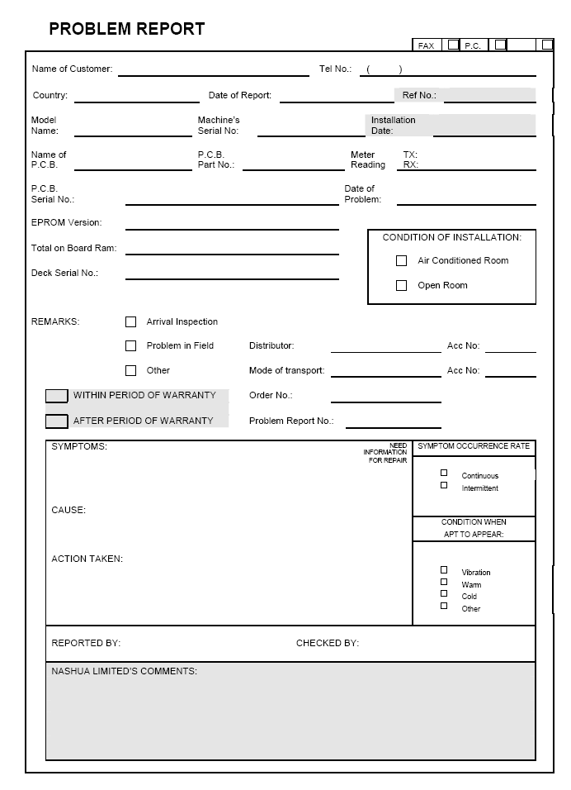

Sample Problem Report Confirmation

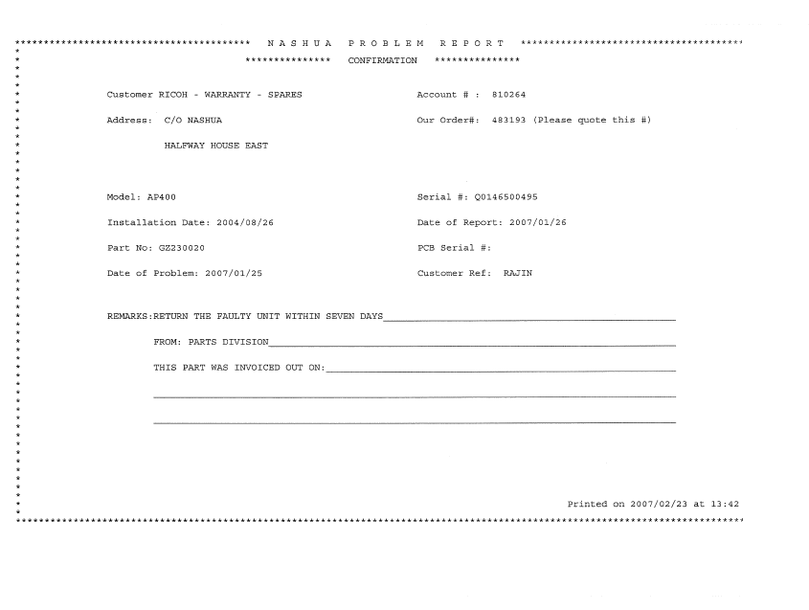

IS Department – AS400 Procedures

AS400 Training
- The Franchises will phone the IS department with their training requirements
- The Trainer will establish if it would be easier to give training at the Franchise or at Nashua Limited.
- The Trainer will then work out times, place and period.
- The Franchises will submit official orders that are to be authorised by relevant managers. They will email the orders through to confirm the request for the training and/or flights, accommodation, etc.
- The Trainer will set up a Training Register which on the day of the training will be filled in and signed by the candidates.
- Once the training is completed the Trainer will check if there are problems which need to be addressed and sort them out.
- The relevant Franchise will then be billed for the training provided.
- The Trainer will retain the Training register as quality records and supply a copy if required to the franchise for their training register
- The Trainer will issue a Certificate of attendance to the candidates for the training provided.

Network Department Nashua User Request
Require Network Access or Support
User logs call at Helpdesk

Helpdesk
Support team will only act on LOGGED calls and will not be responsible if not logged.

Cost and Time
Relevant user is contacted. Time and costs are calculated. Queries may be made by quoting reference number.

Administration
Keep track of users on Network. Allocate specific rights to Network resources

Systems Development Department (User Problem Request)
Log User Problem
Advise user to log a User Request on the AS400 for investigation/process or log IT related call on AEGIS and quote user a reference number.

Logged
The problem/request can be logged for another user, in which case both users will be able to log it off at a later stage. If the user is not authorised, a Manual User Report Request is completed and sent to the departmental "authorised user" for evaluation. If the user is authorised, the request is automatically accepted and sent to the Help Desk Supervisor for allocation. Confidential information requires written authorisation with a Director’s signature (e.g. Releasing customer information to another company) in which case, the user can print the problem in a Fax format for authorisation.
When a user request is received from staff with no access to the AS400, the Help Desk will assess the request. An authorizing fax / email is requested from either a Manager (Nashua Ltd.) or a director of the Franchise involved.
If this request can be solved by the Help Desk, they will do it and the fax will be filed.
If the request requires work from a Developer, the Help Desk will log a user problem, record the number on the fax and file it. Once the Developer has resolved the user problem, the Help Desk will test it and log it off.

Authorised or rejected
If the request is authorized, it is sent to the Help Desk Supervisor to be allocated.
If the request is Rejected, it is sent back to the user to be logged off with a rejection reason typed by the authorised user. If I.S. feel the request requires authorisation from a higher source (based on criteria discussed with management), they have two options: the first is to send the message back to the user with a status of "Needs Fax Authorisation", where the request is "locked". A fax transmission page is printed.
There is space for the manager to add any comments and sign. The request is then only allocated to a Developer by I.S. once the fax has been received. The second option is to send the request to an authorised user with a status of "Needs Authorisation", waiting for that user’s electronic approval.

Allocation
The Help Desk Supervisor evaluates the request and fills in the type of problem (from a code list) and the system (also from a code list). The request is also given a priority in the range 1 - 99, 1 being the highest priority. If the priority is in the range 1 - 10, the request is returned to the Help Desk, after it has been processed by the allocated user, for testing, before it goes to the logging user for testing. These codes are used later for history analysis.
The problem is then allocated to a Developer or the help desk for action. A note pad facility is in place for the Help Desk Supervisor to type up notes for the Developers, or themselves about who they contacted or how the problem could be solved.

Processed
The Developer or allocated user will be in Consultation with the user who logged the problem/request and any other users affected by the request. The "note pad" facility mentioned above, will be used to communicate with the users to get feedback in writing and to type minutes of meetings etc. All this information will be stored on the AS/400 along with the problem/request and can be printed on request. From here, the System Development & Change Lifecycle comes into effect, where the planning and developing process is described.

The Nashua IS Department has acquired a software package called IMPLEMENTER which will enable us to monitor changes that are made to the system as well as automating the promotion of verified requests from development through to Q/A into production by bundling programs together & implementing programs in a more controlled manner.
The software tracks programs, which User requests they refer to, which developer made the change and when it was done.
It will also enable the Development Manager to determine any trends if the change request has been rejected by Q/A.
Although failed Q/A requests (or even requests already implemented into production) can be rejected or failed due to multiple reasons:
· Lack of information supplied by the user
· Ambiguous specifications
· Lack of understanding the business
· Developer error
Reporting is available within IMPLEMENTOR to request Activity reports on what changed during a period of time, to track when a program changed and on what request and which Developer made the changes.

Moving from QA into Production
- The Help Desk is required to be on the development machine (JILL).
- The Move request document specifies which User request is to be checked and/or tested.
- The Help Desk must print the User request documentation from JACK and attach it to the Move request.
- The necessary checking and testing will be done and once the Help Desk is satisfied that the development meets the requirements the move request is signed and filed in User request sequence.
Tested
Once the Developer has processed the request and tested it to his/her satisfaction, the problem/request is flagged as "Resolved" with resolution comments from the Developer. If the priority of the problem \ request is in the range 1 - 10, it is flagged as "IS testing" and returned to the Help Desk Supervisor for approval before being flagged as "Resolved". If a complex change was made, the user may be called to I.S. department to test the changes on the Development machine, using test data.
If the change was simple, it may be implemented on the Production machine, where the user can see the effect using their live data.

Logged off
Once the user who logged the request is satisfied with the results, the request is logged off and archived to history. Requests for a franchise can be viewed by the users at that franchise only.

Fundamental program Change or Additions (Technical Service Programs)
- Issue or change is raised at Technical Regional Meetings, Technical Steering Committee Representative will ensure all or majority agree with the change or new issue.
- TSC Rep will then discuss the issue or change at the TSC Meeting.
- If it is accepted by TSC then it is given to the IS Department for implementation.

Request for changes to the Service programs
All changes to Service Programs should be channelled through the Technical Franchise Liaison. These change requests will first be investigated and then the best possible solution be implemented.

If the request is authorized, the Technical Franchise Liaison will log the necessary user request on the AS400 and will see the process through.

Installation Procedures

Introduction
Except for the sales process, the customer’s next experience with Nashua is during the Installation process. To keep a good customer experience, it is important that the Installation is done accurately and correctly. By having a check list type approach, we are able to ensure that nothing is forgotten during the installation process. All processes involved in the installation of the machine is handled in this module

Responsibilities
Technical Director / Manager should ensure that the latest version of the forms always be supplied to the Sales team and Service Engineer. The Technical Director / Manager needs to confirm that the forms are correctly completed. He will also ensure that the forms and relevant Installation data is archived correctly.

Service Engineer should ensure that the completed Post-Installation forms are returned to the Service Office.

Pre-Installation forms
Pre-Installation forms describe the requests from the customer.
Example:
- The product being installed
- The location of the machine
- The configuration of the machine
- The network environment specifications
- User assignments / rights to the machine
- Specific requests from the customer, etc.

This information is part of the Sales process and may be a collaboration between the Technical and Sales teams for final completion.

Post-Installation forms
Post-Installation forms are the check list to ensure that all the things the customer has requested has actually been done. Thus it should contain all the details duplicated from the Pre-Installation form. This form is normally completed by the Service Engineer doing the installation of the machine at the customer’s site.

NOTE:
Both the Pre- and Post-Installation forms needs to be signed by the customer as acceptance to ensure the processes are completed correctly.

Where do you get the latest versions of the Installation forms?
All forms available for Pre and Post installations are available for download on iNForm. Please check under the “Installation Forms” heading.

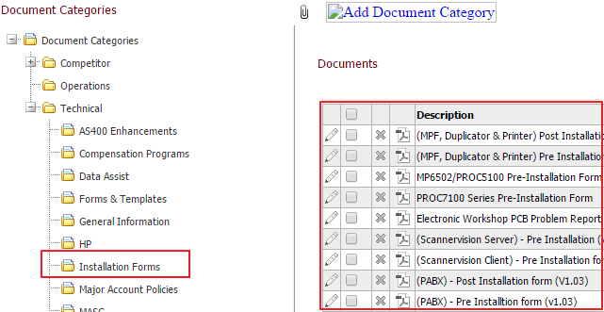

New forms may be available from time to time, thus it is important to always check for the latest version that is available.

Machine data
On installation the Service Engineer should print out all the machine settings (SMC data) and return it to the office for archiving. The archiving system should have the ability to use an indexing system to be able to reference back to machine settings.

Delivery of machines
- ALL machines
  - The Owner Franchise is responsible for the cost of delivery to the Servicing Franchise.
  - The Servicing Franchise is responsible for the cost of delivery to the customer.
- Large machines
  - The cost of delivering a large machine to a customer may be quite high and may require special delivery vehicles, equipment and methods
  - The Servicing Franchise to contact the Owner Franchise to agree on the delivery method.
  - The Owner Franchise will be responsible for delivery cost to the Customer except when the Servicing franchises have delivery vehicles large enough to handle this delivery.

New Machine setup
The Servicing Franchise will determine where they will setup the new machine according to their internal processes.
- Workshop
- Customer’s site
The correct set up codes needs to be selected to indicate where the initial setup was done. If the setup is done in the workshop and then sent to the Customer’s site for installation, 2 separate service calls needs to be logged.

Installation Commission
The Installation commission value is automatically calculated on the AS400. The rate is calculated on the recommended time it takes to install the relevant units. The Installation commission is linked to the Distance Factor. (See distance factor description in the module on DSR)

Main Machine
Installation commission value = (Time x IFL) x (1 hour x IFL)
Time = Recommended time (from supplier) it takes to install the unit
An additional 1 hour is added for delivery and unboxing of the machine and peripherals
IFL = Inter Franchise Labour rate at the time of installation (Refer to module on the IFL rate)
Refer to page 102 for current IFL rate

Accessories / Peripherals (during main machine installation)
Installation commission value = (Time x IFL)
IFL = Inter Franchise Labour rate at the time of installation (Refer to module on the IFL rate)
Accessories / Peripherals (AFTER main machine installation)
Installation commission value = (Time x IFL) x 2
IFL = Inter Franchise Labour rate at the time of installation (Refer to module on the IFL rate)

* Refer to the IFL process for further information on the IFL rate calculations (page 101)

Payment of Installation Commission
- The Installation commission is only payable after full completion of the Machine and its peripherals is installed.
- Billing is in conjunction with the CSA Owner Franchise billing run.
- The CSA Owner will only authorize the payment once all the documentation has been received (as described below)

Documentation needed for Installation commission
- Signed Post Installation form (refer to the NTMG guidelines)
- Surge Protector (The Servicing Franchise is responsible for registering the warranty of the Surge Protectors.
  - Register the Surge Protector on the Suppliers website (www.clearline.co.za)
  - A copy of the Confirmation email needs to be sent to the Owner franchise
- SMC Logging data of the machine installed

Installation consumables
All new machines are delivered with a complete set of consumables necessary for the installation of the machine. This is to ensure we get all machines up and running in the shortest possible time and to not put strain on a Servicing Franchise’s stock holding when they un-expectantly receive a large number of machines to install. This also resolves the issue of Franchises not having the necessary consumables in stock, as they may not have these machines in field at that specific point in time.

All Installation consumables has been logged off on the Installation call (Field) or set up call (Workshop). If these consumables are logged off correctly, the data will be pulled through to the Inclusive Consumable program. The Service Type to use must be “INSTALLATION”, else the Inclusive Consumable program will not recognize this as Installation Consumables.

The cost of the Installation Consumables is for the cost of the CSA Owner Franchise.

Errors in Installation Commission process
If any errors are experienced, report them to the Technical Franchise Liaison at Nashua LTD for resolution.

Technology Training Procedures

Introduction
Nashua’s Technology department plays a vital role in development of the Service Engineer’s skills. Therefore, it is important that the training options and policies are clearly stated.

Training Schedules and bookings
The Technology Administrator, on a quarterly basis, sends out the next training schedule. These training courses contains information on training courses planned at Nashua LTD and Regional training courses where Product Specialists have already been booked.

To request a regional training course at your Franchise, you need to contact the relevant Product Specialist to check for availability. This agreed information will be logged into the Technology Training Organizer and is added to the Training Schedules.

Training Options
All training courses are registered in the Technology Training Organizer. This database is saved on the Nashua Network server to ensure that information is backed up and history are available.

Training at Nashua LTD
Product Specialists will schedule training courses at Nashua LTD. All franchises can book training for these courses by contacting the Technology Administrator and requesting the amount of seats to be reserved. All bookings will be confirmed via email (Training confirmation Letter) directly to person that has requested the booking. Trainees will attend classroom training at the Technical Training centre in Woodmead on the booked dates.

Regional Training
Regional training is training that is not conducted at Nashua Limited but at the Franchise premises or assigned venue. All travel, accommodation and meals will be for the cost of the hosting Franchise or shared between multiple Franchises. Regional training conducted during weekdays inside normal working hours will not have any cost for the Trainer/Facilitator to the Franchise.

These training courses is conducted from Mondays to Fridays. All Regional training courses to be first confirmed by the Product Specialist, where after the Technology Administrator will register the training course in the Technology Training Organizer.

The requesting Franchise/s is responsible for the travel, accommodation and all meal expenses of the trainer.

For Regional Product training, the respective Franchise needs to have a machine available for the Service Engineers to take apart for the practical portion of training. This should be done in an environment that has work space to allow for effective practical training.

Weekend Training
Weekend training is training that is either conducted at Nashua Limited or at the Franchise premises or assigned venue over a weekend.

All travel, accommodation and meals will be for the cost of the hosting Franchise or shared between multiple Franchises.

The Technology Administrator will administer all weekend training from the Technology Department.

No payments must be made directly to the Trainers but instead a purchase order must be e-mailed to the Technology Administrator.

After the training has been conducted a completed time sheet will be handed to the Technology Administrator for the particular Franchise to be charged the standard costs

Nashua Limited will take care of the payment of the Trainers through the Nashua Payroll.

Weekend Training rates are as follows:
Saturdays: R350 / hour
Sundays: R450 / hour

Minimum weekend rate which includes Saturday and Sunday @ R 5600-00

Training course booking cancellations
If your Service Engineer is unable to attend training, the cancellation should be done at least one week before training commences. Should a Service Engineer not be able to attend, you may send another Service Engineer in his place.

If a Service Engineer does not attend the booked training, and no cancellation has been received, then the Franchise may occur a R1000 course cancellation fee. This will be done at the discretion of the Senior Manager Technology

Training course pre-requisites
Most training courses require a Service Engineer to have certain prerequisites. It is the responsibility of the Technical Director / Manager to ensure that the Service Engineer complies with all these prerequisites before enrolling him on training.

It is will be the discretion of the Product Specialist to send the Service Engineer back to the franchise if he does not comply to the specified prerequisites.

Training Life Cycle
Product training for new products will be done for a period of 8 months after launch, where after training will be available at a cost.

Training cost for products older than 8 months: R500 per student per day

Bear in mind, that with online training, only practical training where required will be necessary for training on older products.

You will be notified as and when products have reached the end of their Training life cycle.
For any queries regarding the available training, you can contact the Senior Manager Technology

Online Training Tools

Currently we have 2 online training tools available for use by all Technical Staff
- Ricoh (My-Ricoh)
- HP (HP Portal)

Both these tools are managed by the various suppliers, but administrated (mostly) from Nashua LTDs side.

My-Ricoh Training portal
On all Ricoh products, Ricoh makes available on-line training on the following web address:

www.my-ricoh.com

All Service Engineers needs to register on-line to be able to have access to this training option. The site is update on a regular basis with the latest products and services. My-Ricoh contains training material and technical information (Technical Bulletins, etc.).

Requesting Access
All requests to get access to My-Ricoh has to be done on-line. NO manual requests can be done. To get access, the Service Engineer needs to have a valid business email address. No GMail / HotMail, etc email addresses allowed. Your email address will be used as your user name to access the My-Ricoh portal.

My-Ricoh should work with any browser. Open the website and locate the “Request Access” button.

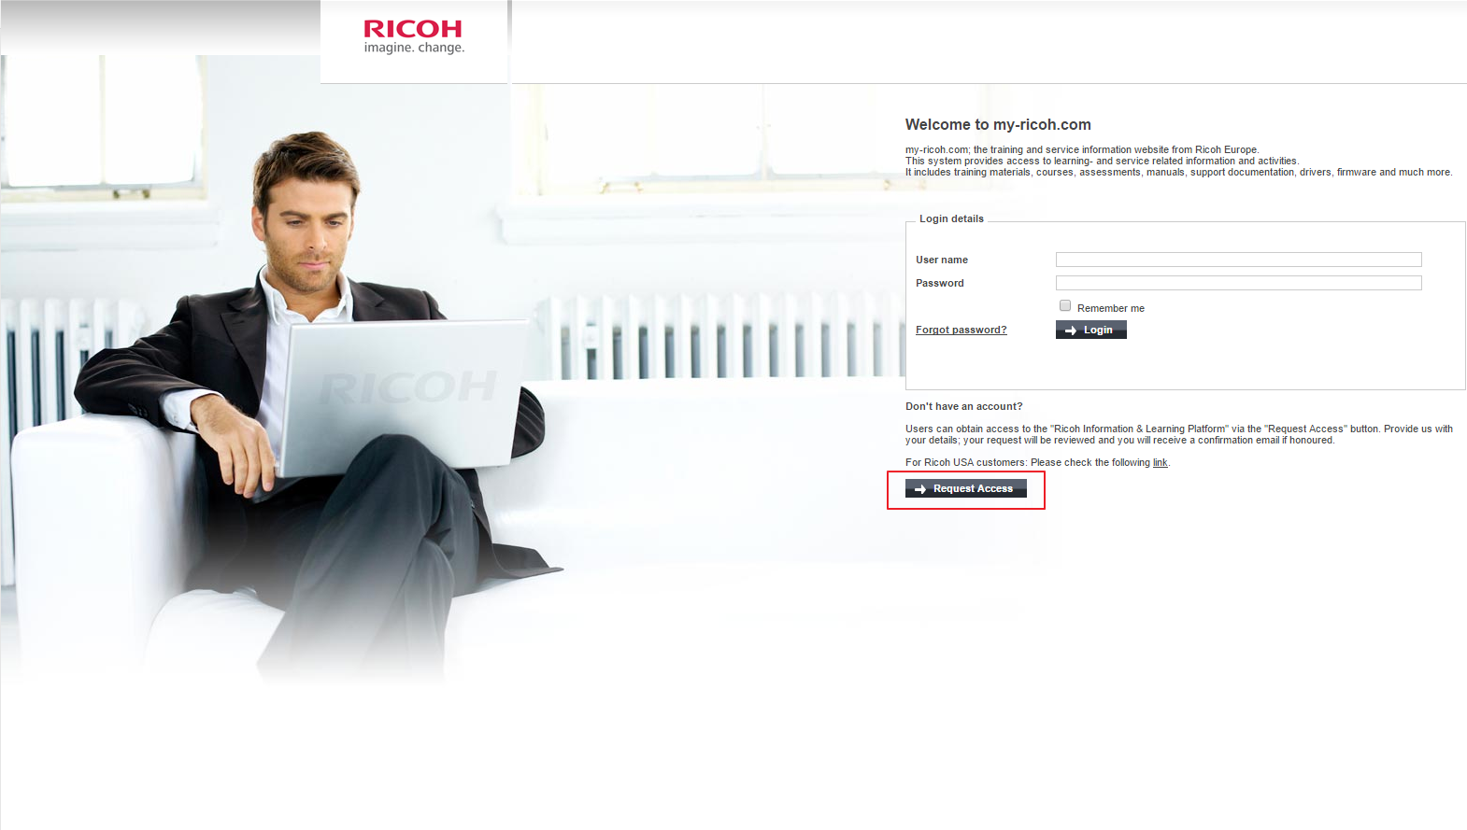

Follow the online prompts to complete the necessary information
Once completed, your online request should look like the following before submission. If you have any special requests, please add them to the “Reason for Request” section.

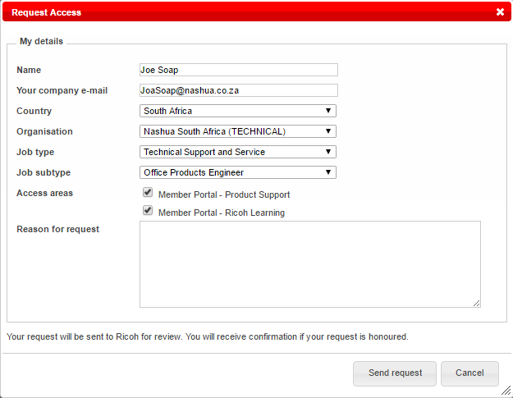

Your request will be forwarded to the Administrator and will be authorised once the relevant confirmation checks has been done.

Job Types and Job Sub Types
All Technical Department’s personnel must select “Technical Support and Service” in the Job Type. Some KPIs depend on what this value is set to, and therefore it is important that you select these correctly. Should you need to have them changed, send an email to the Technical Franchise Liaison or Technology Administrator.

Please select the Job Sub Type according to the list below

Job Sub Type | Description of Sub Type
Assistant | Registered on My-Ricoh, but not servicing machines.  May be My-Ricoh Administrator or Service Controller
Call Centre | Person/s doing a Help Desk function towards Service Engineers.
Dispatch | Toner Runners
IT Engineer | All Service Engineers only working on IT Calls. (not servicing machines)
Manager | Manager (Administrative), and not doing field calls.  Managers that do field calls must register as Office Products Engineers
Office Products Engineer | All Service Engineers doing field calls of OA products
Production Print | All Service Engineers Servicing Production Print machines.  Production Print = Product Codes starting / containing “PRO”
Solution Specialist | All Service Engineers only working on Solution products
Technical Specialist | Nashua (Pty) Ltd Trainer / Product Specialist
Technical Support | PABX or other Service Engineers that do not service Office equipment, but perform other Servicing roles.
Trainer | Persons that are the Nashua (Pty) Ltd approved trainer at the franchise
Workshop Engineer | All Service Engineers only based in the workshop repairing machines

NOTE:
Do not submit multiple requests. If you are unsure if your request has been handled, you can contact either the Technical Franchise Liaison or the Technology Administrator.

When the request has been authorized, you will receive an email with a welcome message

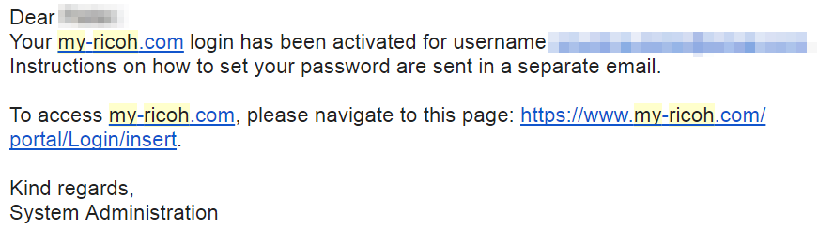

And thereafter a second email with a link that will take you to a page to set your password. Note the password is set by the individual users. Click on this link, set your password, and you will then be ready to log into the My-Ricoh portal.

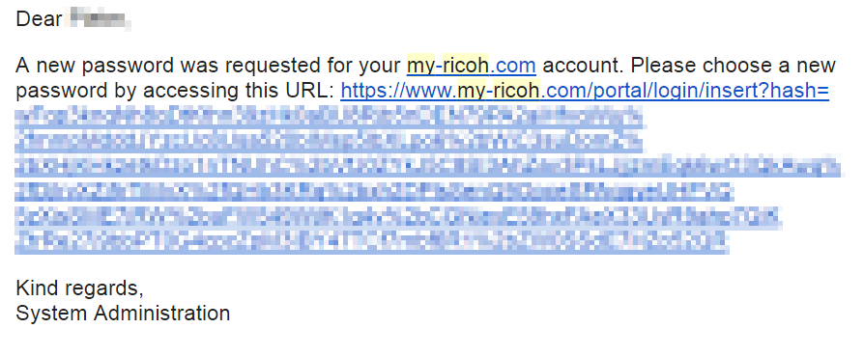

How to use the My-Ricoh training portal
The My-Ricoh learning portal has online training available on how to use the website. To download this training material, follow these instructions.

- Log into your My-Ricoh portal
- On the main menu, select the Learning Guide

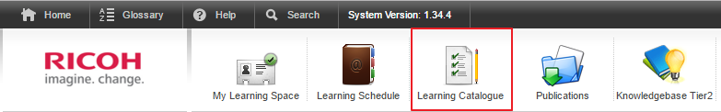

- Then type in the Learning event name as described below

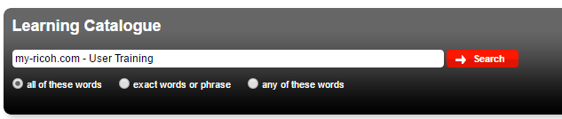

- This will take you to the Learning event that will teach you how to use the My-Ricoh portal

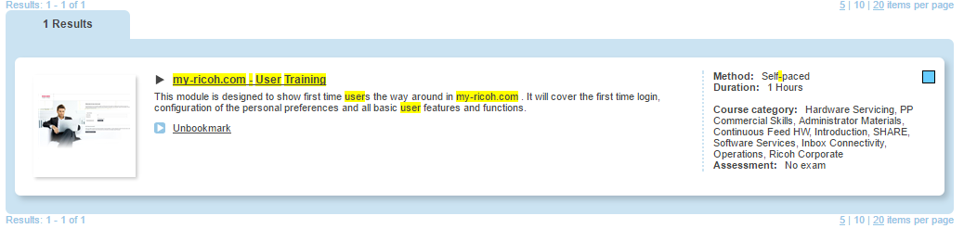
- Click on the heading to open the Learning event details
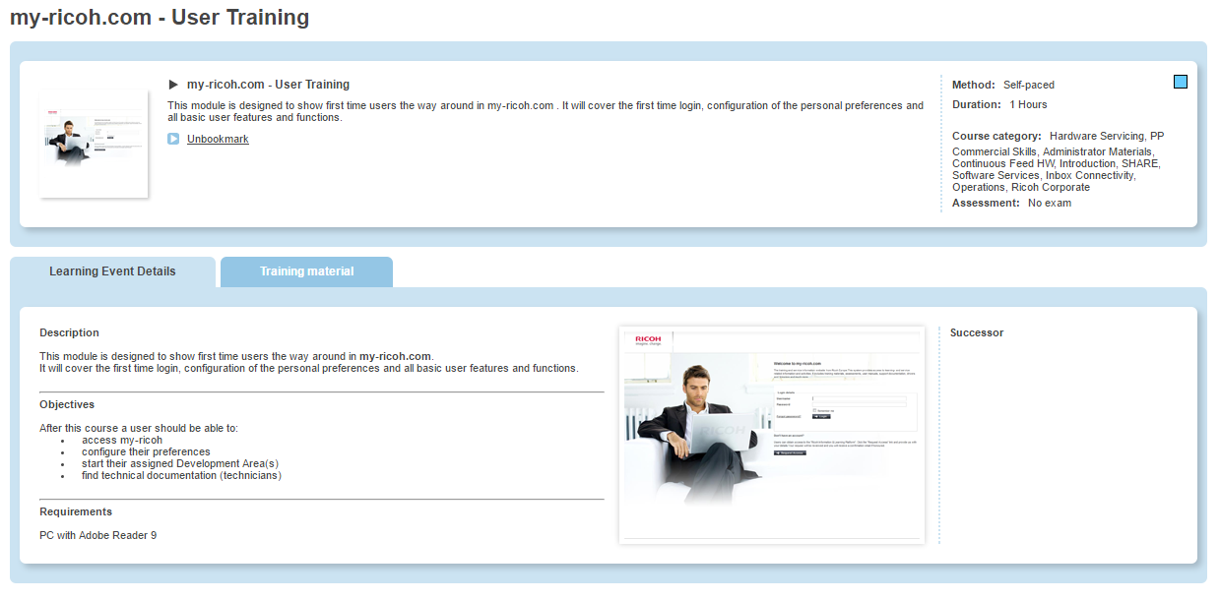
- This will give a brief description about the Learning event as well as the Training material for this Learning Event (LE)
- Next click on the “Training Material” tab and then select the “Download” option to download the training material.
- NOTE: make sure you download the Training material for the language you require
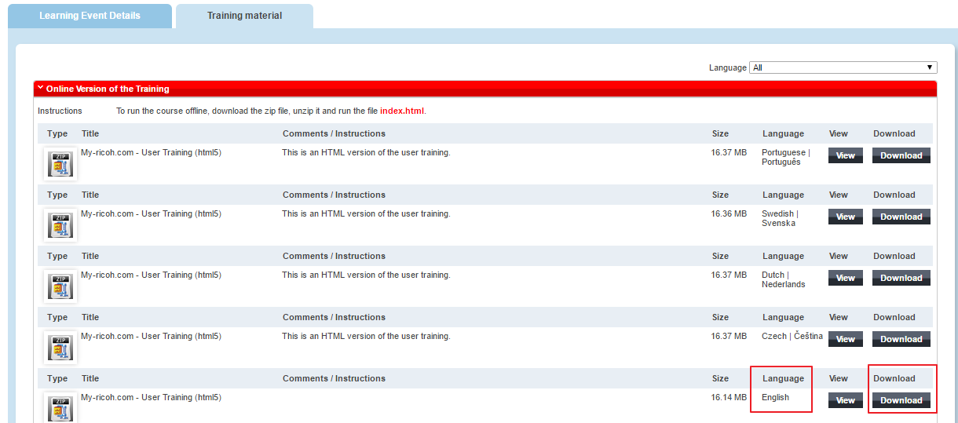

My-Ricoh Admin functions
The decision has been made to leave most of the main administration functions with Nashua LTD. Franchises have a limited administration function on My-Ricoh

Nashua LTD – Admin functions
The following functions will be done by Administrators at Nashua LTD:
- Authorising users on My-Ricoh
- Assigning the Technical Template to the relevant users
This template determines the access that the Franchise and the Service Engineer has on the Training and Technical Data on My-Ricoh
- Unlocking of Exams
  - When a Service Engineer fails an exam for the 3rd time, the relevant exam is locked and the Service Engineer is not allowed access to re-write the exam
  - This process is put in place so that the Technical Director / Manager can ensure that the Service Engineer is properly prepared for the next exam
  - An email needs to be sent by the Technical Director / Manager to the Technical Franchise Liaison or Technology Administrator to unlock the relevant exams
  - Once the exam has been unlocked, the Service Engineer is allowed another 3 examination attempts before the process is repeated.
- Unlocking Informal exams
  - All third party exams need to be manually overridden by the Nashua LTD administrators on the respective Service Engineer’s profile.
  - These exams include any of the following:
    - CompTIA Network+ certification (NEW) - CompTIA Network+ certification
    - CompTIA Security+ certification - CompTIA Security+ certification
    - Fiery Certified Expert - Operations - Fiery Certified Expert - Operations
    - Install and Configure Windows Server 2012 (70-410) - Install and Configure Windows Server 2012 (70-410)
    - IP 5000 certification Step 1 - IP 5000 certification Step 1
    - IP 5000 certification Step 2 - IP 5000 certification Step 2
    - IP 5000 certification Step 3 - IP 5000 certification Step 3
    - IPM, IPPD and AFP Advanced class - IPM, IPPD and AFP Advanced class
    - IPM, IPPD and AFP Basic class - Informal assessment classroom training
    - Networking Fundamentals MTA Exam 98-366 - Networking Fundamentals (MTA)
    - Nuance Mobile - Introduction - NSi Mobile - Introduction
    - Nuance Output Manager - Introduction - NSI Output Manager - Introduction
    - Nuance Output Manager 4.0 - Inbox Connectivity - Nuance Output Manager 4.0
    - PlanetPress Connect - Software Services - PlanetPress Connect Technical Training
    - PP SW Sales Classroom Training - PP SW Sales Classroom Training
    - PRINCE2® Foundation (2009) - PRINCE2® Foundation (2009) - Exam
    - PRINCE2® Practitioner (2009) - PRINCE2® Practitioner (2009) - exam
    - Security Fundamentals MTA Exam 98-367 - Exam 98-367 (MTA Security Fundamentals)
    - Server Administration Fundamentals MTA Exam 98-365 - Server Administration Fundamentals (MTA)
    - Windows OS Fundamentals MTA Exam 98-349 - Windows OSFundamentals MTA Exam 98-349
    - Wireshark Certified Network Analyst™ (WCNA) - Wireshark Certified Network Analyst™ (WCNA)
  - The exam will show active on the Service Engineer’s profile on the next working day
  - Proof of passing the examination needs to be sent with this request before the process is initiated
- Removing users (When a user has resigned and needs to be removed from the Franchise profile) (See process below)
- Moving users between franchises (See process below)
- Re-instating users when returning back to Nashua (See process below)
- Assigning Report user and Report admin functions to main users at a Franchise. (see process below)

Franchise – Admin functions
Franchises have the option to nominate certain users for to administration profiles. Both these functions needs to be assigned / activated by the Administrators at Nashua LTD. Normally these functions will be assigned to the Technical Director / Manager of the respective Franchise.

Report User
Every time that one of the Franchise’s users attempt an examination, the Report user will be notified by email and Message on their My-Ricoh home page. This information will include the respective users name, the examination attempted, his score and if he has passed or failed. This allows this administrator to assist users in ensuring that they prepare properly for examinations before attempting them.

Report Admin
This function allows this user to extract reports from the My-Ricoh system. If a user has been given access to this administration function a new button will appear on his My-Ricoh home page.

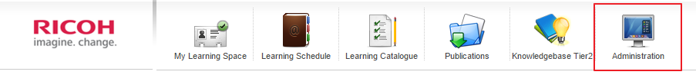

This button will take him to the Reporting menu in the Administration section.
The option will be visible in the left margin of the page

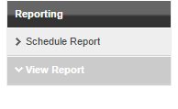

By clicking on the “View Report” option, all the available reports will become visible in the body section of the page.

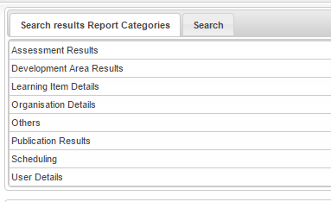

By selecting the individual headings, the available reports will be displayed in the section below.

Example: these are the available reports in the Development Area results section…
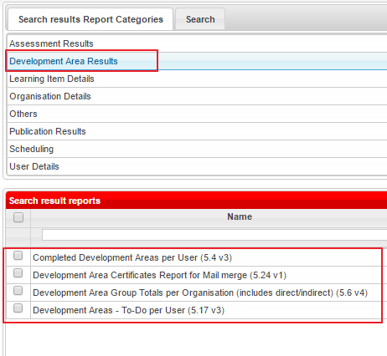

All reports can be exported after they have been generated.

TIP:
Export reports as “Microsoft Excel (97-2003) Data-Only”
This will allow you to effectively work with the data you have exported.

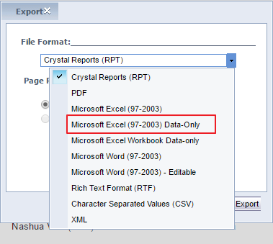

Cost of Examinations on My-Ricoh
Ricoh off charges Nashua for the usage of the My-Ricoh portal. In an attempt to recover some of these costs, there is a charge for every exam attempted on the system.

Charges are as follows:
Exams passed: R110 per exam
Exams failed R110 per exam

Before the Nashua LTD billing date, a complete list of exams written will be downloaded and the respective franchises will automatically be billed.

Service Engineer leaving Franchise
When a user leaves a Franchise, an email needs to be sent to the Technical Franchise Liaison and the Technology Administrator. They will perform the necessary tasks to remove the user from the system and lock his account.

Service Engineer movement between Franchises
Should a Service Engineer move between Franchises, his account can easily be moved without him losing any of his exams that he has written. All history for this user is transferred to the new Franchise.

To request this, send an email with the Service Engineer’s new email address to the Technical Franchise Liaison and the Technology Administrator. The Service Engineer will be transferred only when the new email address has been received. The Technical Director / Manager will receive an email confirming the movement.

Service Engineer returns to Franchise after a resignation
When a Service Engineer returns, after resigning from a Franchise, it is possible to recover his examination data. Ricoh keeps this information for a period of 3 Years after deletion and therefore if the users has not been removed from the database, it may be possible to recover his examination history.

NOTE:
Do not create a new user profile until we are sure that the old information cannot be recovered.

In the case that we cannot recover the Service Engineer’s profile, a new profile needs to create and the Service Engineer will have to redo all exams. There is no system in place to re-instate the lost information. Please contact the Technical Franchise Liaison or Technology Administrator for more information.

My-Ricoh KPIs
All My-Ricoh KPIs are measured from Job Sub Types. Ensure that all Job Sub Types are set correctly to ensure your KPI measurements to be done correctly. These values can be extracted by the appointed Report Admin person in your organisation.

Refer to the module on KPI’s for further information on My-Ricoh KPIs that needs to be achieved by all Nashua Franchises.

HP Training Portal

Requesting Access to the HP training portal
Registering can be quite easily done in a couple of steps.

Step 1
Open any browser and do a search for “HP Partner First Portal”
Open the link

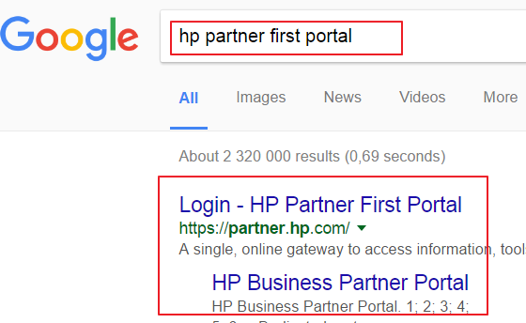

Step 2
Select the “Register Here” option to get access to the HP Partner First Portal

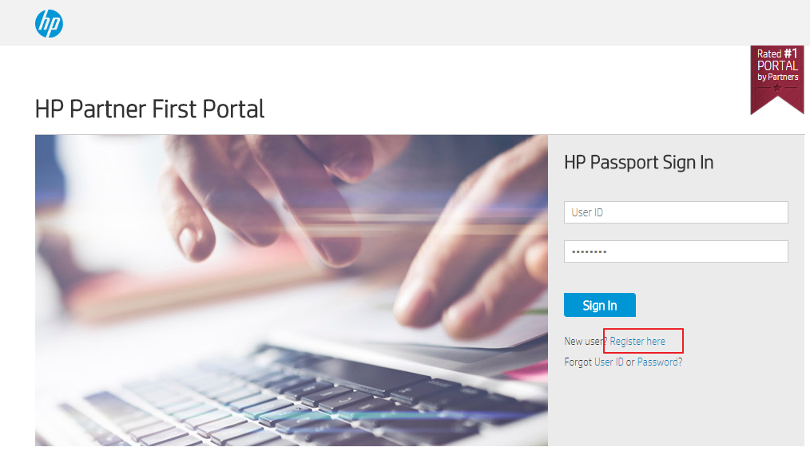

Step 3
Complete the registration details on the page that opens. Use the images below as reference:
(note images are representative of the on screen page)

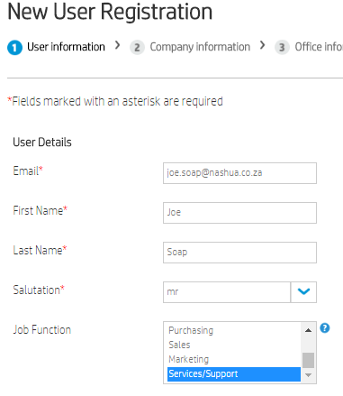 | 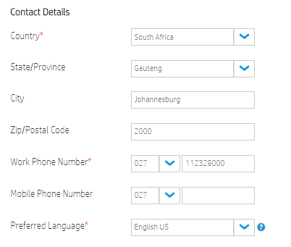
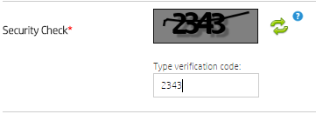 | 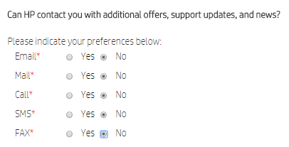

Then select the Next button to complete the next step of registration

Step 4
Complete the requested details and then click the “Search” button
NOTE: use the Locator ID exactly as shown below

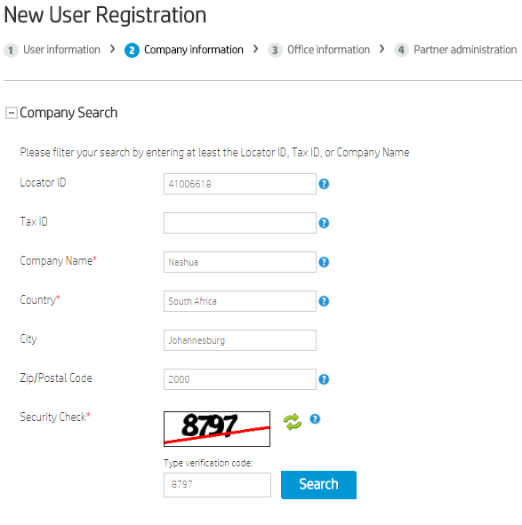

Step 5
Ensure the company show is NASHUA LIMITED and then click the “Next” button

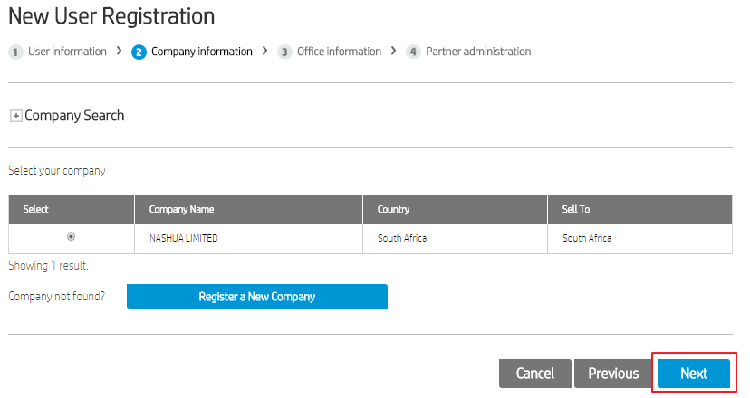

Then final confirmation and click “Next”

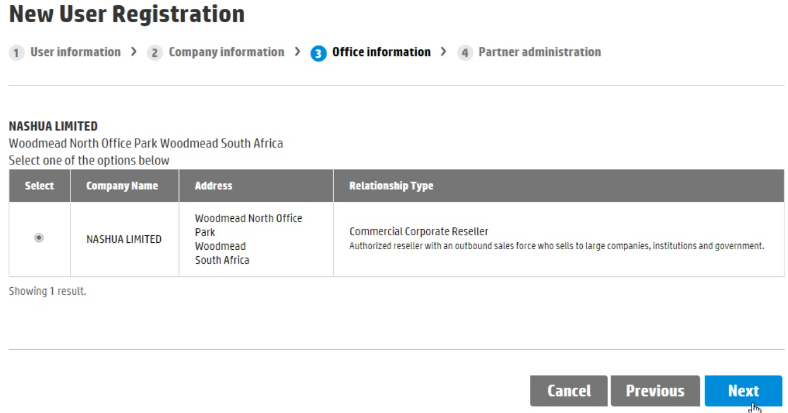

Your registration now needs to be submitted and will be processed by the HP administrators.
This is not done via a Nashua Administrator, but directly from HP.

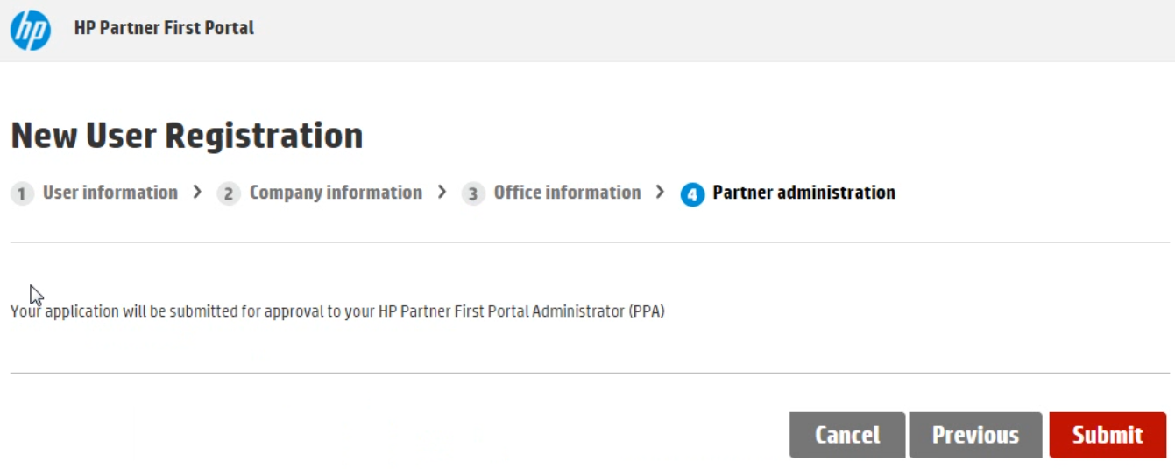

Link Product to Engineer
The Link Product to Engineer was designed to ensure that all Service Engineers are training on the relevant products that they work on. The AS400 will only allow a Service Engineer to service a product if the product link was created to his name. All products need to be individually linked and cannot be linked as a group of products.

The link can only be created at Nashua LTD level. To assist with this function, a Link Product to Engineer form has been designed. The latest form with the latest products is available on iNForm for download. Please complete the form and email to the Technology Administrator. The link will be created on the AS400. The AS400 has been set up to send an email to designated persons (by the franchise) once a link status has changed.

On certain occasions, a temporary link may be created. This link only valid for 3 months and will not be done more than twice. This gives the franchise ample opportunity (6 months) to ensure the Service Engineer receives the necessary training.

Automatic Linking of Service Engineers
As the Franchises are expected to do all the basic training and products, Nashua LTD has decided to do automatic linking to the following segments of products:

- Black / White: Segment 1
- Black / White: Segment 2
- Black / White: Segment 3
- Colour: Segment 1
- Colour: Segment 2
For all other segments, the Service Engineer still needs to complete all the pre-requisites and do the training as defined on the Link Product to Engineer form.

NOTE: Production Print machines do not qualify for any exceptions. Service Engineer must do Classroom training and complete the examinations on the My-Ricoh Training portal.

Product Training Course Content
Service Engineer should have the minimum knowledge as required for every training course and Service Engineers may be tested with an entrance test before allowed on training.

All product training should address the following topics:
- Product specifications
- Product limitations
- Product installation
- Machine operation and process
- Service and replacement procedures
- PM Procedures and schedules
- Update of all RTB's and MB's published before the training.
- Final examination (on relevant Supplier portals)

Successful completion of the training course and examination needs to be added to the employees training record.

Training course evaluations
The trainee should complete a training course evaluation form. These evaluations should be scrutinised by the Senior Manager Technology to identify areas where the training experience and process can improve.

Technical Documentation

iNForm
Nashua recognizes the importance of having a central repository of all common documents used during the normal work process. iNForm is Nashua’s Customer Relationship Management (CRM) solution. This is a web based application that contains a lot of Sales and Technical processes.

iNForm can be access via any web browser at the following web address:

inform.nashua.co.za

Requesting access for the first time
All persons that need access to the Technical section of iNForm, will need a username and password. This can be requested from the Technical Franchise Liaison that we request the information on their behalf.

Technical staff will be given access to the Technical Documentation section

Enter the iNForm website by entering your appropriate login details in the login screen
NOTE: Passwords are case sensitive

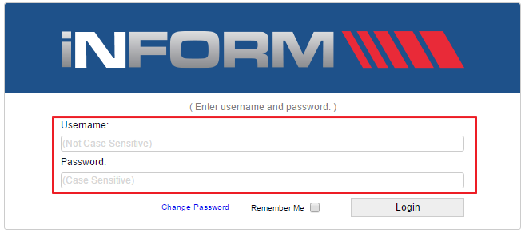

Account locked
NOTE: you have to log onto the system once in 16 days else the system will automatically lock your user account. A new password can be easily requested from the main screen by selecting the “Change Password” option.

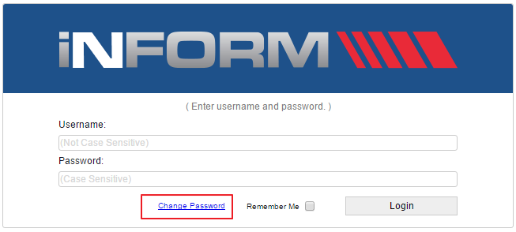

You will shortly receive an automatically generated email that will contain the instruction on how to reset your password.

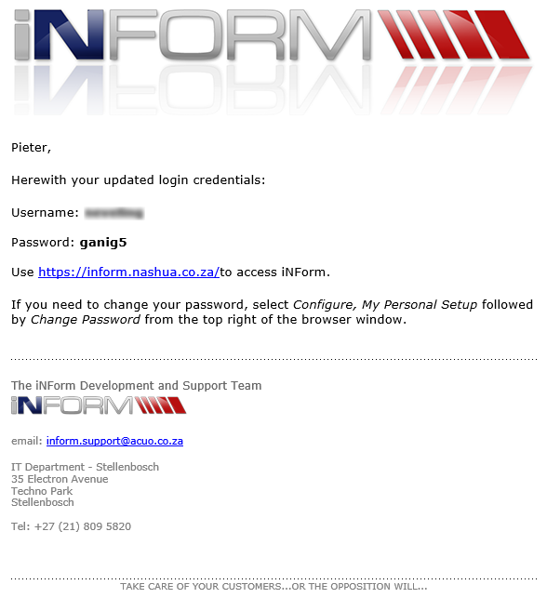

Log in with the new access details and change your password to one that you will remember. You can do this by clicking on the gear on the right hand side of the heading bar.

Accessing the Technical Documentation
In the Document Categories section (Left hand side of the screen), you will be able to access all the relevant technical documentation. These include topics like AS400 enhancements, Compensation programs to Service Launch Guidelines.

Select the required heading to display all the relevant documents in that section. Then select the link for the required document to download / open or save the document. Documents are updated from time to time.

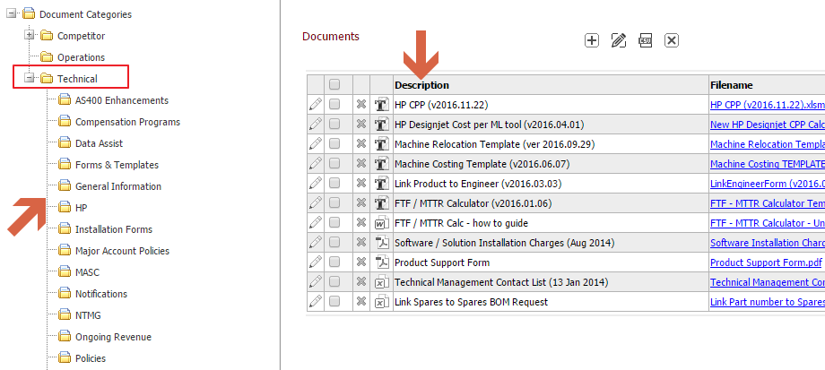

Technical DVDs
Ricoh normally releases new DVDs with all the latest information 4 times per year. Nashua LTD downloads these DVDs directly from the Ricoh FTP site. One set of Technical DVDs are distributed to Franchises at a fixed monthly cost.

NASHUA BUSINESS Intelligence (BI) tool

A Business Intelligence tool, which will be the central repository for all reporting and data is available.

Requesting access to the BI Tool
Access needs to be requested on an individual basis. For access a User Application Form has to be completed – (Business Intelligence Portal form). The completed form has to be signed off by the Franchise Owner. Return the completed form to the Technical Franchise Liaison. The Technical Franchise Liaison will send request to the BI team for approval.
To get access to the Technical Reporting only, select the “Technical Dashboards” option only. Else select the other options where you require access

Logon Details
The BI tool uses the AS400 user details for access. Therefore, your username and password is exactly the same as what you would use on the AS400. If you have access to multiple franchises, the BI tool will allow you access to the same franchise.

You will only be given access to the BI tool if you are a valid registered AS400 user. If you do not have AS400 user access, you need to apply for AS400 access first, before applying for access to the BI tool access. The AS400 user does not need any specific access on the AS400. Just the username and password is sufficient.

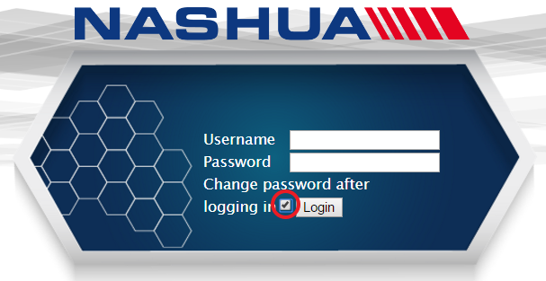
Resetting your Password
The AS400’s security policies forces you to create a new password every 30 days. You can do so without physically logging into the AS400, but rather doing it straight from the BI tool.

Ensure that you have the “Change password after logging in” checkbox checked before clicking on the “Login” button.

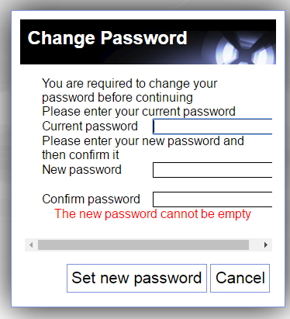

You will be presented with a screen to enable you to set the new password.
Enter your old and new passwords and “Set new password” button. The same password rules apply as it would on the AS400.

The password will automatically be updated to the AS400 and therefore you do not need to update any passwords directly on the AS400 system.

Web details
The BI tool is a web based system and allows you to log into the BI system through any browser (or mobile device). You are also able to log on from any location

https://bi.nashua.co.za/nashuadwh

First Logon
On first logon you will be presented with a window that will prompt you to enter the logon details
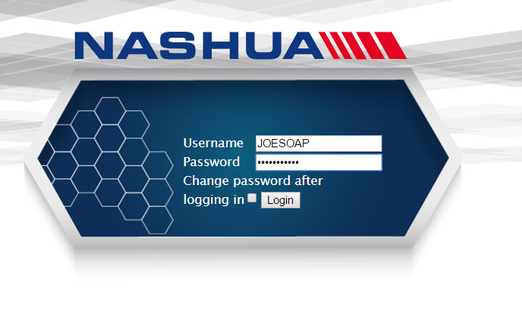

Enter your AS400 logon details and click the “Login” button.
If this is your first entry to the BI, you will get a screen that prompts you to “Contact the Administrator”. During this process, the user details is created on the system. You need to call the head of the BI department or the Technical Franchise Liaison to finalise your logon on process.
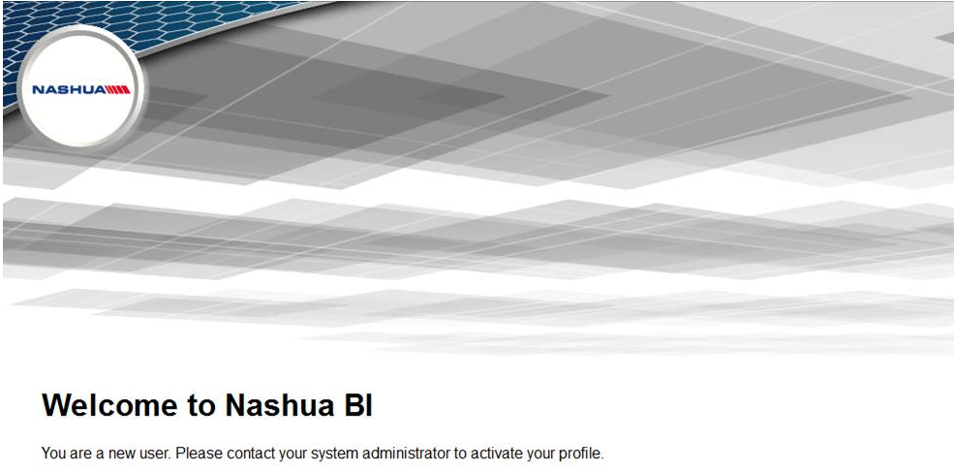

BI Main logon page
On the first logon screen, you will be present with a beehive structure. As you receive more access to the system, the hive will grow.


Each individual hexagon will have individual reporting for the section of the business. If you have only received access to the Technical reports, then you will only see the “Technical Dashboard” on your screen.

Navigating the BI site
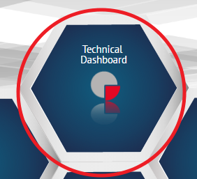
Click on the
“Technical Dashboard” hexagon.

You will be presented with a page that has much the same layout as the DataAssist tool.
There are 3 main sections to start with:
- Franchise Dashboard
- Engineer Dashboard
- General Dashboard


You are able to navigate quickly through the site by either clicking on hexagons, or returning to the “home page” by clicking the “Home icon” in the left hand top corner.

The heading links allows you to return to any of the previous respective screens.



Franchise Dashboard
This dashboard will contain all Franchise related reports.:
- Installation Commission
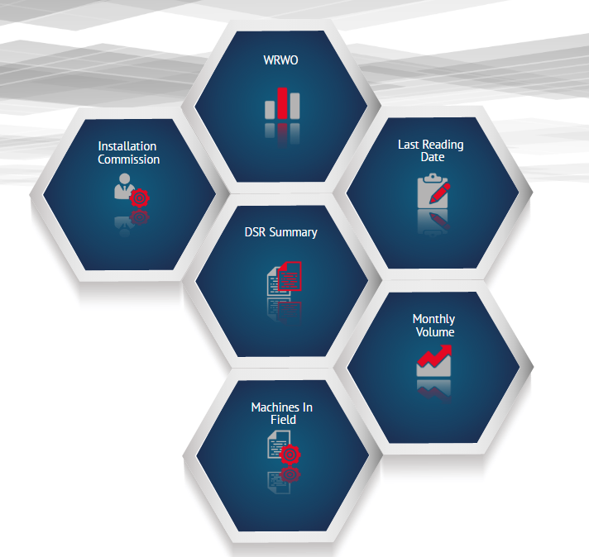
- DSR Summary
- Machines in Field
- Monthly Volume
- Last Reading date
- WRWO (Warranties Received / Warranties Outstanding)

Engineer Dashboard
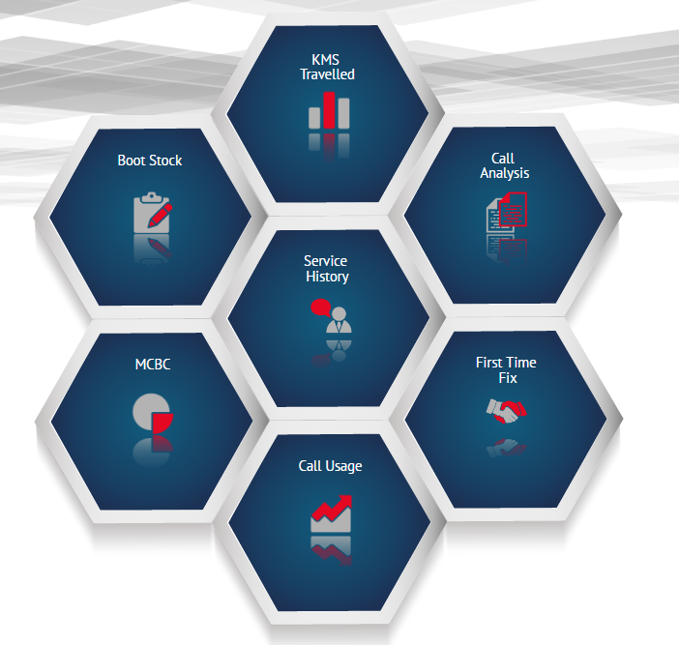
This dashboard will contain all Service Engineer related reports:
- KMS Travelled
- Boot Stock
- MCBC (Mean Copies Between Calls)
- Service history
- First Time Fix
- Call Analysis
- Call Usage

General Dashboard
This dashboard has general reports that can assist in your normal reporting processes.
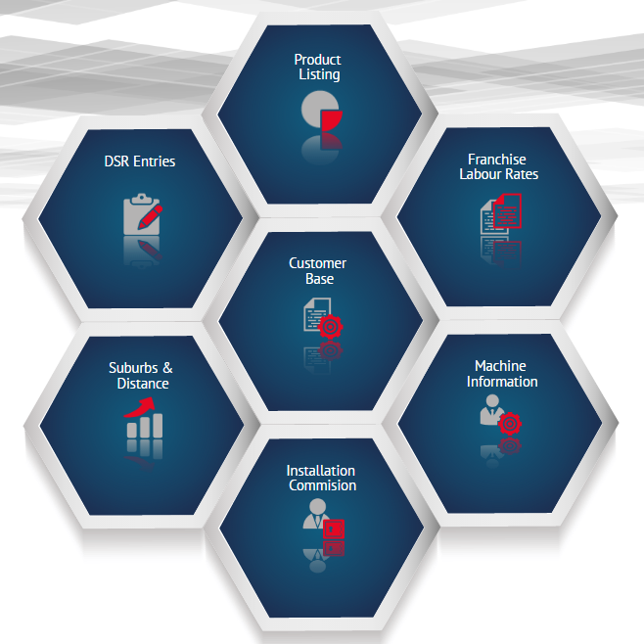
- Product Listing
- DSR Entries
- Suburbs & Distance
- Customer Base
- Franchise Labour Rates
- Machine Information
- Installation Commission

Using the BI tool

The BI tool currently has 2 main types of reports.
- Smart Reports
- Pivots

The Smart report is a normal (row / column) report that is displayed on-screen in a tabular format. Except for setting a couple of filters, you have very little control over the fields that is displayed.

The Pivot reports allow you full control over what you see on screen and how it is displayed. This is similar to pivot reports in Excel.

Setting a Report Filter

(To be updated. More changes of the dashboards operation to follow. Will add when they have finalised the info)

HP Global Channel Service Network (GCSN)

The HP Global Channel Services Network (HP GCSN) enables Nashua as an Authorized Service Provider to easily access service systems worldwide, minimizing the cost and complexity of service.

HP GCSN Service Delivery Tool is a powerful feature to help you improve customer service by giving you access to ordering and a claims functionality directly from your office.

Confirm Serial Warranty Entitlement
The warranty status of the serial number determines the most cost-effective service delivery method. All serial numbers registered with a Base Warranty and/or with a care pack has service delivery benefits available such as parts or machine replacements with no cost and in certain cases a labour remunerate.
First check if your serial number is covered under warranty.

Open the link below and type in the serial number when the page opens in the first available block then click on Submit

http://h20564.www2.hp.com/hpsc/wc/public/home

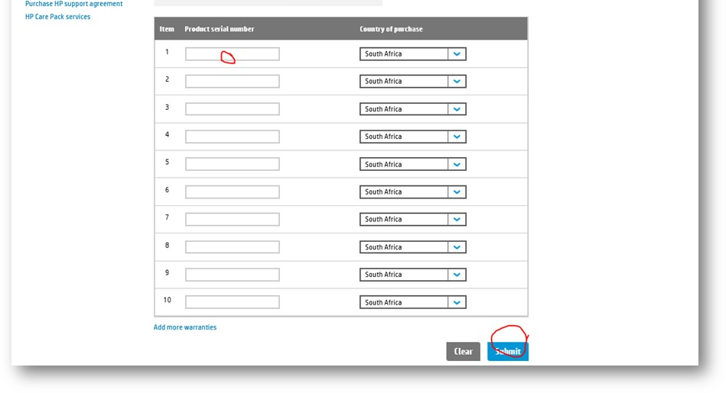
Image 1
Ensure your care pack is still active:

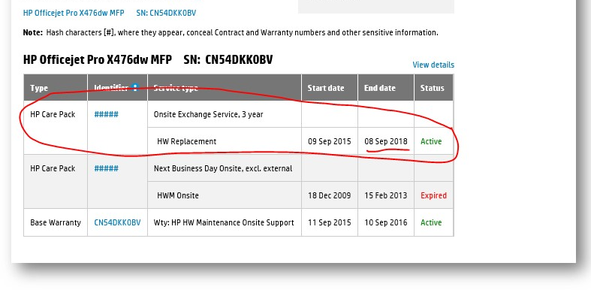
Image 2

Confirm Part Number
Ensure you have the correct part number to use on the GCSN ordering screen.

We need to find the correct part number from HP’s Partsurfer website:

Use the below web address to access the part surfer which is HP’s parts manual:

http://partsurfer.hp.com/search.aspx

Type in your machine model number in the available block or the machine’s serial number and click search:

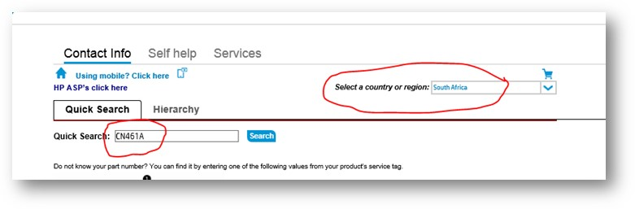
Image 3
Scroll to the part description the engineer notified you of ordering e.g. ADF or Document Feeder:
And keep the part number for ordering on the HP CSN Portal

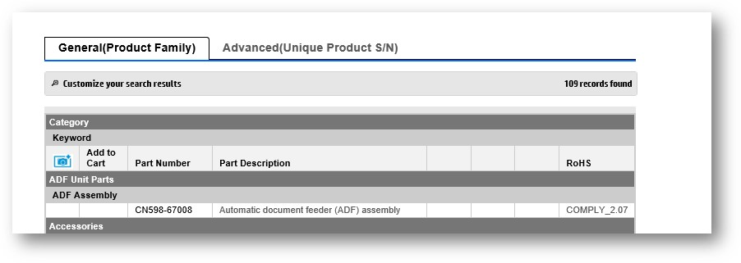
Image 4
GCSN Login Process

GCSN (Global Channel Services Network) a portal to promote service efficiency which begins with the below step by step login process

Use the below web address, you can only access the GCSN Portal with a user name and password which is provided by the Technical HP Administrator at Nashua Limited.

https://h30125.www3.hp.com/hpcsn/?hpp

Complete your login details:

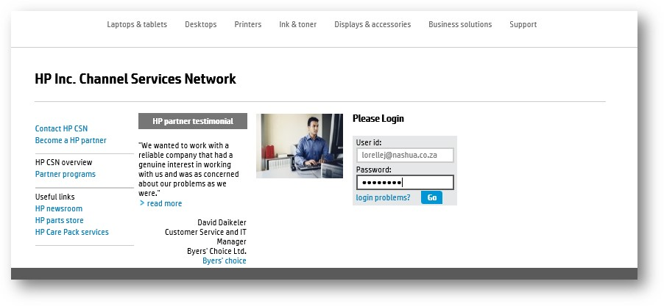
Image 5
Click on HP Service delivery on the left hand side of the screen:

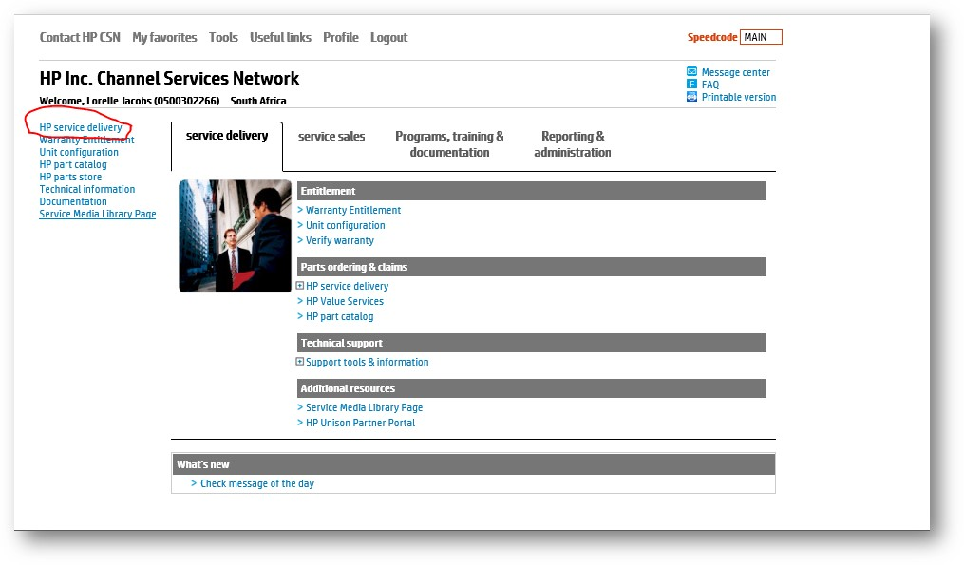
Image 6

GCSN Warranty Parts Order Process
GCSN (Global Channel Services Network) provides a tool to minimize the cost and complexity of service delivery. The below step to step process needs to be followed once you know that the machine serial number has an active warranty or carepack and you have the correct part number

After following the Login process at proceed with the steps below:
Click on Create warranty exchange in Global Service Delivery

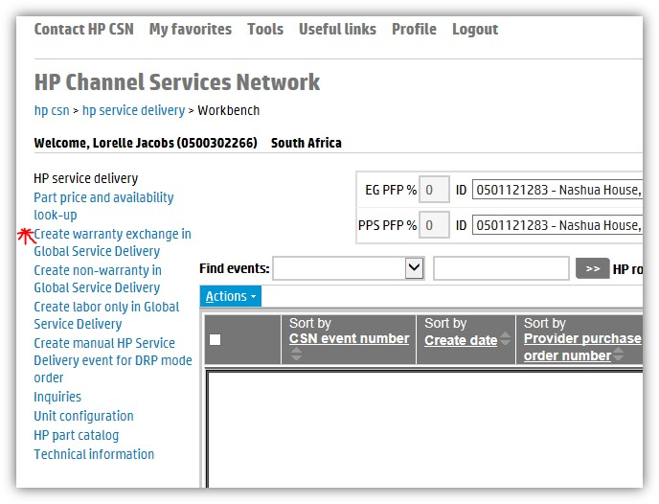
Image 7
Create the warranty exchange – to order the part as well as to claim for warranty on labour
A pop-up screen will appear. Complete all the required information on the INFORMATION Section which is marked with a x as displayed below:

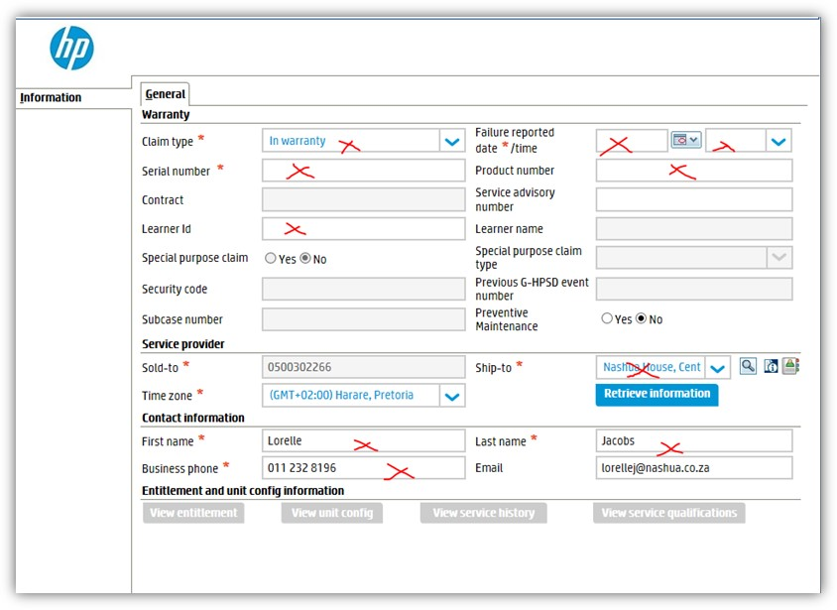
Image 8
Click on the Blue Button: Retrieve information

Image 9
The menu options will appear on the top left hand side as below in Image 10:

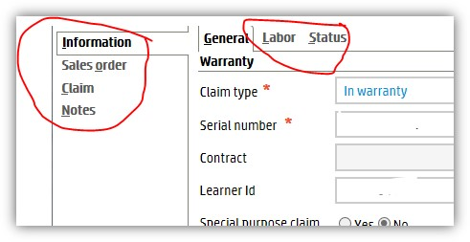
Image 10
Click on SALES ORDER on the left hand side and complete the details as required:

Enter the part number (Please confirm the part number on the Part surfer first)
Enter the quantity and click on Add Part

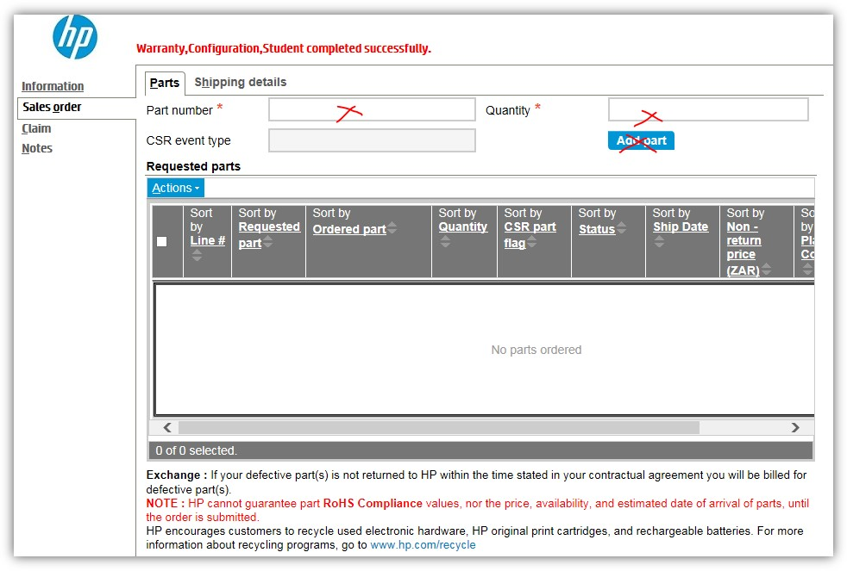
Image 11

Next complete the Shipping Details Tab:

The address will be pre-selected, just enter the Attention TO contact person’s name,
Fill in your AS400 call number in the Provided purchase order number
Select the Shipping options – always select Next Business Day

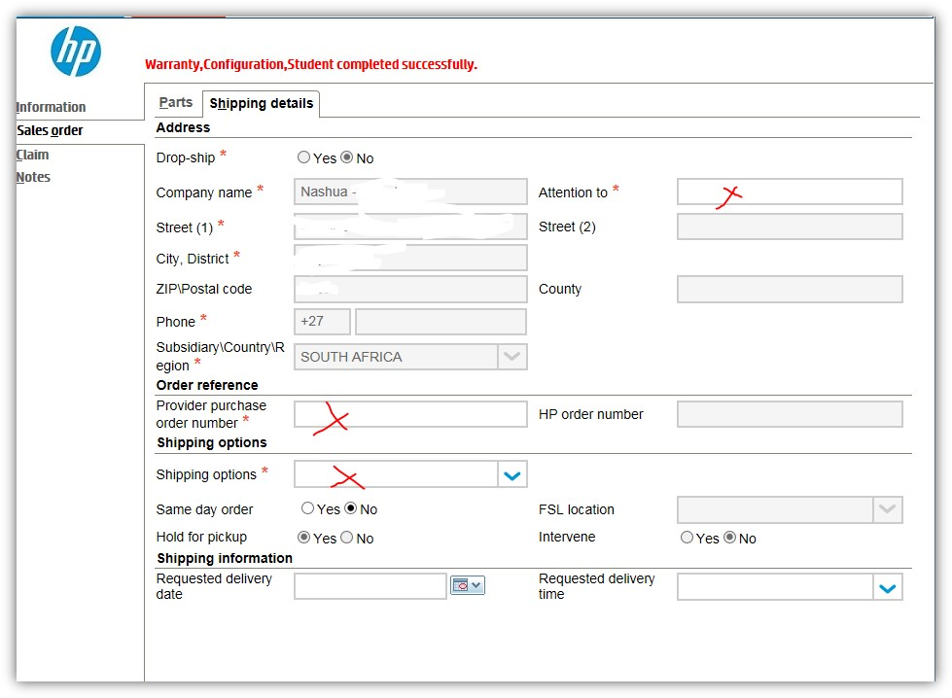
Image 12

Click on Save and Validate which is on the top left hand side of the screen:

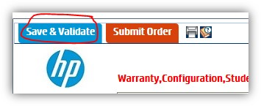
Image 13
If there are any errors on the order, a message will be displayed on the top of your ordering screen like below in Image 14:

“Field not complete Go to Information/Status tab for more information”
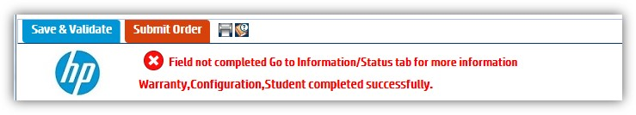
Image 14

Go to the INFORMATION tab then click on the STATUS tab on the top menu selections as below:

First click on Information, then you can click on the Status menu which will indicate what is needed to validate the claim:

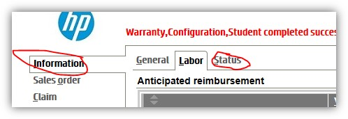
Image 15

Click on the very small down arrow most left of the error or errors to list the exact location where the error is and what the error is:

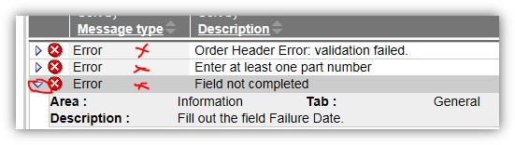
Image 16
In above example, the date was not completed on the General Tab under the information screen, go back to where the location is as per above:
Area: Information
Tab: General
Description: Fill out the field Failure Date

Go to the various Area and Tab as indicated on the error fix the error, then click on the “Save & Validate” section again as in Image 13

Once the very top of your order page displays: Warranty, Configuration, Student Completed Successfully (sometimes it will exclude student if your student has not completed the training)

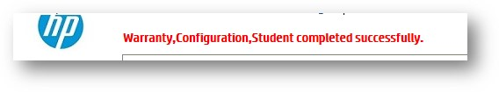
Image 17
Now click on Submit Order on the top left hand side of the screen:
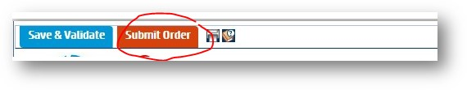
Image 18
Ensure your status displays Order Submitted as below in the very bottom left corner of this screen:
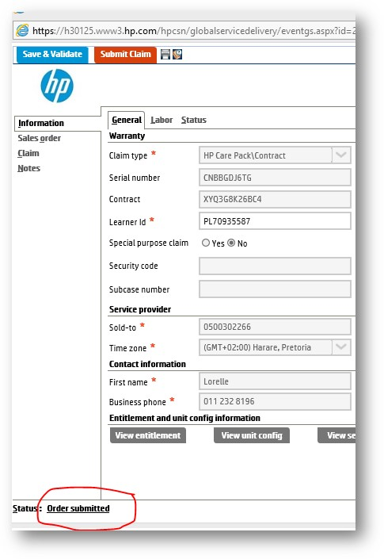
Image 19
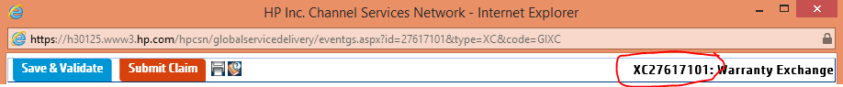
Image 20
That is it. You may close the screen, keep record of the XC number which is displayed in the top right hand side of your ordering screen to reopen the order to submit the claim after you received your part. Close the website and the part will be delivered to your franchise.

GCSN Faulty Part or Machine return
After you received your part from HP the following day, your engineer goes and fit the part at the customer. He MUST bring the faulty part back to the office.

Send an email to Seabourne Couriers who is HP’s Hub to collect the faulty part from your office. In the email to Seabourne, provide them with the following details:

- Part number
- Your office address where they need to collect
- Who is the contact person and the contact number for the collection
- The reference number from the part that was delivered to your franchise POD
It starts with the numbers 100 and is 10 digits long as displayed in Image 21

Image 21
Seabourne will respond to your email, and will bring their own waybill completed with your details, or you need to complete your details and ensure you keep a copy of the waybill.

GCSN Warranty Labour Claim Process
The GCSN (Global Channel Service Network) portal requires all part orders to be closed after the part has been delivered which is known as the Claim Process. The claim will pay out a remunerate on a labour portion for your engineering servicing and replacing the part, therefore the engineer needs to be qualified to work on the specific model for the claim to have a valid labour portion. If the engineer is not qualified, no labour remuneration will be available, but the below procedure still needs to be completed to avoid a penalty invoice from HP Inc.

Go back to GCSN Portal and repeat the login process then continue as follows:

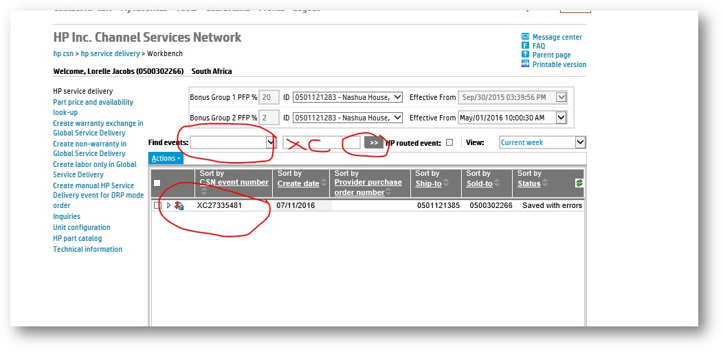
Image 22
If your XC number does not display at the bottom of the headers in grey, then select the down arrow by Find events, and select, By Event Number, in the empty block next to that, type in your XC number from your original order as per Image 20 which is also displayed on your POD at the Instructions block and click on search button which is the grey button with 2 right side arrows on it.

Once your order displays, double click on it to open it and go directly to the CLAIM Area and complete everything marked with an X below with the details corresponding to the AS400 call you have logged: (End User is your customer’s details)

NOTE:
Your Event Start Date and Time must correspond to the Failure Date and Time you filled in on the INFORMATION Area on the GENERAL TAB

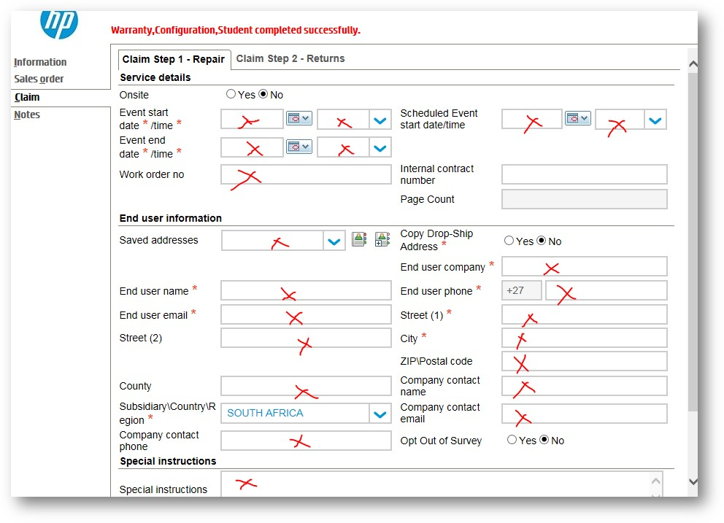
Image 23
Click on the second tab Claim Step 2 – Returns

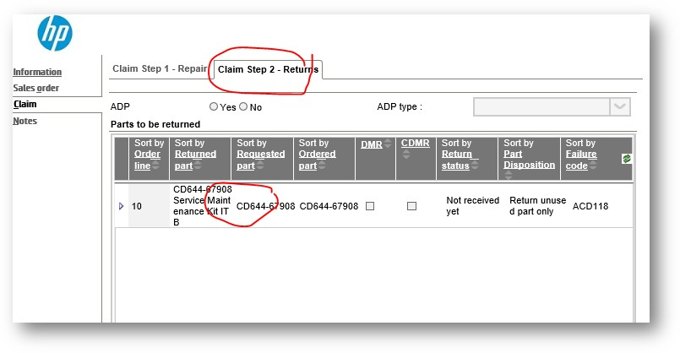
Image 24
And double click on the part you are returning and complete the Waybill number for the collection of the faulty part in the Provider waybill number section as below, click on save and close:

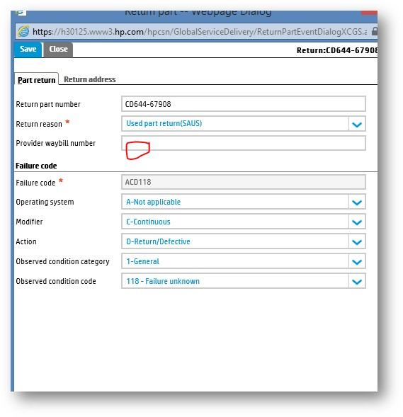
Image 25

Now click on “Submit Claim” on the top left hand side of the page:

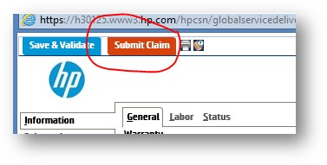
Image 26
Ensure when you are done, that your status now says CLAIM SUBMITTED or COMPLETED on the bottom left side of the screen:

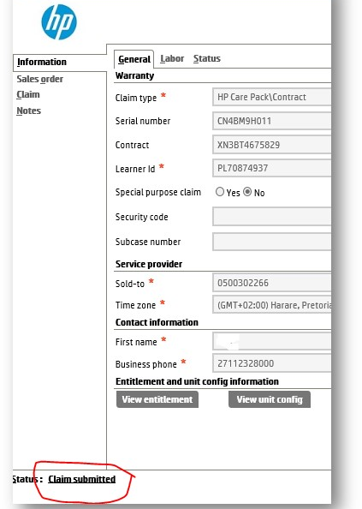
Image 27
You may now close the event, and the web page.
That completes the entire warranty claim and labour claim process, the labour will only be successful if your engineer is qualified on the machine – you will know if he is or not, on the status page where the errors are displayed. If your engineer is not qualified you will not qualify for labour, but still need to complete the claim event.

Also a note to remember, if you need to order a replacement machine instead of a part, the HP Part surfer created part numbers for the machine, you search the part number for the machine the same way you would search for a part.

GCSN Non-Warranty Parts Order Process
GCSN (Global Channel Services Network) provides an additional service to order a required part for machines that does not have an active warranty or CarePack. Following the steps below will provide you with an efficient service which avails the part cost immediately upon order:

Follow the GCSN Login process in step 3

Then click on Create non-warranty in Global Service Delivery
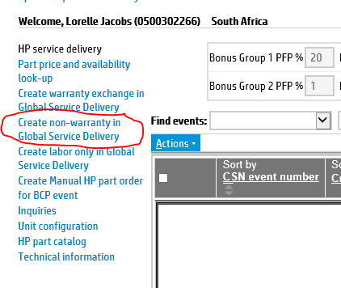
Image 28
The following pop-up screen in Image 29 will appear on the Sales Order Section on the Parts Tab
Fill in the Part number which you confirmed from the PartSurfer and the quantity then click on Add Part
Image h29
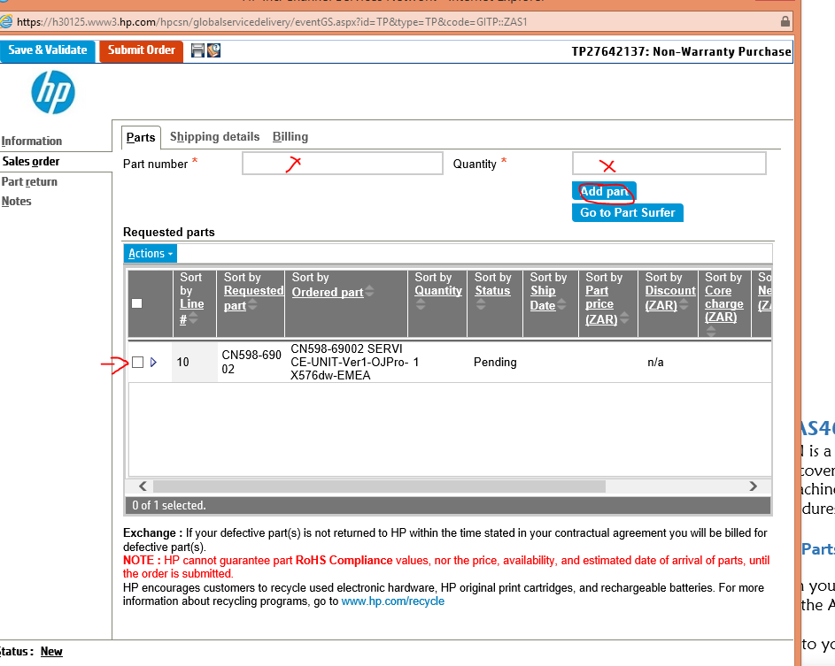
Image 29
Go to the Shipping Details tab and complete the Attention To with the contact person’s name who will be receiving the part or machine at your warehouse or service department. Complete the Provider purchase order number with your AS400 call number and lastly select the Shipping Options which affects the total cost of your order.

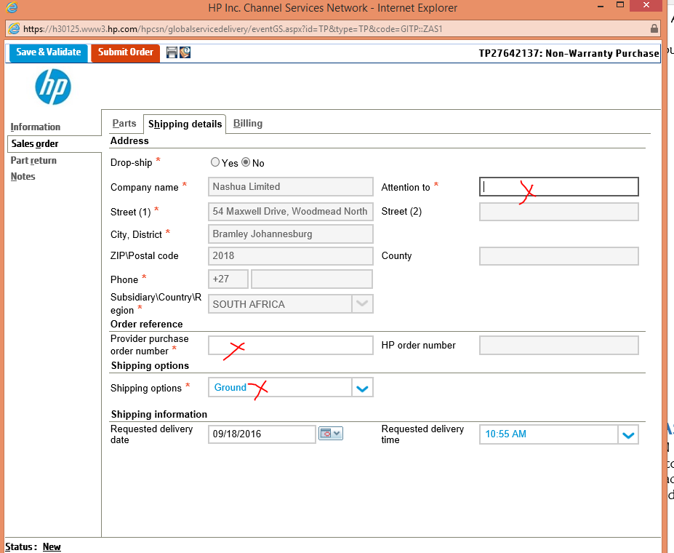
Image 30
Click on “Save & Validate” then the cost is visible on the Billing tab

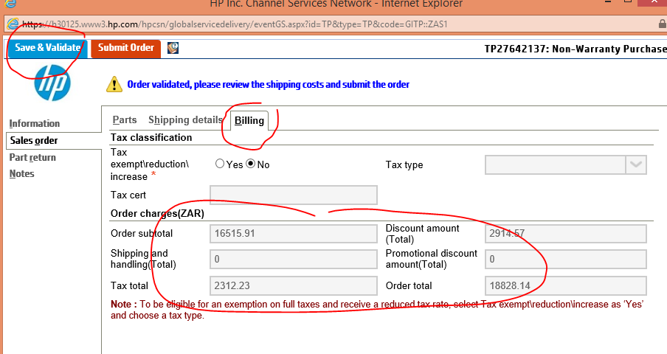
Image 31
If you are happy with the charges you may click on “Submit Order” as in Image h18

The same concept applies to the non-warranty parts, which needs to be returned to HP.

Follow the Steps referred to Returning faulty parts or machines

GCSN Labour Only Claim – SWAP (Service Without A Part)
The GCSN (Global Channel Service Network) portal provides a remunerate on a labour portion for your engineering servicing rendered on a HP device, therefore the engineer needs to be qualified to work on the specific model to have a valid labour portion. If the engineer is not qualified, no labour remuneration will be available, below is a list of permitted services by model where labour will be made available.

SWAP Permissions on Various models marked with an x

Reason | Other | LaserJet Printers & MFPS | 1 User Mono LaserJet  MFP’s Printer Based  Contractual SKU’s & Formatters | OfficeJet Pro Printers | DesignJet | InkJet Enterprise Printers
Clear Paper Jams inaccessible to customers and adjust paper paths |  | x | x |  |  | x
Reseat PCA Cables | x | x | x |  |  | x
Reset Printer/Formatter PCA |  | x | x |  |  | x
Clean Laser exit Mirror |  | x | x
Print Quality Problems |  | x | x |  |  | x
Refit misplaced PCB, belt 7 Mechanism |  | x
Electro-Mechanical adjustments |  | x | x |  |  | x
Printer Calibration |  |  |  |  | x
Firmware Upgrade |  |  |  |  |  | x
DesignJet Calibration |  |  |  |  | x
Consulting on usability & configuration

If your service call on the above mentioned machine products meets the criteria marked above, then follow the Login process as indicated in step 3

Click on Create labour only in Global Service Delivery

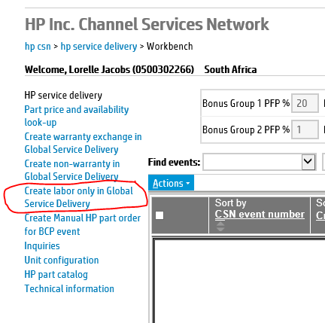
Image 32

The following screen will appear as displayed in Image h33.
Complete all the required information marked with an x on the INFORMATION Section under the GENERAL tab and click on the blue Button “Retrieve information”
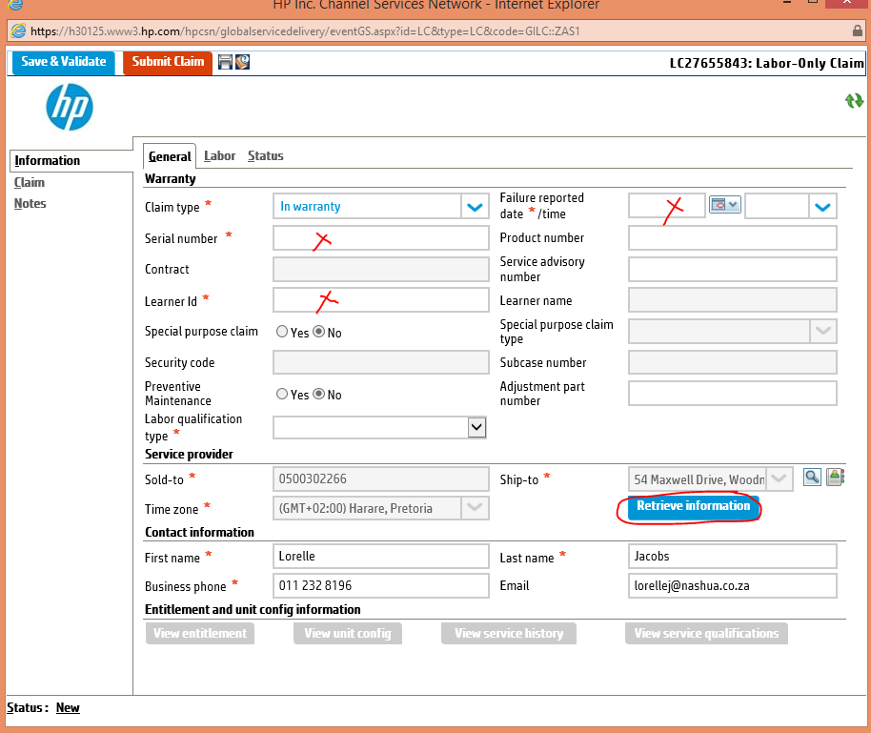
Image 33
Next click on the CLAIM section and complete all the required information marked with an x and you may add Notes on the NOTES section (basic summary of the problem of the machine) and click on the button “Save & Validate” on the top left section of the screen, if your status on the bottom left side of the screen has changed from New to Validated, you may now click on the button “Submit Claim” – once your status on the bottom left has updated to Claim Submitted, you may close the event which HP will authorise to pay the labour value which the Technical HP Administrator will make known to you.
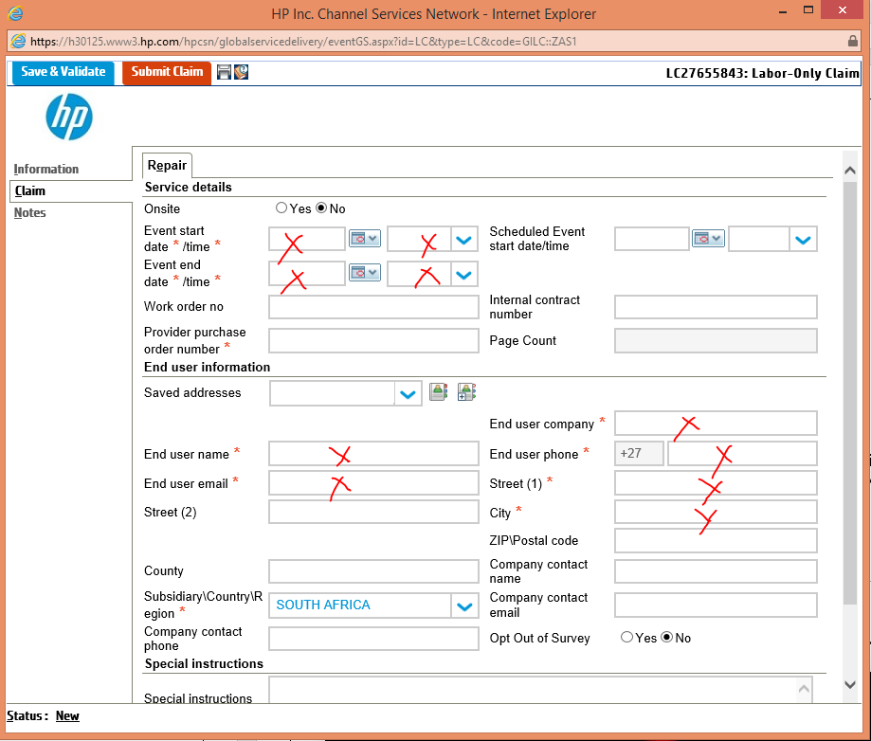
Image 34

Re-Link Existing CarePack to Replacement Machines
HP Care Pack Services are support packages that expand and extend standard warranties for HP hardware and software. HP Care Pack Services provide hardware and software support, installation services, education services and premium support options to meet the needs of business-critical IT environments. Please follow the steps below to re-link the CarePack from your faulty returned unit to the replaced machine as ordered on the GCSN Portal.

Send an email to the HP CarePack centre using the below email address and provide the details clearly indicating which is the ‘old’ machine serial number and the ‘new’ machine serial number.
Attach the invoice of the new machine and if possible the invoice with the purchase of the old machine and CarePack (you may request this from Nashua Limited).

Email: rsacarepacks@hp.com

AS400 Procedures in line with GCSN Orders
GCSN is a separate system for all the HP devices, from Printers to MFP’s as well as Design Jets which is all covered in warranty. There is no automated link to the AS400 which is why all parts require or machine replacements needs to be recorded with every instance on the AS400. Below follow the procedures to ensure proper record is captured on the AS400.

Parts Ordered on GCSN – Link on AS400
When you have ordered a part through GCSN and need to log off the part and it is not loaded onto the AS400, follow the following steps:

Go into your Stock Menu Or the Parts Menu and use option 20 - Request NAS to load Products
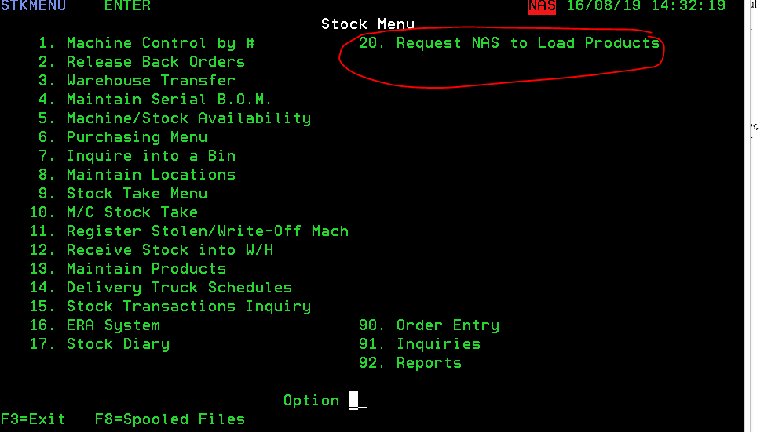
Image 35
Follow the prompts and Ongoing Revenue will load the part number onto the AS400 which you may now adjust into your stock or engineer’s bootstock to log off on the outstanding service call.

Machine replacements Ordered on GCSN – link on AS400
In the instance of ordering a complete machine, and the machine has been delivered to your offices, log a user request on the AS400 for IS Department to register the new serial number and once that has been done, you may then GRN the machine into your warehouse to your client and then perform a serial swop.

Image h36
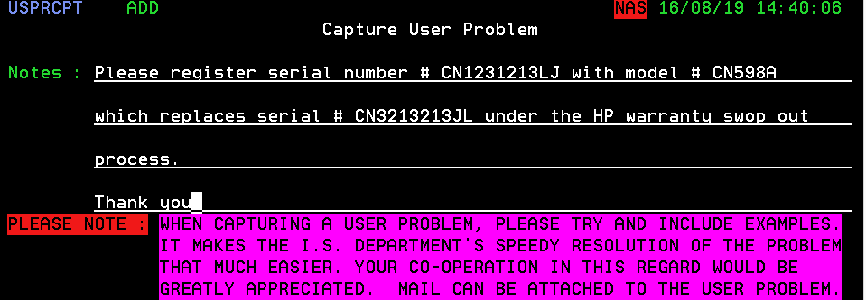

N.B. The faulty machine still needs to be returned to HP through Seabourne Couriers

References

HP Web Links to save maybe in your favourites bar on your Internet Explorer:

HP Warranty Check - http://h20564.www2.hp.com/hpsc/wc/public/home
HP Part Surfer - http://partsurfer.hp.com/search.aspx
HP CSN - https://h30125.www3.hp.com/hpcsn/?hpp

Email Addresses to remember:

Seabourne Collection: spljnb@seabourne.co.za
CarePack Link/Transfer: rsacarepacks@hp.com

Policies and processes

Dealer Service Revenue (DSR)
Whenever signing a Service agreement (CSA) with a customer, and the machine will not be in your own service area, you need to pay DSR to the Servicing Franchise. The DSR rate is calculated by the Technical Franchise Liaison and uploaded onto the AS400.

Product groups may be treated differently when applying DSR. Currently we have 5 types of DSR.
- Copy Click DSR
- PCR
- Flat Rate
- HP DSR
- Variable DSR

All DSR rates are summarised in the DSR file on the AS400 and rates are separated by Effective Date, Meter and Accounting mode (Developments or Prints).

DSR Date Sold
For each machine (Serial number), a DSR date sold value is stored on the AS400. This date represents the first time it was sold from Nashua LTD to a franchise and there also determines the actual age of the machine. If a machines is deleted off the Service Base system, it may be necessary to add the DSR date sold to determine the true age of the machine. This is done by the Technical Franchise Liaison at Nashua LTD.

Colour Products Accounting mode
It was possible to set the accounting mode of Colour products to Developments or Prints. No new product’s contract can be set to Developments any more as Nashua has decided to standardise the accounting mode to Prints.

Consumables
All consumables are excluded from DSR and the CSA Owner Franchise is responsible for the cost there of. Some parts are deemed as Consumable parts, and is included into the DSR value. (Example: PCU1515 and Developers)

Labour rates used in DSR
The labour rates are standardized in the DSR calculations

 | Black Meter  (M1) | Colour Meter (M2) | A3 Black  (M4) | A3 Colour  (M7)
B/W MFP | 0.0139
Colour MFP | 0.0139 | 0.0139
Production Print (B/W) | 0.0110 |  | 0.0139
Production Print (CLR) | 0.0139 | 0.0139 | 0.0139 | 0.0139
Duplicators | 0.0110

Basic Cost per Print calculation process
To calculate the CPP of any machine, you will need the cost and yield of all the PM parts (as per Service manual). For each part you divide the cost of the part by the yield. This will give you a CPP value for each part. The sum of all the calculated CPPs will then give you the total CPP for the specific machine.

This of course is a theoretical calculation and the true CPP depends on the true yields that the relevant parts reached. The CPP calculation is an indication of what you can expect based on the yields that the manufacturer expects from the parts in the PM parts list.

To get a more accurate CPP value, the CPP is calculated by looking at the amount of parts replaced over the contract period. This calculation method is used in the DSR calculations below.

Copy Click DSR
The Copy click DSR consists of a calculation for Parts and Labour. (see Labour Rate Description on page 96)
The Parts value for the copy click DSR is calculated by using the following parameters:
- 60 month contract period
- 50% of Maximum Copy Volume (MCV)
- Standard Colour Ratio (as per manufacturer) (Colour Products)

The formula for calculating the DSR value is as follows:

DSR rate = DSR Rate X Age Factor X Distance Factor X Usage.
(see description for the Age factor and Distance factor below)

The value of the DSR paid is then calculated based on the usage for the month.
The Copy Click DSR has 2 other factors that influence it.
- Age Factor
- Distance Factor

Distance Factor
Servicing machines that is further from the office costs more in travelling costs. This is recognized and therefore taken into account by the multiplying the DSR rate with a Distance factor. All machines are defined in some suburb on the contract. The Suburb distance is determined by calculating the distance from the Servicing Franchise. These distances are divided into groups and each group has its relevant factor.

KMS | Distance Group | Factor
0 to 49 | 000 – 049 | 1.000
50 to 149 | 050 – 149 | 1.250
150 to 299 | 150 – 299 | 1.560
300 and higher | 300+ | 1.950

Age Factor
As the machine becomes older, it becomes more service intensive and for this reason an age factor is brought into the formula for calculating the DSR value. From the 1st of December 2016 a new age factor system has come into place. The DSR Date Sold determines the Age factor table that is used for the DSR value calculation

 | DSR Date Sold
Age | Before 1 Dec 2016 | 1 Dec 2016 and after
0 | 1.00 | 1.00
1 | 1.07 | 1.00
2 | 1.16 | 1.00
3 | 1.26 | 1.07
4 | 1.36 | 1.16
5 | 1.51 | 1.26
6 | 1.66 | 1.36
7 | 1.90 | 1.51
8 | 2.19 | 1.66
9 | 2.52 | 1.90
10 | 2.95 | 2.19
11 | 3.39 | 2.52
12 | 3.90 | 2.95
13 | 4.49 | 3.39
14 | 5.16 | 3.90
15 | 5.93 | 4.49
16 | 6.82 | 5.16
17 | 7.85 | 5.93
18 | 9.02 | 6.82
19 | 10.38 | 7.85
20 | 11.93 | 9.02

All Refurbed machines, will attract the DSR age factor as determined by the DSR date sold.

Printer Care Revenue (PCR)
PCR is only applied to printer products that have a print speed lower than 50 ppm. All printer products that has a higher print speed, will attract a normal Copy Click DSR.

The PCR is calculated as a fixed monthly value and is determined by the following formula:

PCR = (FTP price x 30%) ÷ 36 months

Distance factor is applied as described above.
The PCR has a minimum value of R50.00

Flat Rate
The Flat rate DSR is reserved for Fax products only (non-laser). The concept was to have a full replacement machine for every 5 in the field during a 24-month period. The formula calculating the Flat rate value is as follows:

Flat rate = (FTP price x 20%) ÷ 12

HP DSR
The HP DSR rate uses very much the same principle as the PCR calculation and is determined by the following formula:

HP DSR Rate = (FTP price x 5%) ÷ 36 months

HP DSR Rate has a minimum value of R50.00.
The HP DSR rate is not applied to HP Wide format / Design Jet products.

Variable DSR
In some cases, it is necessary to deviate from the standard DSR rates. (Example Major account deals). To secure a contract we sometimes need to suggest lower CPP rates to the customer. The lower CPP billing value means that the DSR rate also needs to be adapted.

NOTE:
No Age or Distance factors apply

Currently we have 2 Variable DSR processes in place (variable DSR options discussed further in this document):
- Franchise to Franchise: For all deals where 50 or less machines are involved; Franchises need to negotiated between themselves.
- Franchise (major deals): For larger deals, the process is administrated through Nashua LTD.

Variable DSR options
- Fixed – Cents / Copy
This option applies a fixed value for every print the customer makes. It can be loaded for Black (Meter 1) and Colour (Meter 2). There is no automatic escalation of this value and this should be initiated from the CSA owner.
- Fixed – Flat Rate
This normally would only apply to printer products. A fixed monthly value is paid for this product. The rate will be different to the standard fixed rate.
- Actual Service Billed
The value that is paid to the Servicer is equal to the Service billing value to the customer. Note that this excluded any admin and services fees that is billed to the customer and is purely the copy click value of this billing.
- Use DSR +/- Pcnt
This uses the normal DSR value as in the DSR file on the AS400, but a percentage is added or subtracted depending on the setting
- User DSR +/- Cents
This uses the normal DSR value as in the DSR file on the AS400, but the amount of cents defined, is added or subtracted from the DSR rate. This is normally used, when the CSA is paying for extra services, at the Servicing Franchise (example a Service Engineer’s salary)
- Exclude all areas
This option prevents any DSR to be paid to all Franchises.
- Use DSR no Age Factor
The normal DSR rate is applied for these products. Distance factor will still be calculated on the DSR value, but the Age Factor has a fixed rate of 1.00.
- Fixed – Copy Breakdown
This is a new V/DSR type that allows the Owner to specify Parts, Labour and Toner separately. This is the only DSR type where the Servicer will carry the cost of the toner and the Variable DSR value will then include a value to accommodate for toner.
- Enter the Calc Type = 8
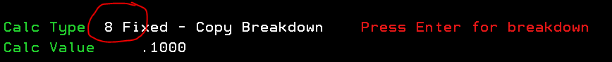

- This will the give you the option to enter the individual values for Parts, Labour and Toner
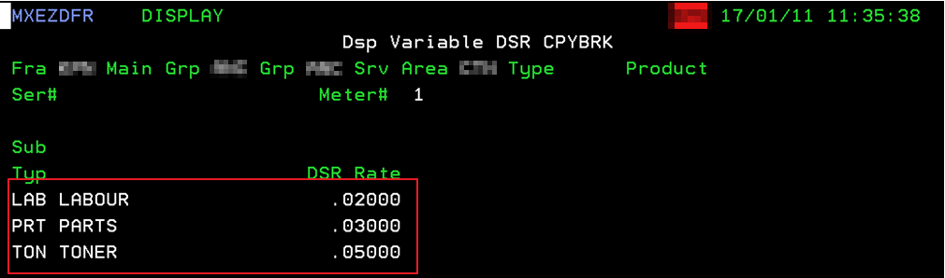

AS400 TIP
To enter a negative number in the field, you need to following this procedure:
Enter the positive equivalent
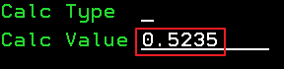

With the cursor still in the 1st position after the value, press the “-“ (Minus) key on the keyboard.
The number will now change to a Hexadecimal number
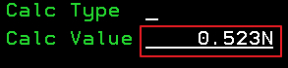

On the Enter and confirm action at the end of the screen, the value will be changed to a negative value
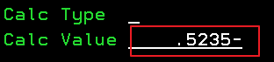

Franchise to Franchise
When you have a deal where there is less than 50 machines involved, the Franchise doing the deal can negotiate with the Servicing Franchises to have them service the machines at a different rate to the DSR value. The CSA Owner, on agreement with the Servicing Franchise, can load the Variable DSR rate on the AS400. Once loaded, the Servicer needs to “authorise” the process. Once authorised it is accepted that the Servicer has agreed to the servicing value.

Variable DSR loaded between Franchises can be found in the Service menu under Administration

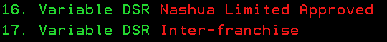

Select the “Variable DSR (Inter-Franchise) option to load the Variable DSR.

How to load Variable DSR
- Enter the appropriate menu
- Press F9 to add a new Variable DSR
- Enter all the relevant information
NOTE:
An entry for every serial number must be loaded.
If you are loading V/DSR for Black (M1) and Colour (M2) meters, it needs to be loaded as 2 separate V/DSR entries.
The expiry date will prevent it from running further than the indicated date.

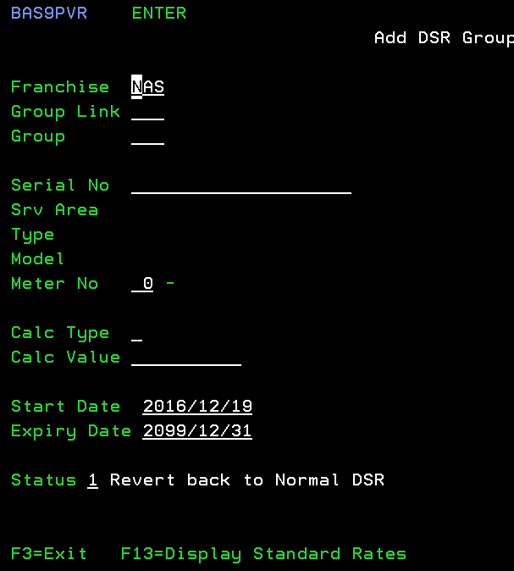

NOTE:
- The Servicing Franchise needs to enter the same AS400 menu in order to authorise the process. The variable DSR calculation will only start once the Servicer has authorised
- Follow on screen prompts to authorise.

Franchise (major deals):
When the CSA owner needs to have a variable DSR rate loaded, and the deal is for 50 machines or more, then the process needs to be administered through Nashua LTD.

The following information needs to be sent to the Senior Manager – Technology and the Technical Franchise Liaison to get the process started

- The customer name
- The amount of machines
- The models involved
- The rate at which the CSA owner wants to charge the customer (all meters)
- The expected margin that they are willing to make

The Technology manager will evaluate all the rates and compare the values to the current CPP and DSR rates and based on these will make a recommendation. Should it be necessary, the Ongoing Revenue manager will also be involved to help calculate the best possible DSR rates and pricing for the relevant franchise.

Inter Franchise Labour Rates (IFL)
To standardise the rates that is charged between franchises, the IFL rate is calculated. This standardised rate is used in a multitude of calculations and therefore needs to be updated on a regular basis.

To also have a more detailed labour rate value by franchise, the IFL rate calculation will separate the labour rate for the following levels:
- Manager / Supervisor
- Senior Engineer
- Engineer
- Junior Engineer
- Trainee Engineer

These rates are used as the labour rate calculation on every service call. And although the rates are calculated by the individual franchises, the rates will be loaded onto the system by the Technical Franchise Liaison

Process
Once per year, the Technical Franchise Liaison will send out a template that needs to be completed by all Franchises. This will contain all the labour costs that is occurred over a year period. The normal dates period that the form is completed is just after the Nashua LTD year end in October of every year. It is the responsibility of the Technical Director / Manager to ensure that these forms are complete timeously.

Once all the templates have been received back from the franchises, will the summary be done. Discussion will then determine the labour rate for the next year. All labour rates for the various Engineer levels will be loaded and a confirmation sent to the various Technical Director / Managers.

The Franchise may, at any time of the year, complete the template again to have the labour rates of the Engineers updated. This may be necessary if some of the Engineer’s job levels change. (Example: from Trainee to Junior Engineer). The change in this level will change the labour rate value and this has an influence on the machine costing calculations.

The IFL rate is calculated on a weighted average value

Franchises not completing IFL forms
Franchises that do not complete IFL forms, will not be part of the process of discussion of negotiating the new IFL rate for the following year

Current Inter Franchise labour rate

The current Inter Franchise Labour rate is valid effective from 1 February 2017 and will be valid until the next review date

Rate: R200 / hour

Warranty Procedures
It may happen that during an installation of a new machine, a problem may occur. To repair these issues, there also may be a cost involved. To cover these costs, Franchises are paid a warranty value for each main machine installed. This value is automatically calculated on the AS400 and no value changes can be made by any user.

Note:
No warranty value for peripherals, parts or consumables. This may only apply to certain manufacturers as individual contracts may be agreed with different manufacturers.

Conditions for Warranty pay out
In order for a Franchise to qualify for warranty, the following conditions must be complied to:
- This must be the first time this machine was sold
Warranty cannot be claimed multiple times on one product
- An Installation call must be logged on the AS400 and one on the following service types must be logged:
  - Installation
  - Awaiting Instal Cpl
  - Awaiting Instal Stk
- The machine must be on Contract
- The Warranty flag must be set to “Y” on the AS400
- The time lapse between the Date Sold and the conditions above, may not exceed 6 months.

What does the warranty cover?
The warranty paid out to the Franchise should be kept in a provision type account, where it can be utilized for all the issues occurred on new machines. The Warranty covers any and all Out of Box Failures. Eg: parts, consumables and machines that may have an error during the first period after installation

Re-instating warranty on a machine where the Warranty has expired
If the above conditions are not met in time, the warranty will expire and the Franchise will not receive warranty for this machine. The warranty status will then show as Expired.

In certain instances, Nashua LTD may consider to re-instate the warranty for pay out on the next billing run. The conditions for this to happen, is only when the above conditions were not met and were out of the Servicing Franchise’s control. This does not apply to situations where the Servicing Franchise did not log the appropriate Service calls, etc.

For any queries, send the necessary information to the Technical Franchise Liaison.

Transferring Warranty to another Franchise
Sometimes a machine is installed at one franchise, immediately uninstalled and then re-installed at another Franchise. The machine’s meter reading is very low and it is clear that this machine was most probably incorrectly installed at the one customer and but then re-installed at another. Or as example may have been on demonstration for a short while, but then re-sold to another customer. In these cases, the Warranty may have been paid to the first servicing Franchise already.

It is possible to transfer the Warranty to the second Servicing Franchise. Both franchises are informed with all the necessary information when this happens. The AS400 history will show a transfer of the Warranty value.

Software Installation Charges
Effective Date: 1 August 2014

This policy overrides all previous policies regarding Software / Solution installation charges.

Standard Software: Printer drivers, LAN Fax drivers, Device Manager NX
Advanced Software: Scan to Mail, Scan to Folder, Twain Scan
Solution Software: Ntrack, Softlog, Papercut, Equitrack, Scannervision

Mainframe and peripherals to Networks | 2 hours x Current IFL rate
All Users for the Standard Software | Included in the Main Frame
Additional Users for the Advanced Software | Actual time spent x IFL rate  (AS400 software Installation call time)

Multi User Printer | Same as above
Single User Printer | Only Installation Commission

Solution Software | As per IFL Matrix (refer to page 104)
Solution Software | As per IFL Matrix (refer to page 104)

Refer to page 102 for current IFL rate

The Pre-installation and Post installation forms has to be used to enforce these charges. Please ensure that these are loaded on the AS400

Ensure that these costs form part of your quote.

Detailed breakdown of times for Solution Software on the next page.

All MDS/MPS Solution Installation charges will be project based and calculated per installation

Inter Franchise Labour (IFL) Rate Matrix

 |  |  |  |  | Support | Support | Support | Support | Support
Line of Business | Manufacturer | Product Range | Site Inspection | Installation | Call Out | Rate (B/H) | Rate (A/H) | Travel (B/H) | Travel (A/H) | IFL
Business Infrastructure | Ricoh | MFP | N/A | AS400 | 200 | 200 | 450 | 200 | 450 | 200
Business Infrastructure | Ricoh | Printer | N/A | AS400 | 200 | 200 | 450 | 200 | 450 | 200
Business Infrastructure | HP | MFP | N/A | AS400 | 200 | 200 | 450 | 200 | 450 | 200
Business Infrastructure | HP | Printer | N/A | AS400 | 200 | 200 | 450 | 200 | 450 | 200
Commercial & Specialised Print | Ricoh | Pro Series | N/A | AS400 | 200 | 200 | 450 | 200 | 450 | 200
Commercial & Specialised Print |  | ProC Series | N/A | AS400 | 200 | 200 | 450 | 200 | 450 | 200
Commercial & Specialised Print |  | Wide Format | N/A | AS400 | 200 | 200 | 450 | 200 | 450 | 200
Commercial & Specialised Print | HP | Designjet | N/A | Carepack | 200 | 200 | 450 | 200 | 450 | 200
Content Management | MPS | Equitrack | SOW | 500 | 450 | 450 | 750 | 450 | 750 | 450
Content Management | MPS | Papercut | SOW | 500 | 450 | 450 | 750 | 450 | 750 | 450
Content Management | MPS | Softlog | SOW | 500 | 450 | 450 | 750 | 450 | 750 | 450
Content Management | MPS | Streamline NX | SOW | 500 | 450 | 450 | 750 | 450 | 750 | 450
Content Management | MPS | Ysoft | SOW | 500 | 450 | 450 | 750 | 450 | 750 | 450
Content Management | MPS | Everyone Print | SOW | 500 | 450 | 450 | 750 | 450 | 750 | 450
Content Management | MDS | Docuware | SOW | 500 | 450 | 450 | 750 | 450 | 750 | 450
Content Management | MDS | Nashua Docs | SOW | 500 | 450 | 450 | 750 | 450 | 750 | 450
Content Management | MDS | Scannervision | SOW | 500 | 450 | 450 | 750 | 450 | 750 | 450
Content Management | MDS | AutoStore | SOW | 500 | 450 | 450 | 750 | 450 | 750 | 450
Content Management | MDS | Lawtrust | SOW | 500 | 450 | 450 | 750 | 450 | 750 | 450
Content Management | MDS | Cloud Solution | SOW | 500 | 450 | 450 | 750 | 450 | 750 | 450
Connectivity Infrastructure | Panasonic | NX | 350 | 500 | 450 | 450 | 750 | 450 | 750 | 450
Connectivity Infrastructure | Panasonic | KX | 350 | 500 | 450 | 450 | 750 | 450 | 750 | 450
Voice and Data | ECN | Voice | 350 | 500 | 450 | 450 | 750 | 450 | 750 | 450
Voice and Data | ECN | Data | 350 | 500 | 450 | 450 | 750 | 450 | 750 | 450
Smart Solutions | Ricoh | IWB | 350 | 500 | 450 | 450 | 750 | 450 | 750 | 450
Smart Solutions | Ricoh | Projectors | 350 | 500 | 450 | 450 | 750 | 450 | 750 | 450
Smart Solutions | Parrot | IWB | 350 | 500 | 450 | 450 | 750 | 450 | 750 | 450
Smart Solutions | Parrot | Projectors | 350 | 500 | 450 | 450 | 750 | 450 | 750 | 450
Smart Solutions | Sensor | Video Surveillance | 350 | 500 | 450 | 450 | 750 | 450 | 750 | 450
Smart Solutions | Sensor | Access Control | 350 | 500 | 450 | 450 | 750 | 450 | 750 | 450

Policy authorized by Manager – Technology & Franchise Technical Liaison

Relocation Procedures
It is inevitable that machines will need to be relocated between Franchises. In order to have a standardised procedure, the following guidelines needs to be followed. As the sending Franchise has received the DSR for the machine up to this point, they have built up a “fund” to cover the cost of the PM parts. The Receiving Franchise is therefore entitled to claim a portion of the parts cost from the Sending Franchise. This cost is calculated based on the last replacement of the various parts and then calculated as a percentage of the FTP price.

PROCEDURE FOR ALL MFP MACHINES

The Sending Franchise is responsible for the following when a machine is prepared for relocation:
- Machine must be in a working condition
  - Main machine and Accessories
- Machine must be clean
- Machine must be drained and consumables removed from the machine
  - Developer
  - Toner (should be properly packaged and sent with the machine, unless differently instructed by the CSA owner)
- Machine needs to be secured
  - Scanner
  - Covers
  - Place protection on the Platen glass (Cardboard)
- Accessories
  - Accessories that should be removed for transportation should be taken off machine and all screws and brackets be placed in a package
- Packaged
  - The machines should be properly packaged and wrapped for transportation
- Documentation
  - Relocation form to be sent to the Receiving Franchise Technical Director / Manager
  - ERA to be sent with machine

The Receiving Franchise has the following procedures to follow:
- Machine to be received into their workshop
- General condition of machine to be checked
  - Any physical damage to the machine must be reported to the Technical Director / Manager of the Sending Franchise
- A relocation quote needs to be worked out and sent to the Sending Franchise’s Technical Director / Manager
  - The relocation quote is calculated based on the
- The quote is based on the proportional cost of the following parts:
  - Drum / PCU (if inclusive on DSR)
  - Cleaning Rollers and Blades for drum section
  - Hot Roller and Pressure Roller
  - Cleaning Rollers and blades for Fusing section
  - Transfer rollers and belts
  - Cleaning rollers and blades for Transfer section
- Developer and Toner does not form part of the Relocation costs as this is part of the DSR
- Labour rate is limited to a maximum of 3 hours, however reasonable logic should prevail. The time charged on the relocation quote needs to correspond to the Repair time logged on the AS400.
- Any other major issues/problems should be discussed with the Technical Director / Manager of the sending franchise before repairs commence.
- The Sending Franchise should supply an order number on acceptance of the quote above
- If consumables are not received with the machine, the cost of consumables is for the CSA Owner Franchise

Machines where the NVRAM has been replaced
When an NVRAM has been replaced, the meter readings will be reset and the calculation of the Relocation charges should be calculated slightly differently. As the relocation calculates a proportional cost for the duration that parts have been installed, it should be taken into account the amount of prints done on the part on the “old” meter readings.

Machines that has received Variable DSR and then relocated
The relocation quote is designed to transfer the cost of the parts section to the Receiving franchise. This cost is calculated from the parts portion of DSR received by the sending franchise. With a variable DSR machine, the DSR value is normally (not a rule) lower than the DSR value.

This would mean that the Sending Franchise may be paying out more on relocation costs than what he has received. In these cases, the Sending and Receiving Franchise should get in contact with the CSA Owner Franchise. To assist, the CSA Owner franchise needs to assist with these costs as the Variable DSR was implemented for his benefit.

RELOCATION PROCEDURES FOR FAX AND PRINTERS

The Sending Franchise should prepare the machine as follows:
- The machine should be fully operational. Check and Tested
- For Laser fax machines, the OPC units must be removed from the machine, securely packaged and sent with the machine.
- For Laser Printers, the toner should be removed and properly packaged
- The machines should be properly cleaned and units secured for transportation

The Receiving Franchise should follow this process:
- Check the machine for any physical damage and report to sending Franchise should there be any problems.
- The cost of the consumables is for the CSA owner. The CSA owner can charge the customer based on the agreement done for the relocation.

GENERAL NOTES
The Receiving franchise is entitled to charge the full 3 hours labour, should the machine to be properly drained before transportation. For any major damages the Technical Director / Manager of the Sending Franchise should be contacted and discussed.

Packaging
- All sending parties should ensure good packaging that supports the protection against damage.
- Packaging should clearly be marked as “TOP” and “FRAGILE”.
- TILT and SHOCK indicators to be used
- Do not except liability if indicators shows a problem has occurred. Rather let courier wait while further investigation on product is conducted, or sign NOT CHECKED and comment on receiving docket what you have observed.
- Contact the Sending party immediately if any damage is observed so that a new plan of action can be enforced.

Old and Obsolescent Products
When very old and obsolescent products are relocated, a negotiation should be done by the Receiving part and the CSA owner.

Billing your own and another Franchise’s Customers
In some cases, it may be necessary to bill the customer for whatever reason. Should this be necessary, the following rules will apply:

If the Servicer is not the CSA Owner, then the Servicer may not directly charge the customer. The charging must then be channelled through the CSA Owner. Then only exception to this rule is when the CSA Owner gives permission to the Servicer to charge the customer directly. In the case where the Servicer charges the customer, the parts cost will be at no more than FTP price plus a 30% margin. The labour rate is determined by the Franchise’s standard labour rate.

The Servicer will charge the CSA Owner at FTP price PLUS 9% margin for parts replaced as well as the hourly IFL rate (Refer to page 102 for current IFL rate) at the time of the Service call. The CSA Owner Franchise will then in turn charge the customer. Labour rates will be at the CSA Owner’s standard labour rate.

When charging your own customers, the handling thereof is determined by the individual franchise.

Inclusive Consumables
In most cases will the customer will order new consumables from the Servicing Franchise. In all cases, will the CSA owner be ultimately responsible for the control, management and cost of Inclusive Consumables for their customers.

Inclusive consumable Ordering Process
When a customer calls in to order a consumable, the Inclusive consumable clerk will input all data into the Inclusive Consumable program.

The AS400 will check the yield achieved by the customer by comparing the current meter readings to the previous meter readings. This in turn is then compared to the yield target loaded for this customer on the SLA contract. The expected yields to be achieved for every franchise is set by means of a business rule. These business rules will then also determine how the customer will be charged (for under yield consumables)

If the yield calculation is within acceptable values (as determined by the CSA Owner Franchise), the AS400 will automatically allow the transaction to go through. If the yield achieved is below what is required from the CSA Owner Franchise, the transaction will create a screen entry at the CSA Owner franchise and they need to decide how this is handled. This transaction can be overridden and the Inclusive Consumable will be released and then the Servicing Franchise can issue the consumable. If they decide to charge the customer, an order will be requested from the Customer and the consumable will be released and the servicer will be able to supply.

At the next billing month, the Servicing Franchise will be reimbursed for the consumables supplied to customers.

The value paid to the Servicer is as follows:
MFP, fax and Printers over 50ppm: FTP Price
Printers on PCR: FTP Price + 9% (mark up)

Colour image creation process
When any colour image is created on a colour product, it will always use all 4 colours to create the image.
- Black
- Cyan
- Magenta
- Yellow
Irrespective of the Accounting mode, Black is always used in the creation of colour images. Even though the Black meter does not increment in the PRINT accounting mode.

How do the Copy usage meters increment on Prints and Developments?
The 2 accounting modes that can be selected on colour products are Prints and Developments. These accounting modes increment differently and it is important to understand the difference.

Accounting Mode = PRINTS

Image colour | Copy mode | Black Meter (Meter 1) | Colour Meter (Meter 2)
Black and White | B/W | +1 | No change
Black and White | CLR | No change | +1
Colour | B/W | +1 | No Change
Colour | CLR | No change | +1
B/W or Colour | Single Colour mode | No change | +1

Accounting Mode = DEVELOPMENTS

Image colour | Copy mode | Black Meter (Meter 1) | Colour Meter (Meter 2)
Black and White | B/W | +1 | No change
Black and White | CLR | +1 | +3
Colour | B/W | +1 | No Change
Colour | CLR | +1 | +3
B/W or Colour | Single Colour mode (C,M or Y) | No change | +1
B/W or Colour | Single Colour mode (Blue, Red and Green) | No change | +2

How are Consumable yields calculated?
The yield calculation method depends on the accounting mode. Black & White products use the same calculations as Prints.

NOTE:
Nashua has standardised on the PRINTS accounting mode and all new colour machines will be restricted on the AS400 from having a Development Accounting mode set. For completeness, this section will look at both methods as we still have machines in the field that is set to Developments. (See communication sent to all Franchise holders on page 108)

Usage is always the difference between the current and previous meter readings.

Black Toner / Fusers / Transfer Units / Waste Toner Bottles

Prints Total Yield = Usage Black (Meter 1) + Usage Colour (Meter 2)
Developments Total Yield = Usage Black (Meter 1)

Cyan / Magenta / Yellow toners

Prints Total Yield = Usage Colour (Meter 2)
Developments Total Yield = Usage Colour (Meter 2) ÷ 3

Prints vs Developments on Colour Products

Note this communication that was sent to all Franchise Holders on 10 September 2013

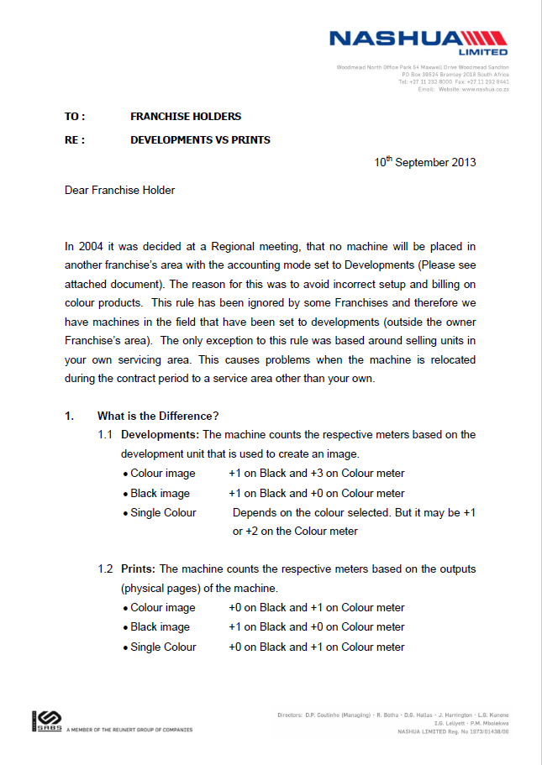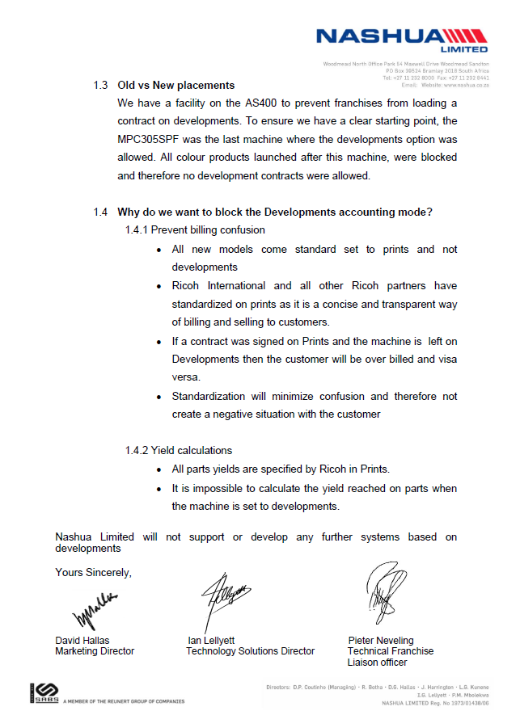

Key Performance Indicators (KPI)

It is essential to monitor how well we perform against set target values in order for us to improve and fine tune our methods of working. As our business grows and develops, new KPI’s will be set and all franchises will be measured against them. These standardized KPI’s allows us to improve our service towards our customers and drive efficiencies within our business. KPI’s will be set for all lines within our business

Mean Time to Repair (MTTR)
Mean Time to repair is defined by the total time it takes to repair a machine. MTTR is a representation of what your customer experiences when he waits for his machine to be repaired. MTTR is measured in hours.

How is MTTR measured?
- It is measured from the time the call has been logged up to the time the call is completed.
- It is measured only during business working hours. As each franchise may have different business hours, this value may differ slightly from franchise to Franchise.
- The Logged and Completed dates and times are used for this calculation
- Rules may vary slightly when calls are logged or completed outside business hours

First Time Fix (FTF)
First Time Fix is a measurement of how often we return to the customer. Its basic measured is based on the time it takes to return to the customer again for the next service call. The basic default period is 10 days. Thus if we do not return to the customer in a 10-day period, the machine is seen as a FTF.
The FTF can have one of 5 statuses.
- Yes (The service call is seen as a FTF)
- No (The service call is not seen as a FTF)
- n/a (The service call is not used in the FTF calculation)
- Linked to Repeat (The service call cannot immediately determine if it is a FTF, and we need
to wait for the duration of the Repeat period before this can be determined)
- BLANK (The FTF has not been set for this service type)
The FTF is then measured as a percentage value: (Count of calls = “YES”) / (Count of calls = “YES” and “NO”)
The FTF period for Production Print machines is 5 days.

Within the AS400 we use a quicker way to determine the FTF. The Service Types quickly describes the function that will be performed on the machine. Refer to the table below to see how FTF relates to the Service Type.

Service Type | FTF status
After Hours | Linked to Repeat
Awaiting Instal Cpl | No
Awaiting Instal Stk | No
Awaiting Install Cus | No
Awaiting IT Instl CP | No
Awaiting Quote Accep | No
Awaiting Spares | No
Awaiting Specialist | No
Call Cycle | Linked to Repeat
Consultation | BLANK
Consumable Runner | Not Applicable
Courtesy | Linked to Repeat
Customer Damage | BLANK
Customer Repair | BLANK
Ex-Dem/Con Machine | Not Applicable
Installation | Linked to Repeat
Pre-Installation | BLANK
Preventative Mainten | Linked to Repeat
Quality Inspection | Not Applicable
Quote | Linked to Repeat
Refurb | Linked to Repeat
Re-Installation | Linked to Repeat
Remote | Not Applicable
Report Call(Meter Re | Not Applicable
Service | Linked to Repeat
Solved By Phone | Not Applicable
Training | Not Applicable
Workshop | Linked to Repeat

Repeats
A service call is deemed as a Repeat call when the following conditions is not met:

- Days between Service calls
The default minimum period between service calls is 10 days. This means that a machine should not have a service calls in 10 working days and then it will not be deemed as a Repeat call. Should this machine generate a Service call in less than 10 days, condition 2 is first checked before the call is deemed as a Repeat call.

Production Print machines have a minimum period of 5 working days between calls.

- Copies / Prints since last Service call
If a machine generates a service call in a period less than the minimum period described above, the amount of prints generated from the previous call is calculated. If the amount of prints is more that the defined Mean Copies Between Calls (MCBC) for this product, then the Repeat is cancelled and the service calls is not deemed a Repeat call.

My-Ricoh
All franchises need to comply to the minimum requirements as set below. The KPIs are set by the Job Sub Type level that is created on the My-Ricoh portal. It is the responsibility of the Technical Director / Manager to ensure that all Job Sub Types are set correctly. For any changes contact the Technical Franchise Liaison or the Technology Administrator.

KPI targets for 2017
Every year Nashua LTD will set new targets to achieve. These targets are created to assist us to improve our service to our customers.

MY-RICOH TRAINING

 | Manager (Servicing machines) | Office Products Engineer | Workshop Engineer | Production Print Engineer | Trainee | IT Engineer | Solution Specialist
OP Maintenance Technician | X | X | X | X | X
OP Service Master | X | X | X | X | X
Basic Connectivity Engineer | X | X | X | X | X
Wide Format Service Engineer | At least 1 SE / franchise
Graphics Arts Specialist |  |  |  | X
PP Service Technician (PP Service Engineer) |  |  |  | X
PP GA Service Technician (PP Service Master) |  |  |  | X
Security Master |  |  |  |  |  | X | X
Streamline NX Specialist |  |  |  |  |  | X | X
@Remote Engineer |  |  |  | X |  | X | X
@Remote Specialist |  |  |  | X |  | X | X
Connectivity Service Master |  |  |  |  |  | X | X

MEAN TIME TO REPAIR (MTTR)

CONDITIONS FOR MTTR MEASUREMENT
- Only Field Calls
- Deleted Calls excluded
- The respective Service Type needs to be taken into account
- OA machines (MFP, Printer & Fax)
  - Does not include Production Print machines (and vice versa)
- SLA machines is defined by the Downtime SLA that is loaded on the specific machine
- Production Print Machines are defined by the product code
  - Only machines where the Product Code contains “PRO”. Example: PRO8100 / PROC7110S / SPPROC7100, etc
  - These will normally fall in the Segment 5 range
- Measurement in hours

MTTR – OA (Service Type = Service)

Distance | Current | 01-Feb | 01-Jun | 01-Oct
All | 5.2 | 5.0 | 5.0 | 5.0
000 - 049 | 4.8 | 4.5 | 4.2 | 4.0
050 - 149 | 6.1 | 6.0 | 6.0 | 6.0
150 - 299 | 8.4 | 8.0 | 8.0 | 8.0
300+ | 17 | 16.5 | 15.0 | 14.0

MTTR - Strategic Accounts (Service Type = ALL)

Distance | Current | 01-Feb | 01-Jun | 01-Oct
All | 3.8 | 4.0 | 4.0 | 4.0

MTTR – Production Print (Service Type = Service)

Distance | Current | 01-Feb | 01-Jun | 01-Oct
All | 5.5 | 6.0 | 6.0 | 6.0

MTTR – PBX (Service Type = Service)

Distance | Current | 01-Feb | 01-Jun | 01-Oct
All | 6.4 | 6.0 | 5.5 | 5.0
000 - 049 | 5.9 | 5.0 | 4.5 | 4.0
050 - 149 | 11.2 | 6.0 | 6.0 | 6.0
150 - 299 | 11.1 | 8.0 | 8.0 | 8.0
300+ | 56.6 | 16.5 | 15.0 | 14.0

MTTR – OA (Service Type = Awaiting Spares)

Distance | Current | 01-Feb | 01-Jun | 01-Oct
All | 25.5 | 25.0 | 25.0 | 25.0
000 - 049 | 23 | 22.0 | 21.0 | 20.0
050 - 149 | 29.2 | 27.0 | 26.0 | 25.0
150 - 299 | 41.7 | 42.5 | 41.0 | 40.0
300+ | 82 | 70.0 | 60.0 | 50.0

FIRST TIME FIX (FTF)

CONDITIONS FOR FTF MEASUREMENT
- Only Field calls
- Deleted Calls excluded
- Includes all Service Types
- OA, Production Print and PBX as defined with MTTR

FTF – OA

Distance | Current | 01-Feb | 01-Jun | 01-Oct
All | 69.20% | 71.00% | 73.00% | 75.00%
000 - 049 | 69.07% | 71.00% | 73.00% | 75.00%
050 - 149 | 69.78% | 73.00% | 75.00% | 77.00%
150 - 299 | 76.31% | 76.00% | 78.00% | 80.00%
300+ | 80.62% | 81.00% | 83.00% | 85.00%

FTF – Strategic Accounts

Distance | Current | 01-Feb | 01-Jun | 01-Oct
All | 66.60% | 68.00% | 69.00% | 70.00%

FTF – Production Print

Distance | Current | 01-Feb | 01-Jun | 01-Oct
All | 56.20% | 71.00% | 73.00% | 75.00%

FTF – PBX

Distance | Current | 01-Feb | 01-Jun | 01-Oct
All | 69.40% | 71.00% | 73.00% | 75.00%
000 - 049 | 69.20% | 71.00% | 73.00% | 75.00%
050 - 149 | 69.40% | 73.00% | 75.00% | 77.00%
150 - 299 | 81.80% | 76.00% | 78.00% | 80.00%
300+ | 100.00% | 81.00% | 83.00% | 85.00%

Production Print

Introduction
Production Print is one of our main lines within our business. The success of Production Print depends on how it is approached. Service Engineers handling the Production Print products should be engineers with good experience in the OA business. This module looks at the requirements that a Franchise needs to adhere to, to ensure the success in the Production Print business.

Always refer to Production Print documentation loaded on iNForm to get the latest updated detailed procedures.

Skills required for Production Printing
Production Print Service Engineers need to be well trained in the following areas:
Hardware
This is the skills required to service and maintain the main frame and peripherals
Software
This is the skills required to operate the software supplied with the machine, as well as the software that is related to the Fiery controller
Graphics
This is the skills required to work with graphic design software. Ex. CorelDraw, Quark Express, etc

Production Print Training
In order to give a professional service to your customers, the guidelines below will indicate the amount of Service Engineers needed to handle the Production Print products.

Device | Min # of Service Engineers Trained | Number of devices in field | Type of Training
ALL | 2 | 1 | Classroom | All classroom based training is subject to the minimum pre-requisites begin met
PRO C series | 4 | Per 10 | Classroom
PRO Series | 2 | Per 10 | Classroom

Minimum requirements for Service Engineer before Servicing Production Print machines
Mono Production Print
- Product training (Classroom)
- My-Ricoh exams completed successfully
- Fiery Training for mono products

Colour Production Print
- Production Print Training (Mono)
- MPC6501 / 7501 Classroom training and My-Ricoh exams completed successfully
- Production Print Training Colour (Classroom)
- My-Ricoh Exams (Colour) completed successfully
- Fiery Training

Parts Holding at Franchise for Production Printing
A minimum parts holding (as specified by Technology) is required at all times at Franchise level and/or on customer site if so required by customer. The recommended parts will be as per OEM specification and/or Nashua Limited communication sent to Franchises by the Technology Department. This list will consist of all PM parts loaded against each machine model BOM on the AS400.

The Franchise would be required to adhere to these minimums to enable professional Production Printing Support.

Refer to the PM Schedules as referred to in the Technical Service manuals of the various products.

Implementation for Production Printing
The following steps are required to successfully deliver and install Production Printing Equipment

- Pre Sales Site visits
- Pre installation forms
- Technical Consultancy
- Customer requirements identified and confirmed
  - Sample print coverage from customer determined
  - Average colour coverage discussed with customer
- Parts holding
  - Franchise (all parts as per PM schedules on the respective machines)
  - On-site (where applicable)
- Delivering the machine (machine movement)
- ORU (operator replaceable units) kits with the machine delivery (ProC series)
- ES1000 / ES2000 Spectrometer required (per site or Franchise)
- Machine Installation
- Operator Training
- @Remote installation and activation (monitored by Nashua Ltd)
- PM Schedules followed according to Ricoh recommendations

Conducting Site Surveys
During the Sales process a detailed site survey needs to be done to ensure that the customer’s site complies to the minimum requirements for a Production Print machine. The site conditions are the responsibility of the customer and any deviations to the minimum requirements should be discussed with the customer beforehand.

The following is necessary pre-requisites on the customer site before any installation can be done:
- Electrical Requirements
  - Note some devices may require more than one electrical supply point
  - Device should not be on the same line as other products that draw a lot of power
- Physical Dimensions and weight
  - For proper operation, Production print machines need a certain space around the machine.
  - This not only allows for proper ventilation, but also to give the Service Engineer sufficient space to service the machine properly. Maintenance should be possible without having to move the machine.
  - Exact dimensions should be taken from the respective Service Manuals.
  - Remember to calculate space including peripherals
  - Device must be installed on a solid surface. Front and rear ends have a tolerance of 2.5mm. (No carpets / soft wood)
  - Ensure that the floor can handle the weight of the machine
  - Sufficient space needs to be available where the machine is being unloaded and moved to its final installation area. Access areas should be of sufficient width and height to enable this process
- Installation conditions and usage
  - Humidity and Temperature plays a major role in copy quality and reliability.
  - Specifications as per respective service manuals
- Network connectivity
  - In order to make full use of the device Charis C1 requires 2 network connections with 2 IP addresses when any Fiery is connected.
  - The device can operate with just 1 connection and 1 IP address, but functions such as GW Scanning, Web Image Monitor and @Remote will only work with 2 connections enabled.
- Storage of Consumables and ORU (Operator Replaceable Units)
  - All consumables and ORU kits needs to be stored in the proper conditions
  - Refer to Service Manual for information

Refer to Technical Manuals for required specifications per device.

NOTE:
In case of specific handling (i.e. door expansion, disassembly of the device, deployment of extra manpower, etc.), additional costs will be charged. The total costs will be for the customer’s account and they should be made aware of this beforehand.

Site survey forms contain all the detailed information needed to properly complete an installation. It should be completed in detail, signed by the customer and then returned to the Technical Manager. The completed Site Survey forms needs to be sent to the Nashua LTD Technology Product Specialist for final approval of the site conditions.

Field Service Calls on Production Print machines
To ensure that machines operate at peak levels, the Production Print machines has to be serviced properly. Therefore, Service Engineers should be allowed the time they need to perform their job.

Tools necessary to service Production Print machines
Mono
- Notebook
- Setting Powder (2 different types)
- Mono Test chart
- Special tools supplied with machine installation
- FluoTribo Grease
- SD card

Colour
- Notebook
- Setting Power (2 different types)
- Fusing Belt Polisher (ProC 651)
- FluoTribo Grease
- ES1000 / ES2000 Spectrometer
- Colour Test chart
- Special tools supplied with machine installation
- SD card
- NICE tool

Preventative Maintenance Procedures
For optimum performance all machines should be kept on PM schedules. These schedules should be arranged beforehand with the customer so that he is aware of the downtime of the machine during this PM period.

List of Acronyms used in this document

Acronym | Description
ACV | Average Copy Volume
AS400 | Nashua’s ERP system
B/W | Black and White
CLR | Colour
CPC | Cost per Copy
CPP | Cost per Print
CSA | Continued Service Agreement
CSA Owner | CSA owner is the franchise that owns the CSA contract
DSR | Dealer Service Revenue
EM | Emergency Maintenance
ERA | Equipment Return Authorisation
ERP | Enterprise Resource Planning
FTF | First Time Fix
FTP | Franchise Transfer Price
IFL | Inter Franchise Labour Rate
KPI | Key Performance Indicator
LE | Learning Event (My-Ricoh)
MCBC | Mean Copies Between Calls
MCV | Maximum Copy Volume
MTTR | Mean Time to Repair
NTMS | Nashua Technical Management Standards
OA | Office Automation
OEM | Original Equipment Manufacturer
ORU | Operator Replaceable Units
PBX | Private Branch Exchange
PCR | Printer Care Revenue
PM | Preventative Maintenance
ppm | Prints per minute
SLA | Service Level Agreement
SRV | This is the Servicing Franchise of the machine
TSC | Technical Steering Committee

