KCS OFFICE MANAGEMENT (PTY) LTD T/A
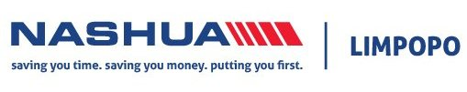
COMPANY PROFILE

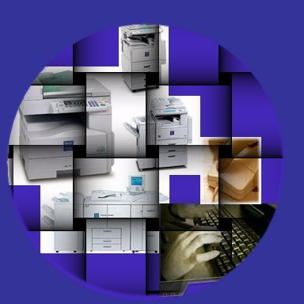

We are committed to strengthening our leadership position in office automation through total quality services by saving you time, saving you money, putting you first.”

Company Overview
“Saving you time. Saving you money. Putting you first” is synonymous with the brand leader of the Southern African office automation market. As the largest provider of corporate printing solutions to the Southern African market, Nashua’s iconic status and solid reputation has been built in the unrelenting commitment to save its customers time, money, and above all put them first.
Nashua is set apart by a ‘lifetime customer’ philosophy. This philosophy is underpinned by the desire to maintain customer relationships that last five, ten and even in some cases in excess of twenty years. This commitment to service excellence coupled with a long-term customer focus has ensured that Nashua has held the number one market position in Southern Africa for 25 years.
For Nashua, “Saving you time. Saving you money. Putting you first.” is much more than an advertising slogan. It is a mission that drives the company and is the true measure of its success.
Franchise Network
One of the factors of Nashua’s success can be attributed to the decision in 1981, to distribute its products and services through a network of exclusive franchises covering South Africa, Namibia, Swaziland, Lesotho, Botswana and Zimbabwe. Franchise map below:

Service
Saving you time. Saving you money. Putting you first. For most companies, an advertising slogan remains just an advertising slogan. For Nashua, it is a mission - a mission made known to every employee and the enduring benchmark of our service performance.
In the Southern African office automation market, competition is intense. Nashua is acutely aware that the quality of after-sales support and service remains one of our customers’ primary concerns. Customer service costs can be managed and minimised through a variety of service level agreements, which tailor our service offering to you based on your requirements and budgetary constraints.
Nashua’s after-sales service and preventative maintenance programme is supported by an extensive network of service workshops and the most up-to-date computerised field service system. Regardless of where a device is located in South Africa, Botswana, Namibia, Lesotho, Swaziland or Zimbabwe, Nashua can assure its customers of a quick and efficient response to any problem.
Nashua’s preventative maintenance programme is designed to ensure that all customer installations operate at peak efficiency and keep downtime to an absolute minimum. Preventative maintenance for all Nashua installations is planned and executed by service teams nationwide. Where unscheduled maintenance is required, downtime is kept to a minimum through a centrally managed service division.
MASC (Mobile Automated Service Call Management System)
In an effort to improve service delivery for Nashua’s customers, ACUO Technologies developed a mobile solution, allowing engineers to receive and complete their service calls using a GPRS driven PDA system. They no longer need to keep phone lines busy by receiving or logging off calls and service controllers are able to attend to customers promptly. This has resulted in a more productive, more professional team of engineers and has put Nashua in the number one position in Service Delivery.

With Nashua as your partner, “Saving You Time. Saving You Money. Putting You First” is our service guarantee

Products
Through partnerships with its major international suppliers, Nashua is able to offer its customers the very latest technology.
The experience, research, development programmes and technology of the global giants of technology are available to Nashua’s customers in Southern Africa. The backing of our global technology partners, has allowed Nashua to focus its own resources on enhancing its technological capabilities to serve the particular needs of the South African market.
One of the principle functions of the Nashua Technology Division is to develop thorough technical expertise of each product that Nashua markets locally. Systems are locally devised to integrate our various products into marketable components of highly effective customer-driven office automation and document solutions.
New and innovative products continuously emanate from Nashua’s world-leading suppliers. After careful selection by Nashua’s product management team, the new products are placed under extensive local testing by the Nashua Technology Division. New products are only added to our offering once they have met and exceeded Nashua rigorous testing standards and have a demonstrated benefit for our customers. Nashua sells a variety of office automation products, including:

• Black & White Multifunctional printing
devices
• Colour Multifunctional printing devices
• Black & White laser printers
• Colour laser printers
• Wide volume printing devices
• High Volume printing devices
• Facsimile machines
• Digital Duplicators
• PABX systems
• Software products

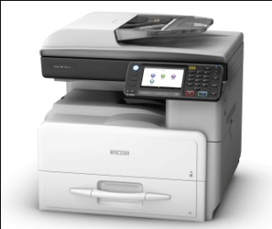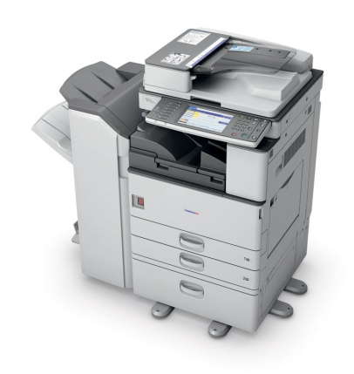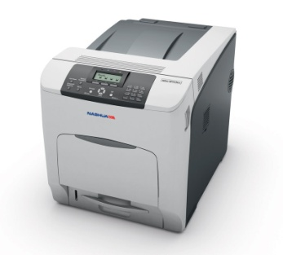
Company Objective
The overall Company Quality Objective is to ultimately achieve a high level of customer satisfaction (internally & externally) with regards to the service we deliver. Nashua Limpopo shall review customer requirements and any additional organizational requirements prior to the commitment to supply a product to the customer e.g.: tender, contract or order review, ensuring that product requirements are clearly defined. Should the customer not provide a statement of requirements, Nashua Limpopo shall confirm requirements before acceptance.
Amendments to contract on order requirements differing from the original requirements shall be resolved between Nashua Limpopo and the customer.
The results of the aforementioned product service reviews and any necessary follow-up actions shall be recorded. If Product requirements are amended, Nashua Limpopo shall ensure that all relevant documents have been amended and that relevant personnel are aware of the changes made.
Customer Communication
Nashua Limpopo shall identify and implement communications with customers relating to:
- Product / Service information
- Inquiries, Contract / Orders inclusive of amendments, Feedback, Customer complaints etc.

Contact Details

Polokwane Head Office
C/O Veldspraat & Prince Hussein Street
Magna Via
Polokwane 0700
PO Box 761
Polokwane
0700
Tel: +27 15 590 0319
Fax: +27 15 495 0935
Tzaneen Office
Shop No.2
Tzaneen Crossing Mall
58 Peace Street
Tzaneen
0850
Tel: +27 15 590 0458
Fax: +27 15 5900458

Email: helpline@nashualim.co.za
Website: www.nashua.co.za

