

COMPANY PROFILE

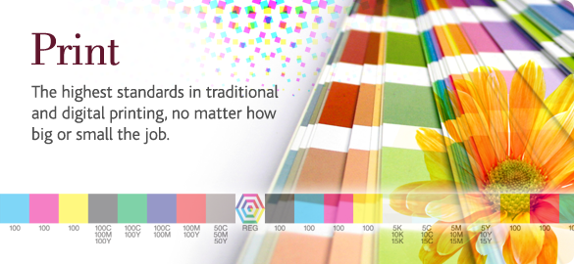

TRUSTED TO DELIVER EVERY TIME

Company Overview
ProntaPrint has been in business since in Polokwane 1986. Their iconic status and solid reputation is well earned and based squarely on their commitment to customer service.
ProntaPrint employs 12 staff members, most have been with the business for more than 15 years. This bears testament to the fact that the business has created a healthy happy working environment where the staff are encouraged to grow and be part of the success of the business.
With a combination of the latest machinery and the skilled enthusiastic employee compliment, ProntaPrint has the ability to handle any workload, promptly and proficiently to ensure their customers always receive the finished product well within their deadlines.
ProntaPrint is set apart by the quality of our finished product. Our focus is built on having long-term relationships with our customers.

Service
ProntaPrint’s service and support system are designed to ensure that all customers are professionally and efficiently assisted with priority given to quality and a realization of their customer’s sense of urgency.

ProntaPrint specialize in the following areas of printing:

- High Volume photocopying and Printing
- Full colour Copying and Printing
- Large Format Printing, Copying and scanning
- Designing
- Invoice books and Receipt books
- Laminating up to size A0
- Manufacturing of Rubber Stamps
- Printing and Designing of Posters up to size A0
- Binding and Finishing of documents
- Fax Services
- Plan Printing, Copying and Scanning
- Laser cutting and engraving

Contact Details
56 Market Street
Polokwane
0700
Tel: 015 295 88 55
Fax: 086 630 7139
Email: pronta@iafrica.com

