Link Product to Service Engineer form

The Link Product to Service Engineer form has taken on a new format. This document has been put together to help you understand how this form works. Although the principle is the same as the previous form, the format is totally different.

STEP 1

- Download the latest version of this file from Nastech.
- Download details as follows:
  - Website: www.nastech.co.za
  - User: Service
  - Password: Request the latest password from Pieter Neveling
- Save it to your hard drive.
  - Extract the file from the zipped document to your Hard Drive.
  - Be sure not to change the file extension!

Conditions for the form to work

- Microsoft Excel 2007 or 2010
  - Excel’s Macro’s must be enabled
  - Must be saved as a Macro Enabled file (.XLSM).
    - If you save it as Excel Workbook (.XLS), the form will not work!
- Your mail client must be Microsoft Outlook

Training Records

- Your training records will play a very big role in using this Link form.
- Whoever completes this form must have complete access to Training records to be able to use this form effectively.
- WICE Examinations
- Classroom training

Opening for the first time

When opening the document for the first time, you will need to do some administration first.
- Open the Link Product form
- You may get a security warning to “ENABLE CONTENT”. Click on the button to enable the content.

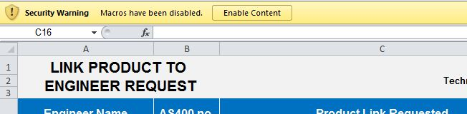

- You also may get another security message that asks you if you want to make this a trusted document. Select “Yes”

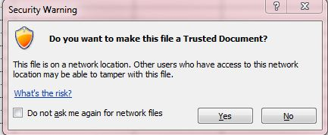

- The Link Product interface and the spread sheet will open automatically.

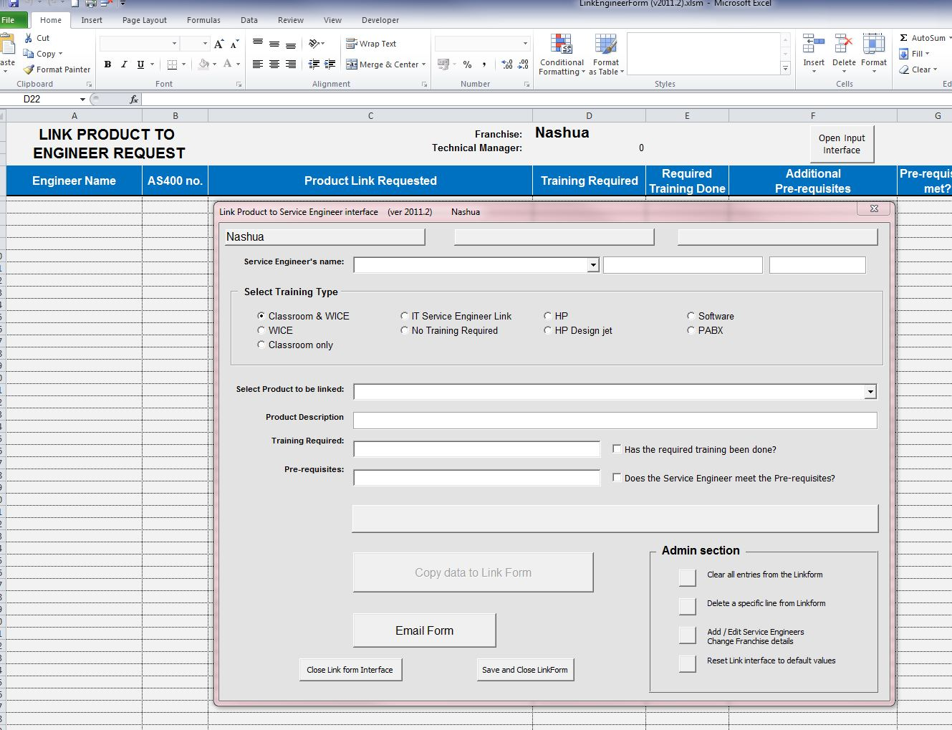

- All actions can be done from this interface. It has been designed to make it as simple as possible and to give you the most options.

- The first thing that you need to do is to add your Franchise and Service Engineer data.
  - On the right hand bottom corner of the Interface is the Admin section

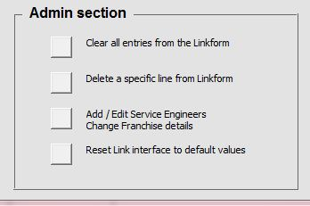
  - Click the button “Add / Edit Service Engineer. Change Franchise details”
  - This will automatically close the interface and take you to the Data sheet

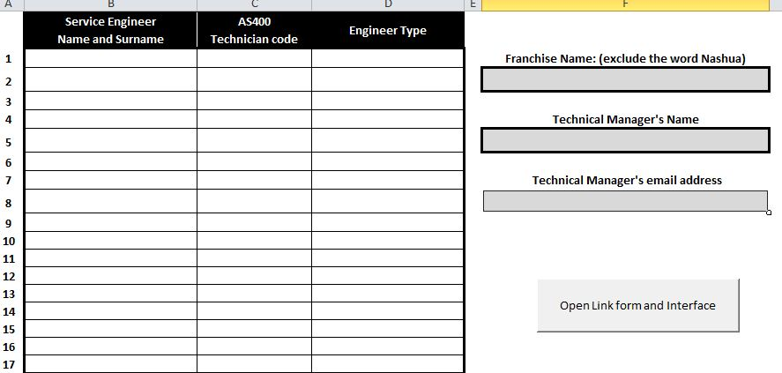

  - You will need to complete this sheet with all the Franchise and Service Engineer’s details
  - Add your Franchise name (Exclude the words “Nashua”), Technical Manager’s name and Technical Manager’s email address in the appropriate blocks on the right hand side
  - A copy of the Link form will always be emailed to the Technical manager’s email address.
  - Add all the Service Engineer’s Names, AS400 Technicians code
    - You will have to select a Service Engineer type for each Service Engineer

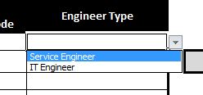

    - Use the drop down box to make the selection. If you type in this box, you will get an error. If you receive the error, simply select the Cancel option and reselect the Engineer type.

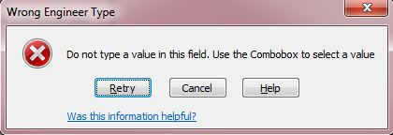

  - The completed form should look like this

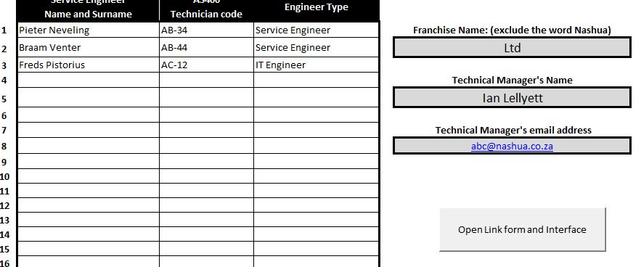
  - Once you have completed all the data onto this form, select the button on the Right hand side to open the Link form Interface

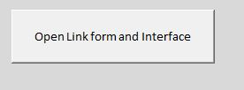

  - The Link form sheet and the Link Product to Service Engineer interface will now automatically open.
  - Note that the heading area of the interface will have all the necessary details completed

  - The version of the form that you are using will always be displayed on the top. If you have problems using the form, please quote this version
- To finalize the setup, click the button on the bottom of the form. “Save and Close Link Form”
- This will save all the data that you have just input and ensure that you do not have to go through this process again.

Understanding the Training and Link Types

Training Types

There are currently 9 different Training types on the form. They are selected by clicking in the Radio button next to the training type.

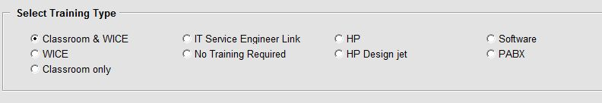

The Link form is based on the type of training required to be able to acquire a Permanent Link. Once you select the Training type, the products in the “Product to be linked” combo box will change. For example, if you select HP, then you will only see the HP products in the combo box. Similar, if you select Software, then you will only see the software products.

Note that the Engineer type will determine the Training types that will be available for that specific Service Engineer.

- Service Engineer Type = Service Engineer

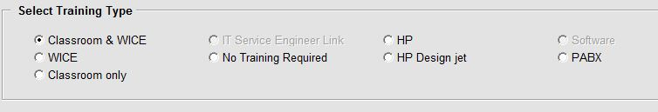

- Service Engineer Type = IT Engineer

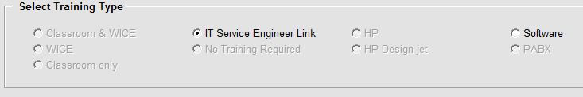

Note that products may be present in more than one of these options. The only difference is the Pre-requisites.

- Classroom and WICE
This option is for machines where the Service Engineer has to do the full training course. He / she must have attended Classroom Training and passed the WICE exam. These may be old and new products.
- WICE
This option is for machines where the Service Engineer has completed the Superseded or Predecessor training successfully.
- Classroom only
For Products, there is no examination. However there may be other Pre-requisites
- IT Service Engineer Link
Only to be used for IT Service Engineers. The minimum pre-requisites is WICE knowledge area Level 4. This information can be obtained for your Franchise WICE administrator.
- No Training required
No training required, but there may be pre-requisites
- HP
Only HP products
- HP Design jet
Only HP Design jet products
- Software
Nashua’s Software range where the Service Engineer needs to be linked
- PABX
Only PABX products.

Link Types

There are 3 displays when you create your Link data. This will guide you what the Link type will be based on the data that you have entered.
- Incomplete data
This means you have not input a sufficient amount of data to be able to calculate the Link type. Ensure that the following fields have been completed:
  - Service Engineer Name
  - Product
- Temporary Link
The Service Engineer does not comply with the minimum requirements to have a Permanent Link
- Permanent Link
The Service Engineer complies to the minimum requirements to have a Permanent Link

Adding data to the Link Form

- Open the spread sheet
- The Link Product to Engineer interface should open automatically
- First select the Engineer’s name by clicking on the arrow of the drop down box

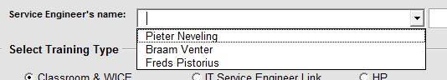

- The Engineer type and his / her AS400 Technician’s number will be filled in automatically

- Select the appropriate Training Type

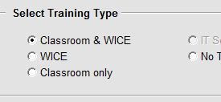

- Click the drop down box next to the “Select Product to be linked” header
- Scroll down until you see the product that you would like the Engineer to be linked to.
- Click on the product

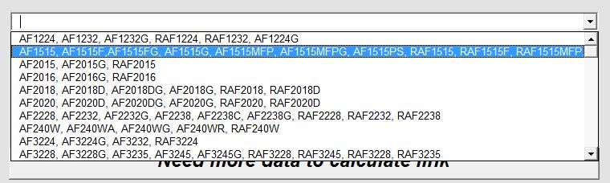

- Now that you have selected the product, the interface will give you the “Training Required” and the Pre-requisites for this product

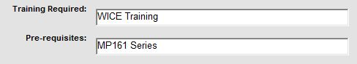

- If the “Required Training” and the “Pre-Requisites” have been done, the Service Engineer will get a Permanent Link. In all other instances, he / she will get a Temporary link.
- Initially the checkboxes have no checkmarks.

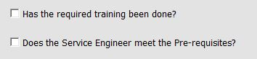

- To confirm if the conditions have been met, you will need to place a check mark in the appropriate boxes

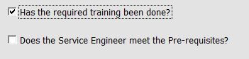

- If “No Training” is required, the checkbox will be automatically marked and then the option will be greyed out so that you cannot deselect it.

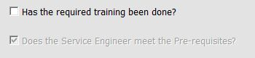

- Once you have completed this process, you will now need to add the Service Engineer’s data to the spread sheet. This can be done by clicking the “Copy data to Link form” button

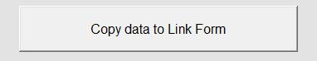
- You will notice the data is then added to the spread sheet at the back of the Interface.

REPEAT THE PROCESS ABOVE

- Repeat the process above to add more Service Engineers and courses to the Link form
- Once you have completed the Link form, you are able to email it to Nashua Ltd

Emailing the Link Product to Engineer form

- The process is quite simple and you only need to click the “Email Form” button

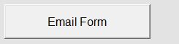
- If there is no data on the form, the form will give you an error. Please add data and try again

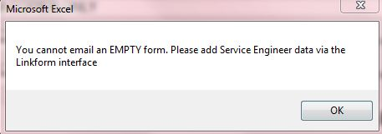

- During the Mailing process, the Microsoft Outlook will request your permission to send data. When you get this notification, select the “Allow” option.

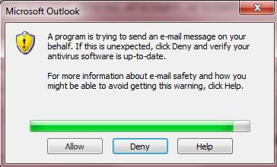

- The Email will now automatically be generated and will be placed in your Outbox in your Microsoft Outlook client. You may have press the Send/Receive button to send it.

Further Administration on the form

- At the lower Right hand side of the Interface, is the Admin section
- You are able to do the following from here

- Clear all entries from the Linkform
  - Use this button to clear any data that is on the Linkform
  - You will be asked to confirm that you want to clear the Linkform sheet
  - If you are satisfied that you want the data cleared, select “Yes”, else select “No”

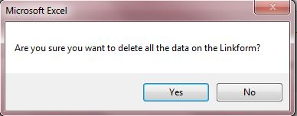

- Delete a specific line from Linkform
  - You should not delete lines manually off the sheet.
  - If you have by mistake added incorrect data to the LinkForm Sheet, you are able to delete that line by using this function.
  - When you have clicked the button, you will be requested to put in a Line number.

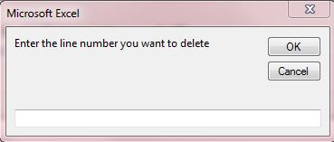
  - Once you have entered a Line number, click the “OK” button.
  - The line will be automatically deleted and you will be returned to the LinkForm Interface.
- Add/Edit Service Engineers ~ Change Franchise details
  - This function has been described earlier in this document
  - You can at any time return to the Data Sheet to Add more Service Engineers or change Franchise details
- Reset Link Interface to default values
  - This will clear all the values on the LinkForm Interface
  - It will not delete any of your Service Engineer data

Troubleshooting

If you have any difficulties with this form, contact Pieter Neveling at Nashua Technology Department.

Pieter Neveling
pietern@nashua.co.za
(011) 232 8194

