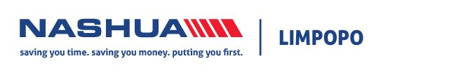

TERMS AND CONDITIONS FOR USEAGE OF NASHUA LIMPOPO SIGNAGE

The following Terms and Conditions apply to any person requesting the use of any / all Nashua Limpopo signage.

- Signage remains the property of Nashua Limpopo. Users shall not remove, deface or obscure any branded signage.
- Users shall not make any alterations, additions, modifications or improvements to the signage and shall use it only for the purpose and in the manner for which it was intended by die user.
- User may not permit the signage to be used by another party or at a different location without the express written consent of Nashua Limpopo.
- User is responsible for damage to the signage due to abuse, misuse or negligence and agrees to pay the charges to repair signage so damaged.
- Signage shall be return to Nashua Limpopo in good condition and repair. Wear from reasonable and proper use expected.
- Upon return, user must confirm that signage is in good working order and any damage must be reported.
- User is responsible for loss or damage to the signage.
- In accepting liability for the safe keeping of all Nashua Limpopo signage, user agrees to pay Nashua Limpopo the replacement cost (as determined by manufacturers current price) of any such marketing material which the user is for any reason unable to return to Nashua Limpopo.

Acceptance

By signing below, the user agrees that they have read and understand the above Terms and Conditions, and will be bound by them.

Name (printed) _____________________________ Signature_______________________________

Company_________________________________ Event__________________________________

Date signed out____________________________ Date returned___________________________

Comments regarding signage_____________________________________________________________

_____________________________________________________________________________________

