

1 – Find your ISO icon on your desktop.

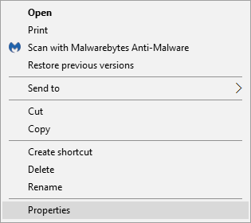
2 – Right click on the icon and click on properties.

3 – Take out http://10.1.1.101 and type in http://172.21.121.101

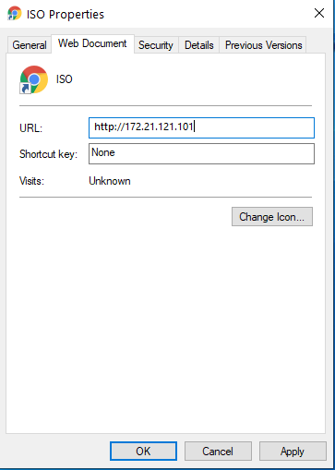
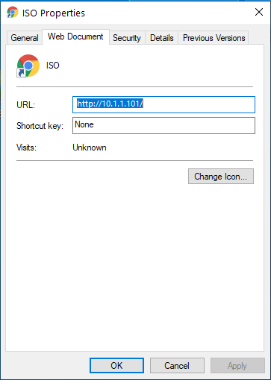

4 – Click on Apply and OK.
5 – Finish, your ISO is on the new server.

