COMPANY PROFILE

TBSS TRADING 28 (PTY) LTD T/A NASHUA LIMPOPO OFFICE SOLUTIONS

REG NO: 2012/161195/07
VAT NO: 4940263108



NASHUA

A FOURTY YEAR LEGACY OF PUTTING YOU FIRST

Nashua’s pay-off line, “Saving you time. Saving you money. Putting you first” has become synonymous with the brand, a leader in office automation and one of the largest providers of printing devices within the South African market for a number of years. In fact, it’s no exaggeration to say that Nashua has managed to achieve iconic brand status. This positioning would not have been possible had the company not consciously set out to live its values and to that end, Nashua endeavours to literally save its customers time and money, and ensures that it always puts them first.

The company’s philosophy of having ‘lifetime customers’ is what sets it apart. What drives Nashua’s approach to its clients is the relationship it plans to have with the same clients in five, ten and even twenty years into the future. It is for this reason that Nashua has held the number one market share in South Africa for 25 years.

For Nashua the pay-off line is much more than a mere advertising slogan. Rather it is a mission that is pervasive throughout the organization and is used to evaluate service performance.

Nashua South Africa was acquired by the Barlows Group in 1983. Since the mid-1990’s Nashua has been part of the Reunert Group, specializing in servicing the corporate business market. Nashua Limpopo has been in existence for 33 years, and currently services well over 2 000 customers in the Limpopo province.

Franchise Network
One of the factors of Nashua’s success can be attributed to the decision to distribute its product and services through a network of exclusive franchises covering South Africa, Namibia, Swaziland, Botswana and Zimbabwe.

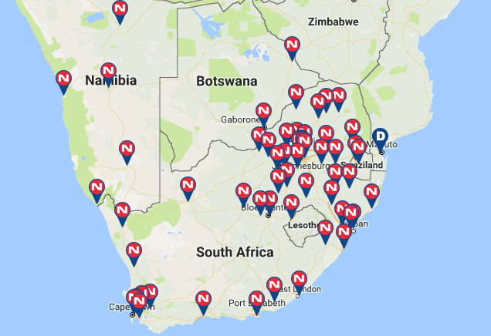

Correct tools for the job

Ricoh hardware advantage

Hardware
Nashua is the largest distributor of Ricoh products in the world. Ricoh hardware is world-renowned for being industry-leading in terms of quality and features. Ricoh constantly strive to remain one step ahead of the competition with the addition of innovative features, security enhancements and refreshing of their industry-related hardware, all whilst making their hardware both more economical and also more aesthetically pleasing.

Nashua is also a Hewlett Packard (HP) Gold Preferred Partner Imaging and Printing Solution Specialist. The HP range comprises LaserJet home, office & business printers, MFP’s, scanners, Latex and DesignJet Printers, to name a few.



Software
Nashua included device monitoring software with all of the devices proposed that helps Nashua increase our customers’ office efficiency and productivity. It helps to ensure the consistent high productivity of all document output devices, as a result of the system's real-time monitoring of printers or MFP's, reporting critical status and condition information. The device monitoring software will proactively manage consumable levels and also automatically collect monthly print volumes of all of the devices on the network.
It ensures our customers’ print environment is monitored and reported on by helping to allocate monthly print volumes to the correct business units and enabling follow-me printing for all the network printing devices.

Support Excellence

In the Southern African office automation market, competition is intense and Nashua is acutely aware that the quality of after-sales support and service remains one of our customers’ primary concerns. We pride ourselves on providing a tailored service that perfectly fits our customer’s requirements and is within their budgetary constraints. Nashua’s after-sales service and preventative maintenance programme are supported by an extensive network of service workshops and the most up-to-date computerised field service system.

Nashua’s geographical presence in Southern Africa is unsurpassed, allowing us to deliver on our corporate clients needs no matter their location in the country.

Integrated solutions

Simplicity, quality and benefit – this is what we look for when introducing new lines of business and brands into the Nashua Group. It is what underpins our brand promise of putting our customers first – as well as saving them time, and money. Over the past 40 years, our business has evolved with the market and its needs in order to ensure that we are consistently in a position to support and add value, as well as offer our customers integrated solutions for every aspect of their business and office environment.

We are proud to announce the partnering with two established and respected companies in order to further enhance our product offerings and expand on our lines of business.

Touch the future with MultiTouch Interactive whiteboards

Parrot – who manufacture, supply and distribute Presentation Products, Office Equipment and Desktop Stationery started as a supplier of two line items only, and now supply almost 1700 line items. They are also the largest supplier of Presentation Products in South Africa. ‘Parrot Interactive’ focusses on the supply and distribution of electronic presentation products and accessories, and following the technological advances in the education and training sectors, Parrot is now the only single supplier in South Africa to offer a range of Interactive systems, to suit all needs.

Nashua and Sensor, setting the standard in Surveillance and Access Control solutions
Sensor Security are the leading importers and distributors of Hikvision surveillance and access control products in Southern Africa, and, are renowned for their high quality product set, expertise, and ability to deliver end-to-end surveillance solutions.

They are also the leading importers and distributors of biometric core technology, ViRDI. The ViRDI Series has set the benchmark for a user friendly fingerprint/facial recognition product line for Access Control and Time & Attendance with its top notch proprietary algorithm and technology, and as such, is trusted by organisations in 80 countries worldwide.

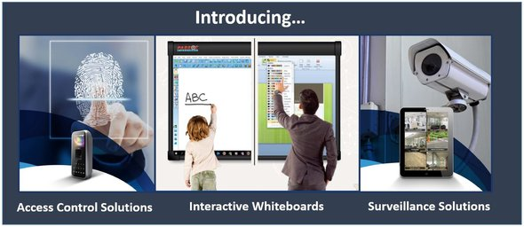

B-BBEE and Socio-Economic Development

Nashua is committed to a Broad-Based Black Economic Empowerment (B-BBEE) and Socio-Economic Development in South Africa and continues to make improvements to our policy strategy on an on-going basis. Nashua Limpopo has been awarded a Level 2 accreditation demonstrating our commitment to making a visible difference in South Africa.




Corporate Social Investment (CSI) is an investment in the community, helping to create an environment that is safe, healthy, educated, secure and conducive to a better life style. Nashua is committed to improving the livelihood of previously disadvantaged communities through its CSI outreach programme. Nashua’s commitment will ensure the sustainability of many previously disadvantaged communities.










Nashua is passionate about education in the Limpopo province and continuously endeavour to support local schools through various sponsorships. On a national & local level Nashua is involved in various sponsorships.
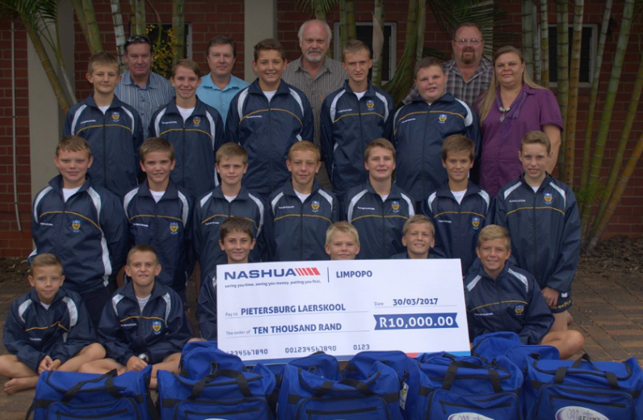









NASHUA CURRENT SOLUTIONS OFFERING INCLUDES:
- Document management software
- Interactive Whiteboard Solutions
- Print management and cost recovery software
- Consumables, Stationery & Paper
- Black and white multifunctional printing devices
- Colour multifunctional printing devices
- Black and white laser printers
- Colour laser printers
- Wide volume printing devices
- High volume production printing devices
- Facsimilie machines
- Digital duplicators
- Nashua Voice - Lite, SIP, SME
- Lite Internet Access
- Business Internet Access
- PBX - Nashua Virtual PBX (VBX)

NASHUA LIMPOPO BUSINESS DETAILS

POLOKWANE OFFICE
Tel: (015) 590 0319
Fax: (015) 495 0935
c/o Veldspaat & prince Hussein Street
Magna Via
P O Box 716
Polokwane 0700

TZANEEN OFFICE
Tel: (015) 590 0458
Fax: (015) 590 0458
Shop 2, Tzaneen Crossing Mall
58 Peace Street
Tzaneen

MOKOPANE SHOP
Tel: (015) 590 0460
Fax: (015) 495 0905
Shoprite Mall
c/o Nelson Mandela & Pretorius Street

GIYANI SHOP
Tel: (015) 495 0915

Fax: (015) 495 0915
Shop 44, Masingita Plaza, Giyani

THOHOYANDOU SHOP
Tel: (015) 495 0865

Venda Plaza, Thohoyandou

Email: solutions@nashualim.co.za
Website: www.nashua.co.za
Facebook: www.facebook.com/Nashualim

